The Avengers’ Survey
The Avengers are doing a survey of villains depending on their power and
whether they are male or female.
They decide to do a stratified sample of 50.
How many should they choose from each group for the sample?

 | Flight | Gadget | Element | Alien
Male | 27 | 48 | 32 | 18
Female | 13 | 26 | 53 | 7
Sample
Male
Sample
Female

The X-Men’s Survey
X-Men are going to ask employees from their various bases on their performance, but they also want to break them down into males and females.
They would like a stratified sample of 60 people.
How many people of each gender should the X-Men survey?

 | Utopia | X-Mansion | Australia | Graymalkin Industries
Male | 44 | 53 | 75 | 97
Female | 58 | 31 | 20 | 122
Sample
Male
Sample
Female
1) There are 10 competitors in an athletics event, see below. Use the random button on your calculator to select 4 competitors for drug testing.
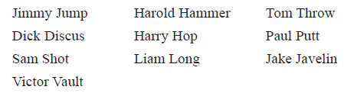

2) In a class there are 30 pupils. The teacher decides to take a random sample of 5 pupils to estimate the mean height of the pupils in the class.
Select a random sample of 5 pupils.
