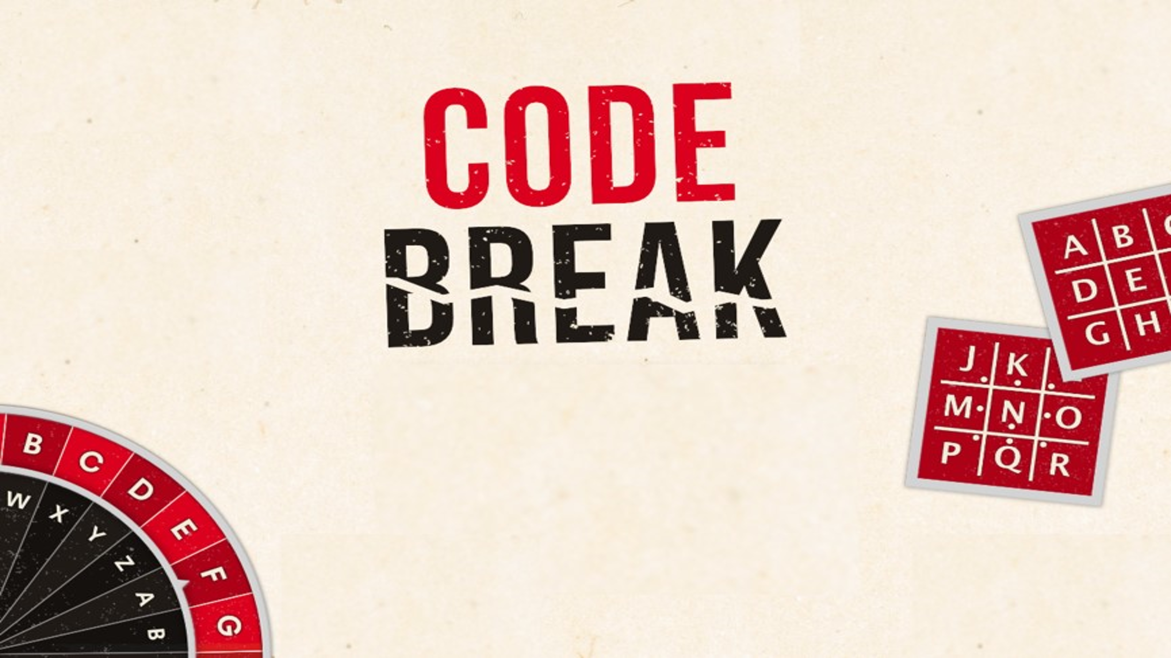

- Pigpen Codes
- Transposition Ciphers
- Mirror Writing
- Letter Swapping
- Semaphore Codes
- Caesar Shifting
- Vigenère Encryption
- Frequency Analysis
Pigpen Codes
HOW IT WORKS
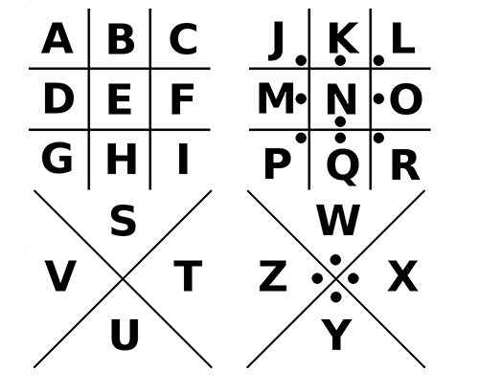
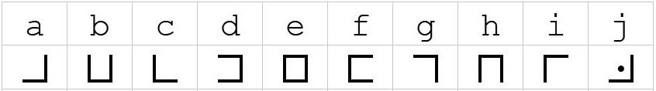

EXAMPLE
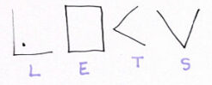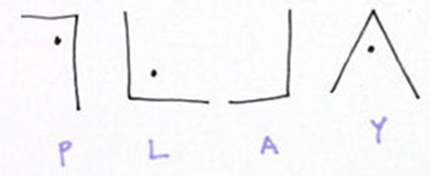

BREAK THE CODE
1)
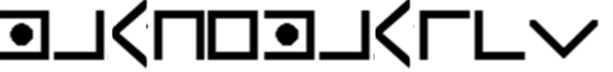

2)
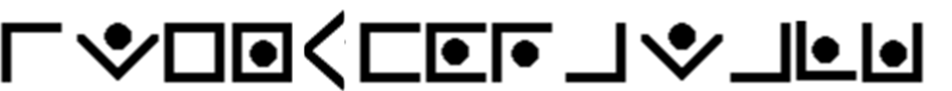
Transposition Ciphers
HOW DOES IT WORK
A transposition means that the letters of the code are simply rearranged into a different order using a grid of rows and columns.
EXAMPLE
Coded Message: ICBKAOREMDERAEAA
Use a grid with 4 rows and 4 columns, the message is then read down the columns
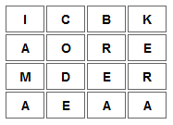
Decoded Message: I am a codebreaker
BREAK THE CODE
1) TIOICCBKTHSRFUORIEIAEFLDENSSMDITEAGT (make 4 rows of length 9)

2) WTFRUELEHQRHIOSADUITUEASUQRPSGSAD (make 3 rows of length 11)
Mirror Writing
HOW DOES IT WORK
Mirror-writing is the production of letters, words, or sentences in reverse direction, so that they look normal when viewed in a mirror.
EXAMPLE
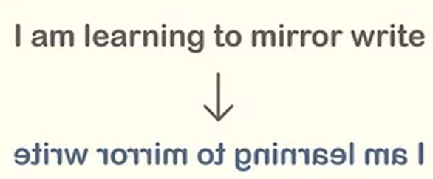
BREAK THE CODE
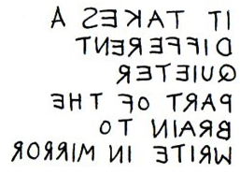
Letter Swapping
HOW DOES IT WORK
Groups of letters, often pairs, are written backwards.
EXAMPLE
wInetttoehwsmiimgnoplo > I went to the swimming pool Pairs of letters of are written backwards.
BREAK THE CODE
1) oycuna erda htsi
2) lumpitcilitano
Semaphore Codes
HOW DOES IT WORK
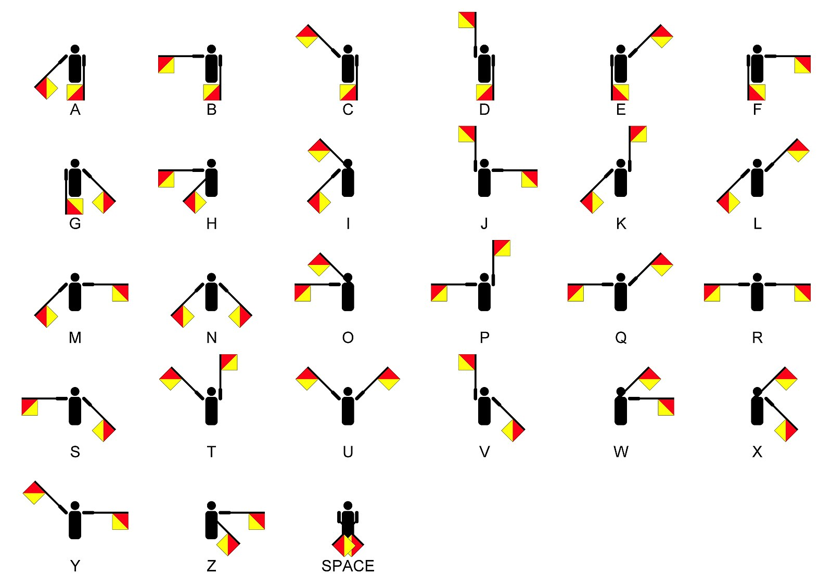
EXAMPLE
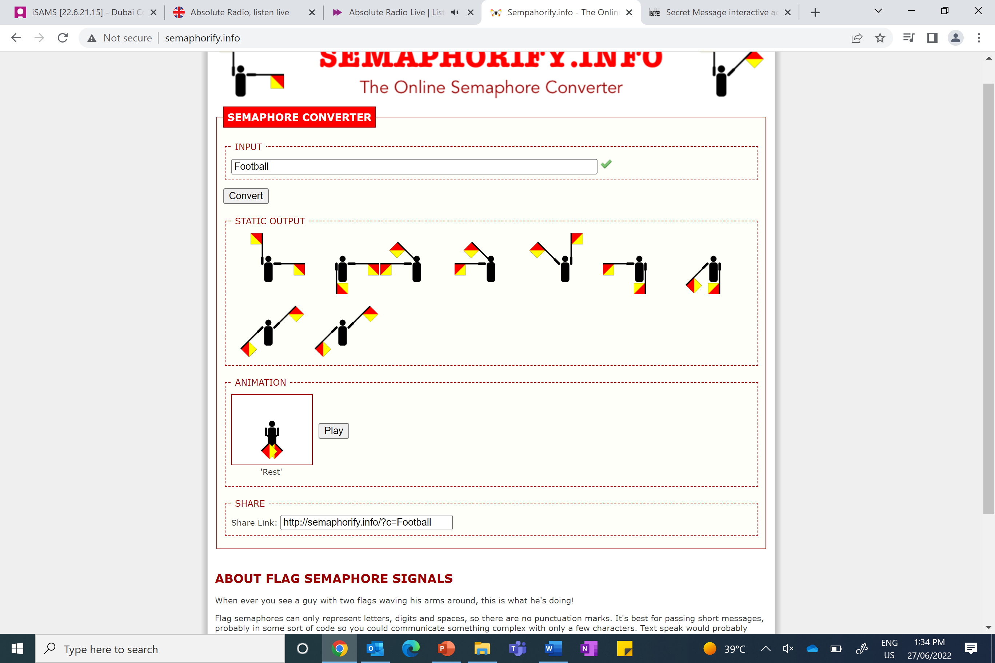
F o o t b a l l
BREAK THE CODE
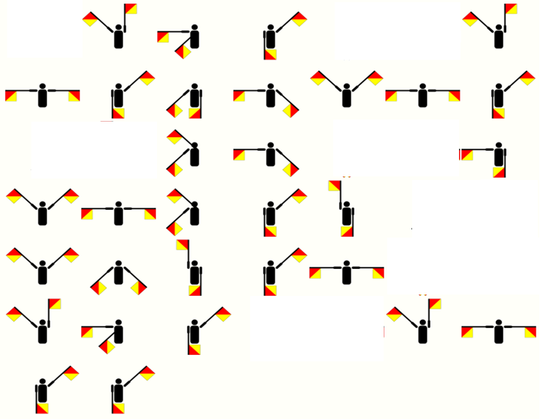
Caesar Shifts
HOW IT WORKS
It is a substitution code, which means that each letter is replaced with another one.
To encrypt or decrypt a Caesar shift you first list the alphabet, and then for a Caesar shift of three right, you move every letter of the alphabet 3 places:

EXAMPLE
Coded Message: EBIIL
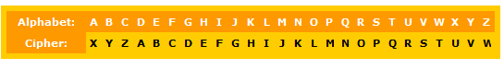
Decoded Message: HELLO

BREAK THE CODE
1) ZLKDOXQRIXQFLKP VLR EXSB ZOXZHBA QEB ZXBPXO PEFCQ ZLAB
Right 3
A | B | C | D | E | F | G | H | I | J | K | L | M | N | O | P | Q | R | S | T | U | V | W | X | Y | Z

2) DOHA PZ AOL MPMAO AYPHUNBSHY UBTILY
Left 7
A | B | C | D | E | F | G | H | I | J | K | L | M | N | O | P | Q | R | S | T | U | V | W | X | Y | Z

Vigenère Encryption
HOW IT WORKS First you need to choose a keyword. The example below uses the keyword “FIRST”. Then it uses five different Caesar shifts, from column F, I, R, S and T.
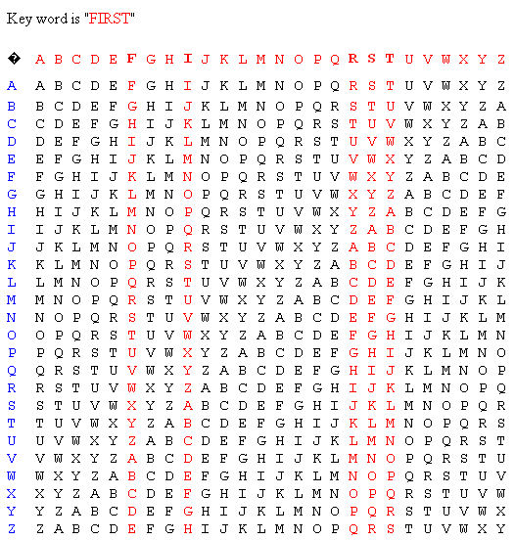
EXAMPLE
Coded Message: BPFAG AMELX IKRDV ZTLK Decoded Message: WHO INVENTED CALCULUS?
With the first letter B, we look down the F column – and find B. Then look across to the far left column - this gives us W.
Next we decode P by finding it in the I column. Then looking across to the far left column – this will give H.
BREAK THE CODE
(Keyword MATHS) TOPTS ZYLLU ANWZA ZAWHQ
Frequency Analysis
HOW DOES IT WORK Concentrate on short words first (especially one letter words). A question begins with a word like why or what. Look for coded letters which repeats. Think about what letter is used most in the English language.
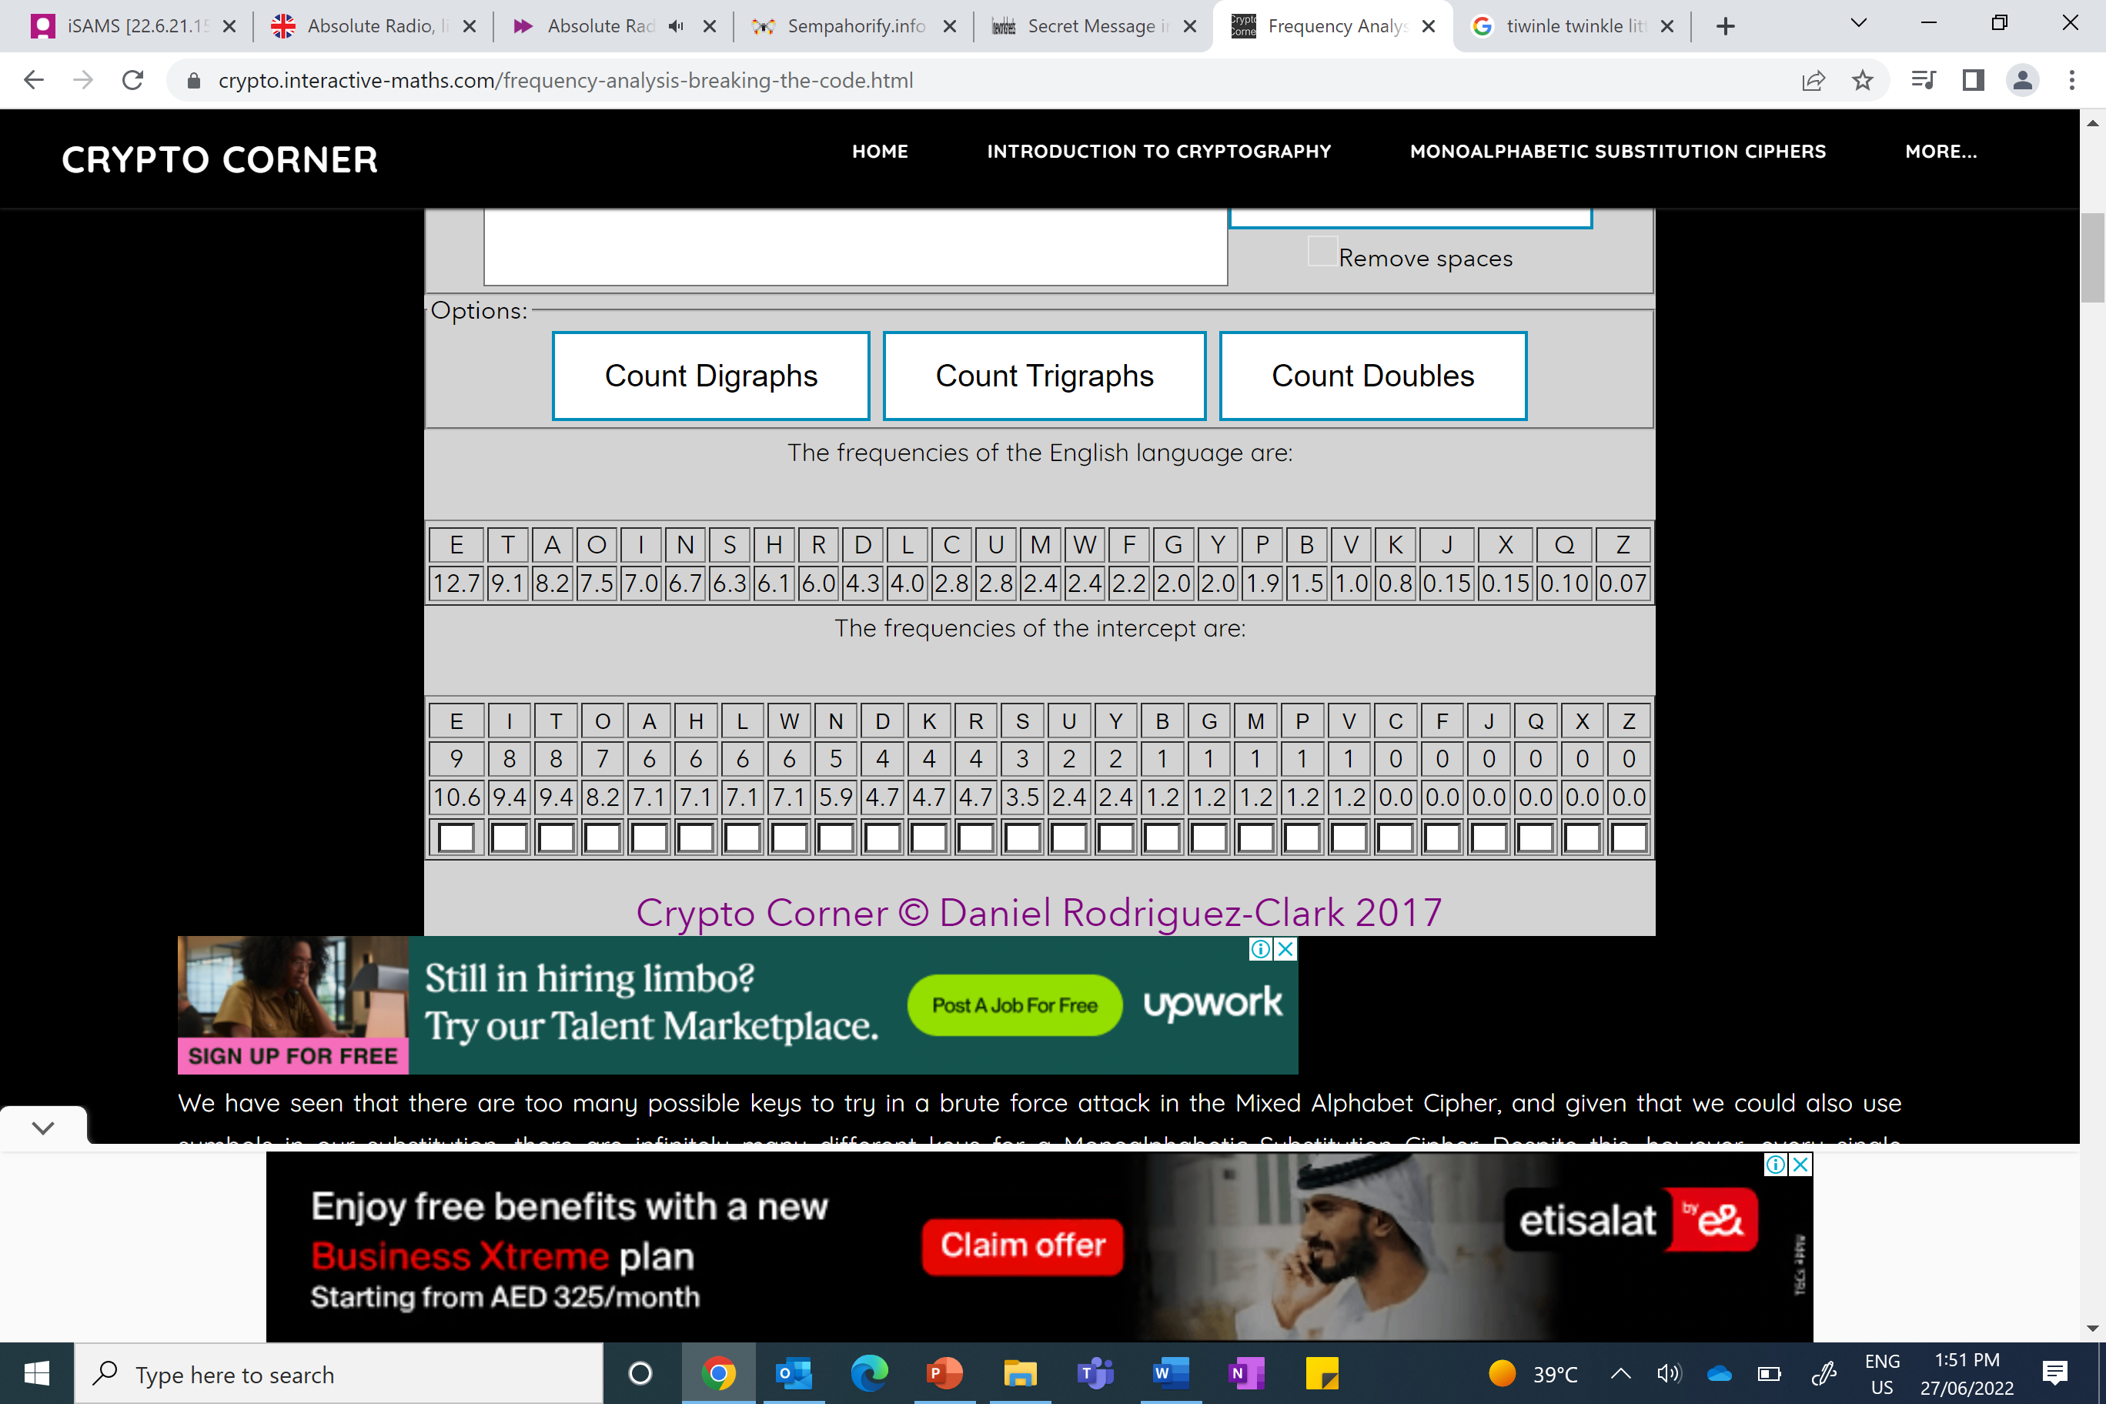
EXAMPLE
TWINKLE, TWINKLE, LITTLE STAR, HOW I WONDER WHAT YOU ARE. UP ABOVE THE WORLD SO HIGH LIKE A DIAMOND IN THE SKY.
Useful website for counting the frequency of your letters: https://crypto.interactive-maths.com/frequency-analysis-breaking-the-code.html

BREAK THE CODE
GITW JAJ XRH PIQW AXHR HEK RCCATK; EK YRIUJKJ HEK YBO IH HEK TRUXKU. EK PKXH HR HEK IAUZRUH.
EK HROOKJ EAO YUAKC TIOK AX HEK HUIOE.
EK QRRWKJ IH I FIZ RC HEK PRUQJ, YRBSEH I HATWKH HR ZIUAO, IXJ XKNKU QRRWKJ YITW.

