Year 9 Delta 3 Unit 9 Revision
Trigonometry
Tangent • Sine • Cosine • Finding Angles • Problems in 2D & 3D • Trig Graphs
Target: Grade 5 → Grade 7 | Time: 60 minutes | Calculator: allowed
Name: ______________________________ Date: ________________ Score: _______ / 105
Section | Time | My score | Red | Amber | Green
1. The Tangent Ratio | 8 mins | _____ / 17
2. The Sine Ratio | 7 mins | _____ / 12
3. The Cosine Ratio | 8 mins | _____ / 18
4. Using Trigonometry to Find Angles | 8 mins | _____ / 17
5. Solving Problems in 2D | 8 mins | _____ / 13
6. Solving Problems in 3D | 7 mins | _____ / 12
7. Trigonometric Graphs | 12 mins | _____ / 16
Total | 60 mins | _____ / 105
Mark each section using the answer booklet, write your score, then tick one colour: Red = need help, Amber = getting there, Green = confident.

How to use this booklet
Each section starts on a new page with a Key Facts box.
Read it first, then work through the questions in order — they get harder as you go.
The purple Problem Solving questions are exam-style: read carefully, draw or label a diagram, then solve.
Show your working — method marks are often worth more than the final answer. Give lengths and angles to 1 decimal place unless told otherwise.

Problem-solving toolkit
1. Sketch the triangle and mark the right angle.
2. Label O, A and H from the angle you know (or want).
3. Choose SOH, CAH, TOA (or Pythagoras), substitute, then rearrange.
4. Check: the hypotenuse is the longest side, angles are sensible, units are included.
1. The Tangent Ratio | ⏱ 8 minutes

Key Facts
Label the sides from the angle θ: Hypotenuse (H) is opposite the right angle; Opposite (O) is opposite θ; Adjacent (A) is next to θ.
In SIMILAR right-angled triangles the ratio of any two sides is the same — so each angle has its own fixed ratios.
tan θ = Opposite ÷ Adjacent (TOA). Remember all three with SOH CAH TOA.
Finding O: O = A × tan θ. Finding A: A = O ÷ tan θ.
Q1 These right-angled triangles are all similar. Complete the table to 2 d.p. What do you notice? [Grade 5]
Triangle (O, A, H) | O ÷ A | O ÷ H | A ÷ H
(a) 3 cm, 4 cm, 5 cm
(b) 6 cm, 8 cm, 10 cm
(c) 4.5 cm, 6 cm, 7.5 cm
(d) 7.5 cm, 10 cm, 12.5 cm
Q2 Label the hypotenuse (H), opposite (O) and adjacent (A) in each triangle, using the marked angle θ. [Grade 5]
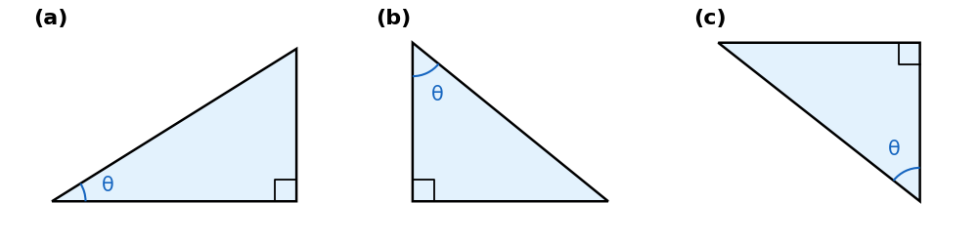
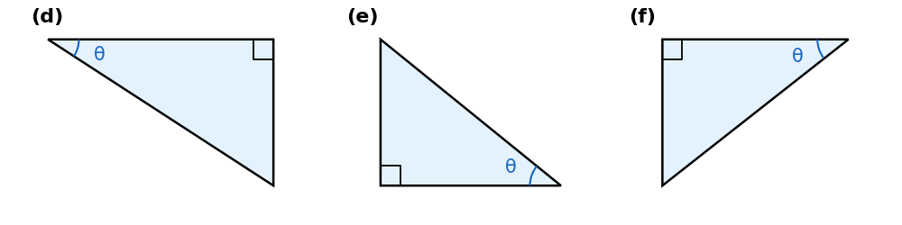
Q3 Use the tangent ratio to find the length marked with a letter in each triangle. [Grade 5]
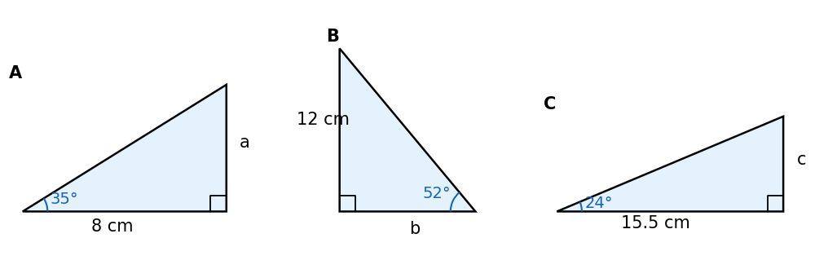
a = | b = | c =
🧩 Problem Solving — think, plan, then solve
Q4 A ramp rises at 8° to the horizontal. Find how high it rises (to 2 d.p.) over a horizontal distance of: [Grade 5]
(a) 2 m | (b) 5 m | (c) 12.5 m
Q5 From a point 40 m from the base of a tree, the angle of elevation to the top is 32°.
(a) Find the height of the tree. [2]
(b) How far from the tree would the angle of elevation be 45°? [1] [Grade 6]
Working:

2. The Sine Ratio | ⏱ 7 minutes

Key Facts
sin θ = Opposite ÷ Hypotenuse (SOH).
Finding O: O = H × sin θ.
Finding H: H = O ÷ sin θ (H is on the bottom of the fraction, so you divide).
Formula triangle: cover the side you want — O = sin θ × H, H = O ÷ sin θ.
The hypotenuse is always the longest side, so check your answer makes sense.
Q6 Solve: (a) sin 40° = $\frac{x}{9}$ [1] (b) sin 65° = $\frac{7}{y}$ [2] [Grade 5]
(a) sin 40° = $\frac{x}{9}$ | (b) sin 65° = $\frac{7}{y}$
Q7 Find the length x. [Grade 5]
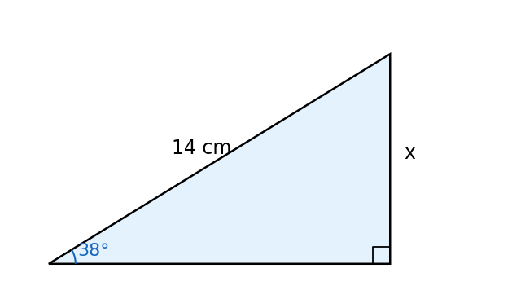
Working:
Q8 Find the length of the hypotenuse y. Then find the length z. [Grade 5–6]
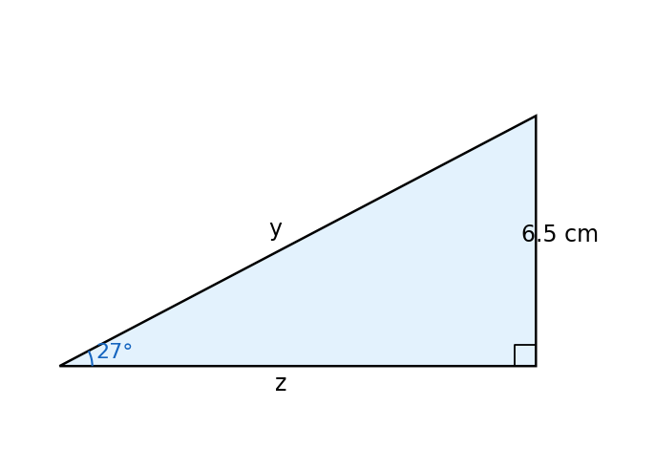
Working:
🧩 Problem Solving — think, plan, then solve
Q9 A kite string is 35 m long and makes an angle of 58° with the ground. How high is the kite? [Grade 5]
Working:
Q10 A wheelchair ramp must rise 0.6 m. The ramp makes an angle of 4.8° with the ground.
How long must the ramp be? Give your answer to the nearest centimetre. [Grade 6]
Working:

3. The Cosine Ratio | ⏱ 8 minutes

Key Facts
cos θ = Adjacent ÷ Hypotenuse (CAH).
Finding A: A = H × cos θ. Finding H: H = A ÷ cos θ.
Choosing: label the sides, cross out the one you don't have or need — the two left give SOH, CAH or TOA.
Exact values: sin 30° = cos 60° = ½ cos 30° = sin 60° = √3/2 tan 45° = 1 tan 30° = 1/√3 tan 60° = √3
sin 0° = cos 90° = 0 sin 90° = cos 0° = 1 sin 45° = cos 45° = 1/√2
Q11 Use the cosine ratio to find x. [Grade 5]
(a) H = 12 cm, angle 50°, x = A | (b) A = 9 cm, angle 33°, x = H | (c) H = 20 m, angle 71°, x = A
Q12 Decide whether to use sin, cos or tan, then find x. [Grade 5–6]
(a) angle 42°, H = 15 cm, x = O | (b) angle 28°, A = 11 cm, x = O | (c) angle 61°, O = 8 cm, x = H
(d) angle 17°, H = 25 cm, x = A | (e) angle 55°, O = 13 cm, x = A
Q13 Josh writes cos 35° = 8/x, so x = 8 × cos 35° = 6.6 cm. Explain his mistake and find x. [Grade 6]
Working:
🧩 Problem Solving — think, plan, then solve
Q14 A 4.5 m ladder leans against a wall at 72° to the ground. How far is its foot from the wall? [Grade 5]
Working:
Q15 A ship sails 85 km on a bearing of 040°.
(a) How far north of its start is it? [2] (b) How far east of its start is it? [2] [Grade 6–7]
Working:
Q16 No calculator: a right-angled triangle has hypotenuse 10 cm and a 60° angle.
Find the EXACT lengths of the other sides. [Grade 7]
Working:

4. Using Trigonometry to Find Angles | ⏱ 8 minutes

Key Facts
To find an angle, use the INVERSE function: sin⁻¹, cos⁻¹ or tan⁻¹ (press SHIFT, then sin, cos or tan).
e.g. tan θ = 5/8 → θ = tan⁻¹(5/8) = 32.0°
Label the sides first, then choose the ratio that uses the two sides you know.
The two acute angles in a right-angled triangle add up to 90°.
Angle of elevation: measured UP from the horizontal. Angle of depression: measured DOWN from the horizontal.
Q17 Find the angle θ in each triangle. The box shows the three ratios. [Grade 5–6]
sin θ = O/H cos θ = A/H tan θ = O/A
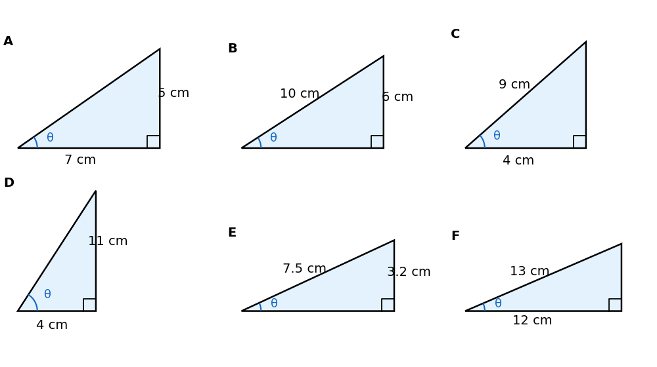
A = | B = | C = | D = | E = | F =
Q18 Find θ, to 1 d.p. [Grade 5]
(a) tan θ = 0.8 | (b) sin θ = 0.35 | (c) cos θ = 3/7 | (d) sin θ = 2.4/5.6
Q19 A right-angled triangle has sides 8 cm, 15 cm and 17 cm. Find (a) its smallest angle [2] (b) its other acute angle [1] [Grade 6]
Working:
🧩 Problem Solving — think, plan, then solve
Q20 A boat is 120 m from the foot of a vertical cliff that is 50 m high. Find the angle of depression of the boat from the top of the cliff. [Grade 6]
Working:
Q21 Find the angle θ in this isosceles triangle. [Grade 6–7]
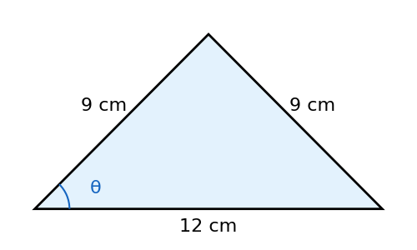
Working:

5. Solving Problems in 2D | ⏱ 8 minutes

Key Facts
Sketch a diagram and mark the right angle. Split shapes into right-angled triangles, e.g. draw the height of an isosceles triangle.
Pythagoras (a² + b² = c²): you know two sides and want the third. Trigonometry: the problem involves an angle.
Two-step problems: find a shared side in one triangle, then use it in the next. Keep full calculator values until the end.
Bearings are measured clockwise from North and written with 3 figures, e.g. 040°.
Q22 Choose Pythagoras or trigonometry each time. [Grade 5–6]
(a) Rectangle 12 cm by 5 cm: find the diagonal | (b) Same rectangle: angle between the diagonal and the 12 cm side | (c) Isosceles triangle 10 cm, 10 cm, base 12 cm: find its height | (d) Same triangle: find its area
Q23 A rhombus has diagonals of 16 cm and 10 cm. Find the sizes of its angles. [Grade 6–7]
Working:
Q24 In triangle ABC, angle B = 90°, AB = 7 cm and angle BAC = 40°. D lies on BC so that angle BAD = 25°. Find (a) BC [2] (b) DC [1] [Grade 7]
Working:
🧩 Problem Solving — think, plan, then solve
Q25 BD is perpendicular to AC. Find the length BC. [Grade 7]
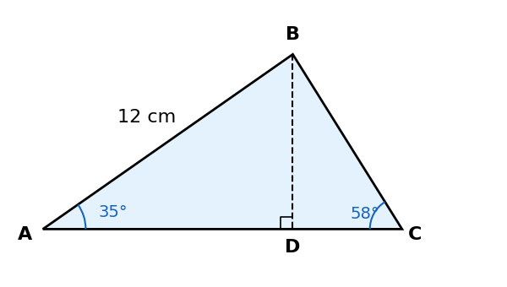
Working:

6. Solving Problems in 3D | ⏱ 7 minutes

Key Facts
In 3D, find a right-angled triangle inside the solid, then sketch it flat on its own and label it.
Space diagonal of a cuboid: d = √(a² + b² + c²)
Angle between a line and a plane: drop the line’s ‘shadow’ onto the plane. The angle is between the line and its shadow.
Usually two steps: Pythagoras on the base to find a diagonal, then trigonometry (or Pythagoras) in a vertical triangle.
Keep unrounded values in your calculator between steps.
Q26 The cuboid is 8 cm long, 6 cm wide and 5 cm tall. Find these lengths. [2 each] [Grade 6]
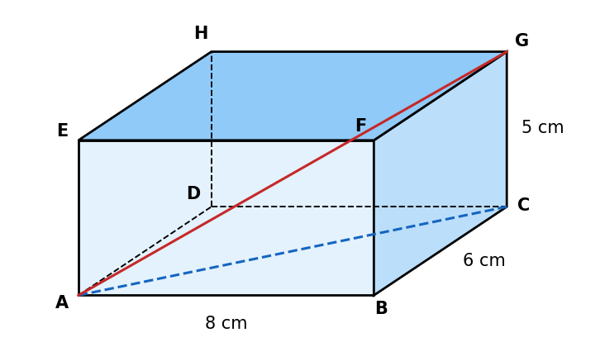
(a) AC = | (b) AG =
Q27 Find the angle between the diagonal AG and the base ABCD. [Grade 7]
Working:
🧩 Problem Solving — think, plan, then solve
Q28 A square-based pyramid has a base 10 cm by 10 cm. Its apex is directly above the centre of the base and each sloping edge is 13 cm. Find its vertical height. [Grade 7]
Working:
Q29 A 12 m flagpole stands at one corner of a rectangular courtyard 20 m by 15 m. Find the angle of elevation of the top of the pole from the opposite corner. [Grade 7]
Working:

7. Trigonometric Graphs | ⏱ 12 minutes

Key Facts
y = sin x: 0 at 0°, maximum 1 at 90°, 0 at 180°, minimum −1 at 270°, 0 at 360°. It repeats every 360°.
y = cos x: 1 at 0°, 0 at 90°, minimum −1 at 180°, 0 at 270°, 1 at 360°. It repeats every 360°.
y = tan x: 0 at 0°, 180° and 360°; it has asymptotes (no value) at 90° and 270°. It repeats every 180°.
Symmetry gives more solutions: sin x = sin(180° − x) cos x = cos(360° − x) tan x = tan(x + 180°)
Your calculator only gives one solution — use the graph to find the others between 0° and 360°.
Q30 Each graph shows y = sin x, y = cos x or y = tan x for 0° ≤ x ≤ 360°. Name each one. [Grade 5]
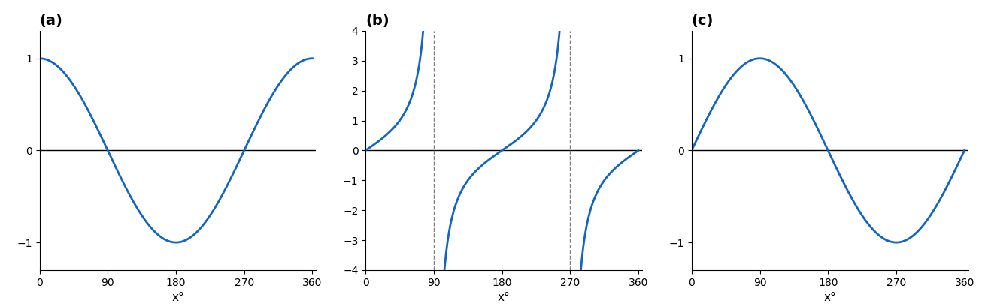
(a) | (b) | (c)
Q31 The graph shows y = sin x and y = cos x for 0° ≤ x ≤ 360°. Use it to answer: [Grade 6–7]
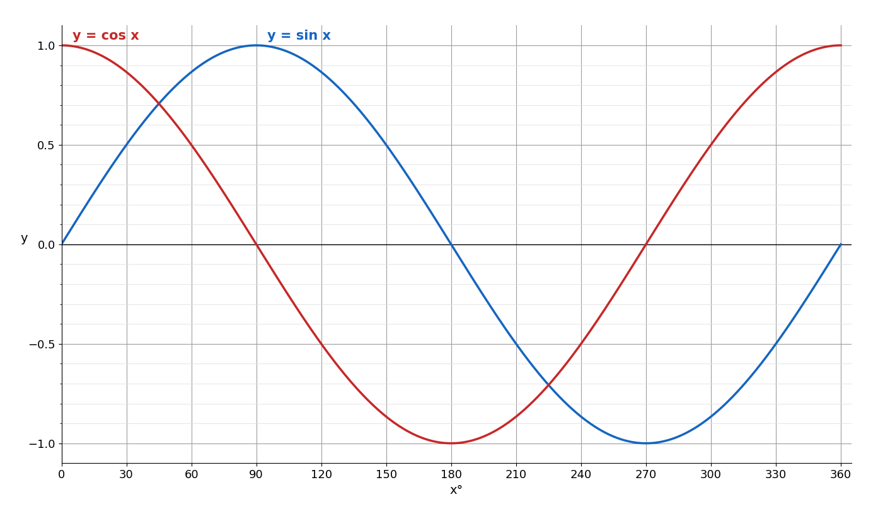
(a) sin 210° = | (b) Solve sin x = 0.5 | (c) Solve sin x = −1
(d) sin 40° ≈ 0.64. Find another x with sin x = 0.64 | (e) Where do the two graphs cross? | (f) Solve cos x = 0.3 (use your calculator)
🧩 Problem Solving — think, plan, then solve
Q32 Sketch the graph of y = tan x for 0° ≤ x ≤ 360°. Use it to solve tan x = 2 in this range. [Grade 7]
Working:
Q33 (a) On the grid, draw the graph of y = 2 sin x for 0° ≤ x ≤ 360°. [2] [Grade 6]
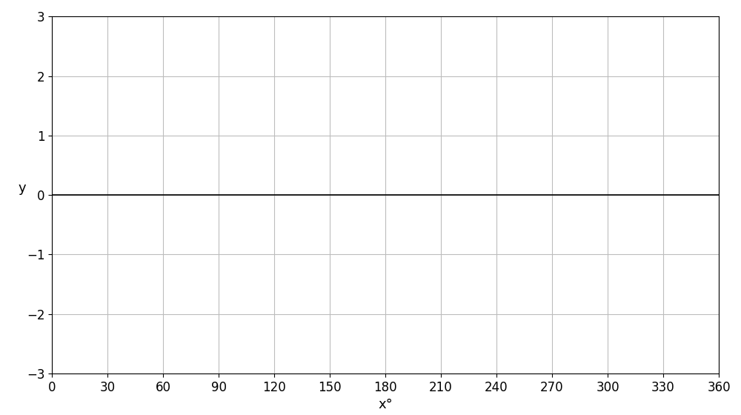 | Working:
(b) Write down the maximum value of y = 2 sin x + 1 and the value of x where it happens. [2] [Grade 7]
Working:

