Label the correct graphs with the correct graphs.
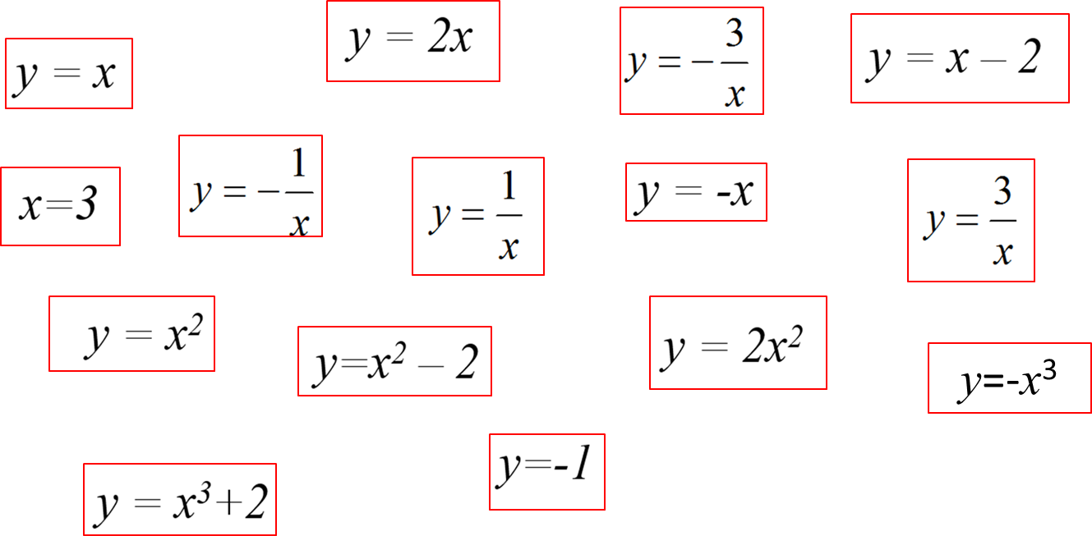

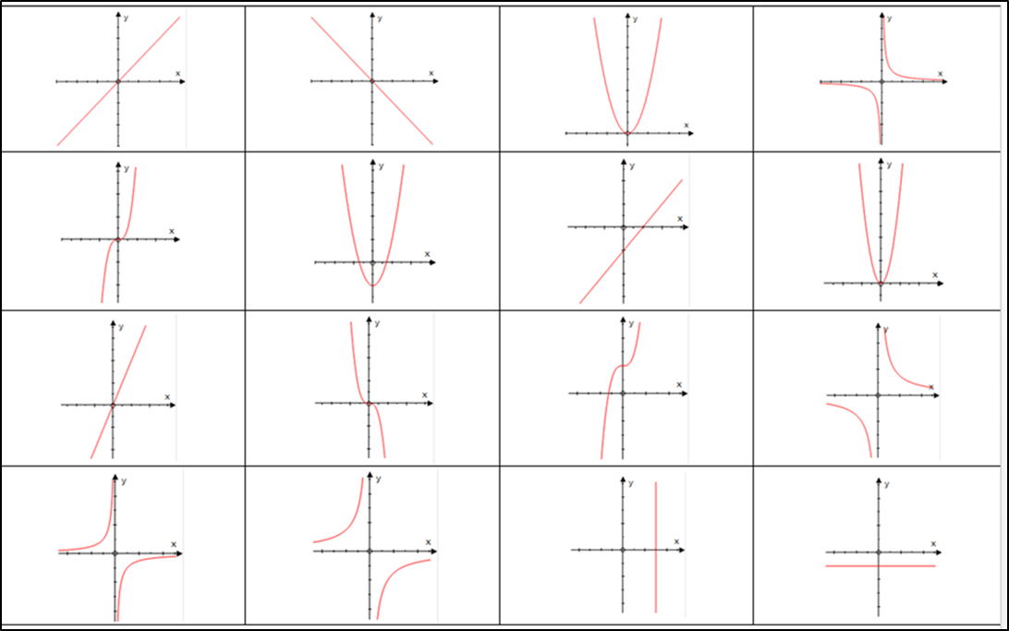
Label the correct graphs with the correct graphs.

