Percentage Profit and Loss - Homes Under The Hammer
You buy and renovation houses.
How much profit (or loss) have you made on the following 4 properties?

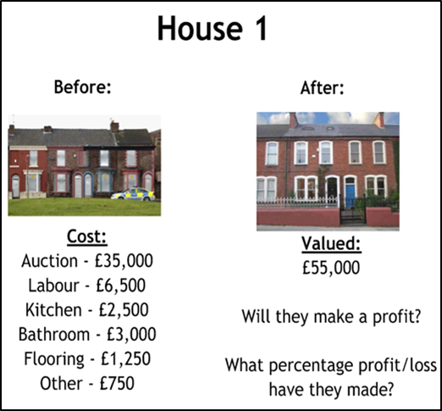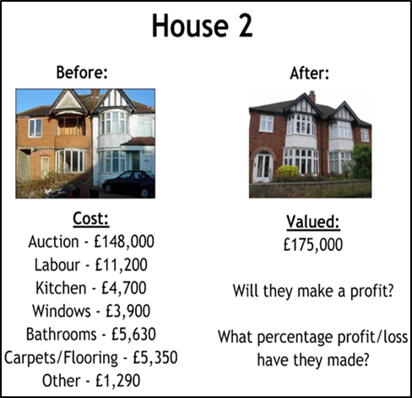

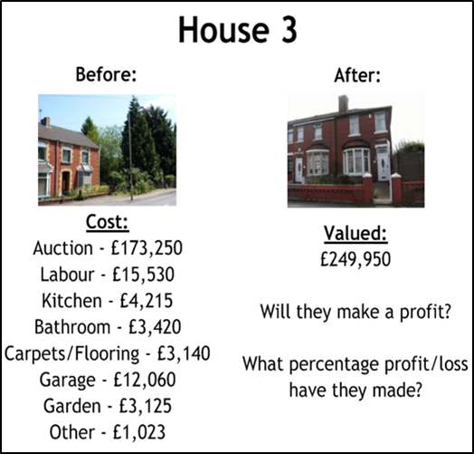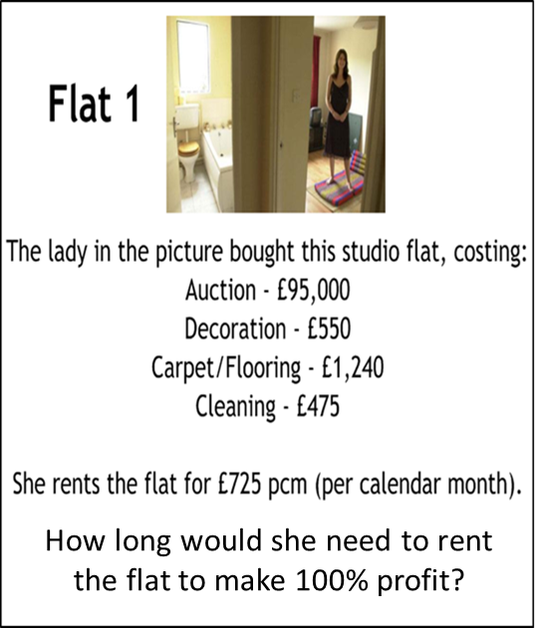

Percentage Profit and Loss - Homes Under The Hammer
You buy and renovation houses.
How much profit (or loss) have you made on the following 4 properties?

