Foundation
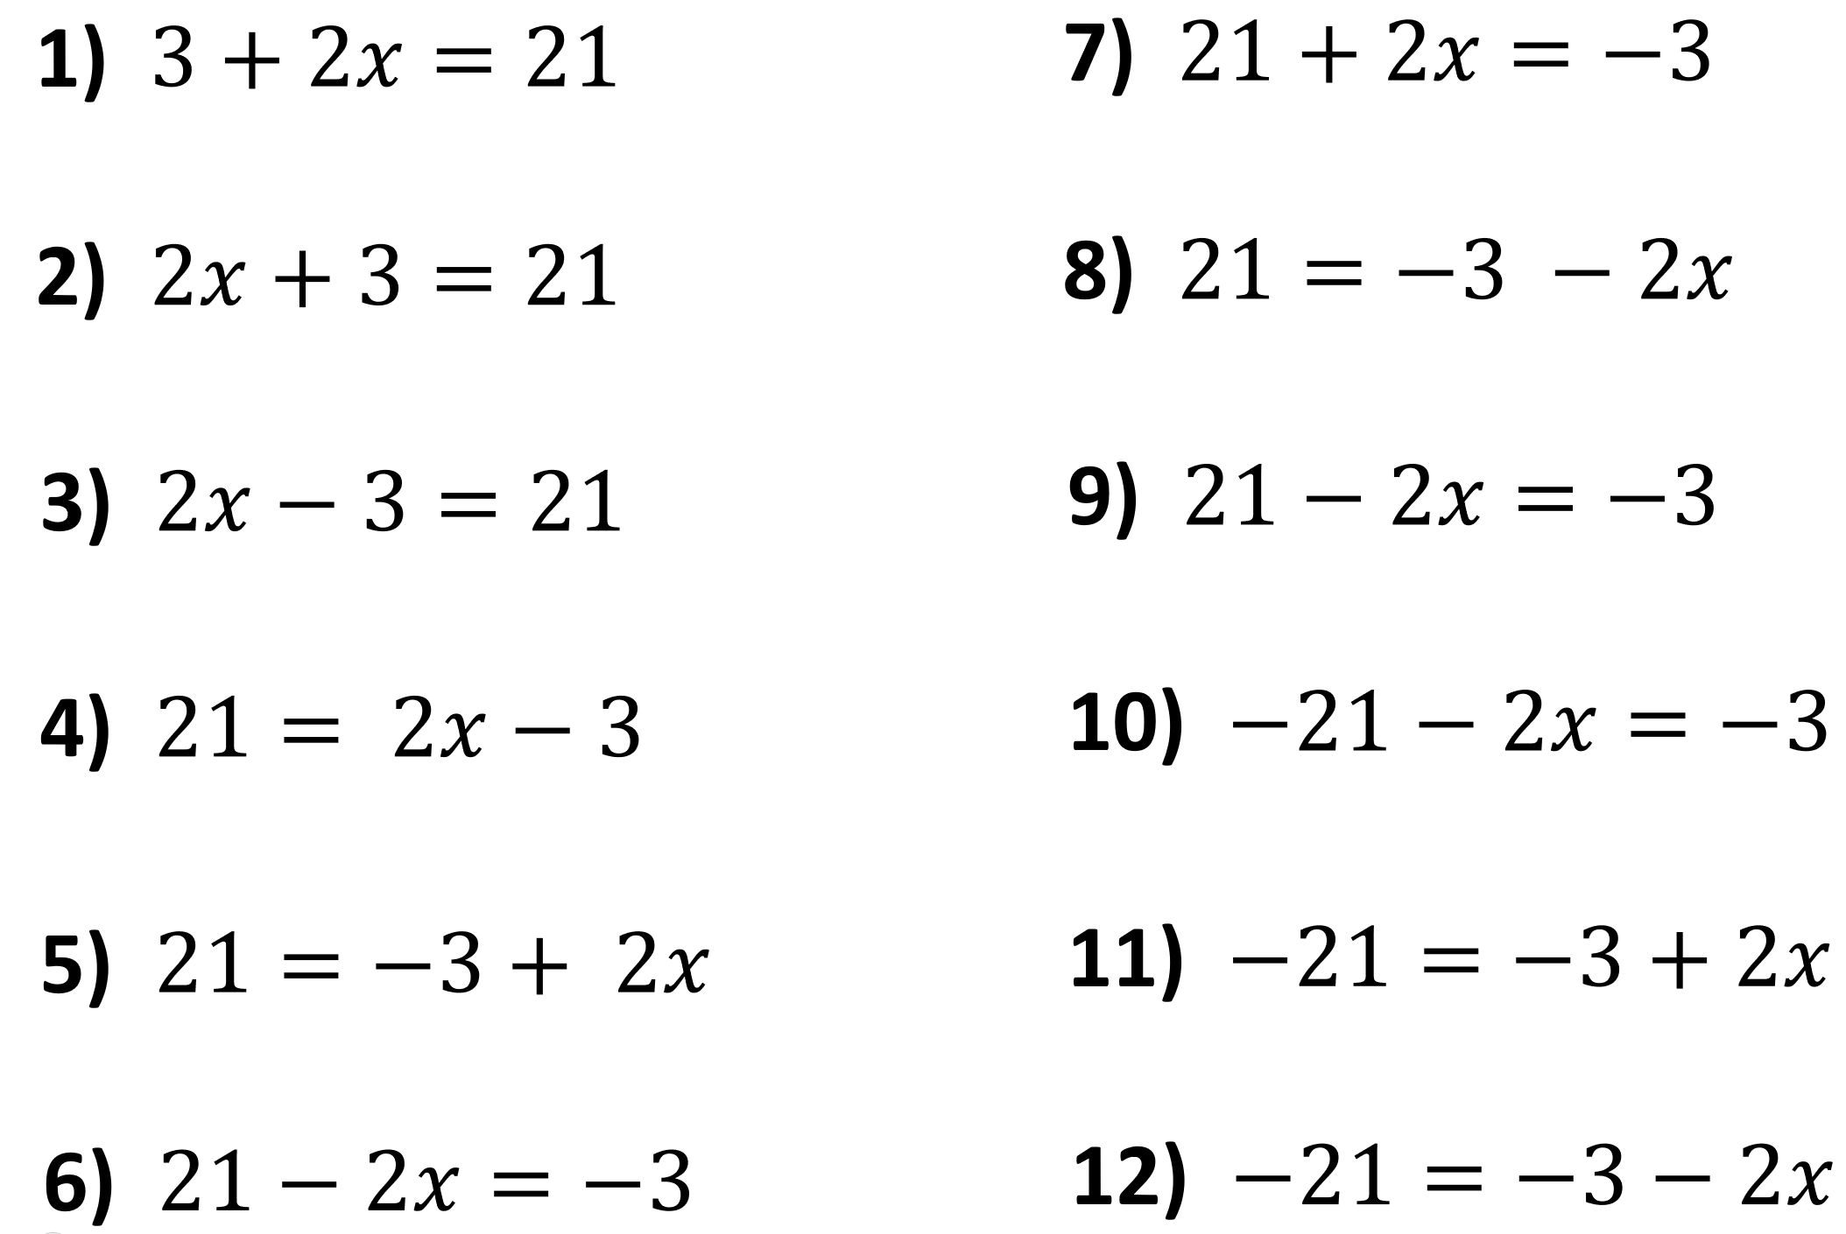
Higher – Give your answer as mixed fraction if needed
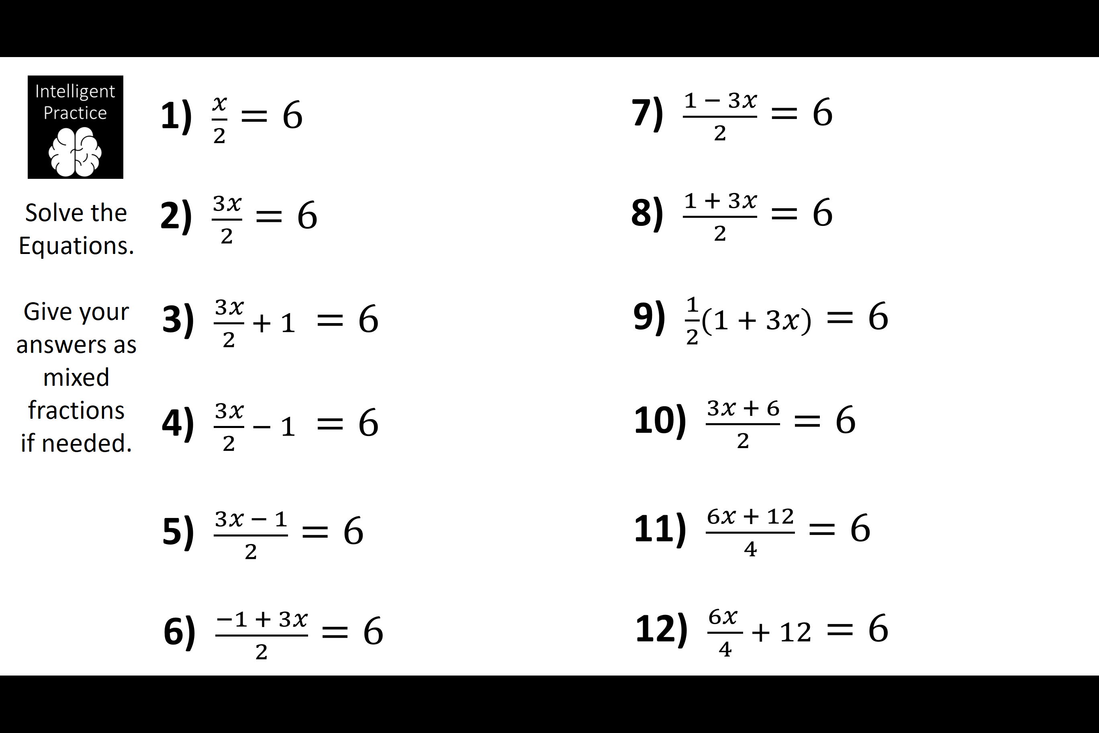
Foundation
Higher – Give your answer as mixed fraction if needed

