Algebraic Fractons – Adding and Subtracting
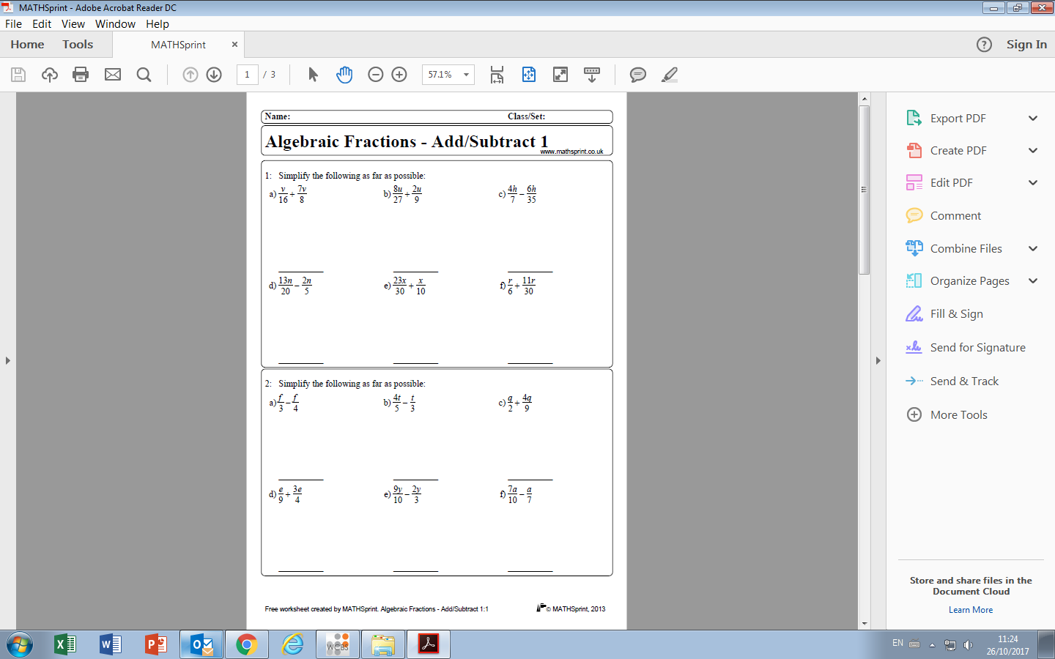
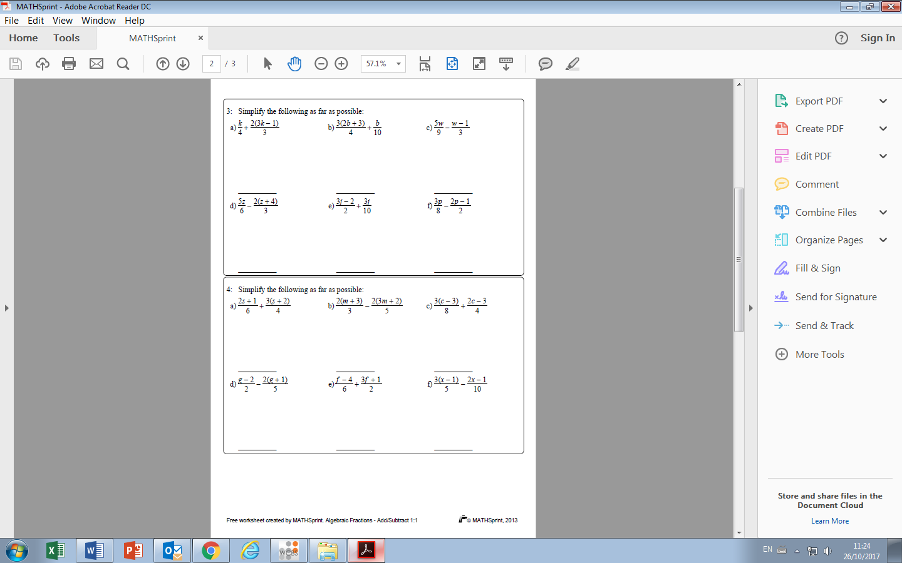

Algebraic Fractons – Adding and Subtracting

