Equations of Linear Graphs from Co-ordiantes
Foundation – Find the equations of each line.
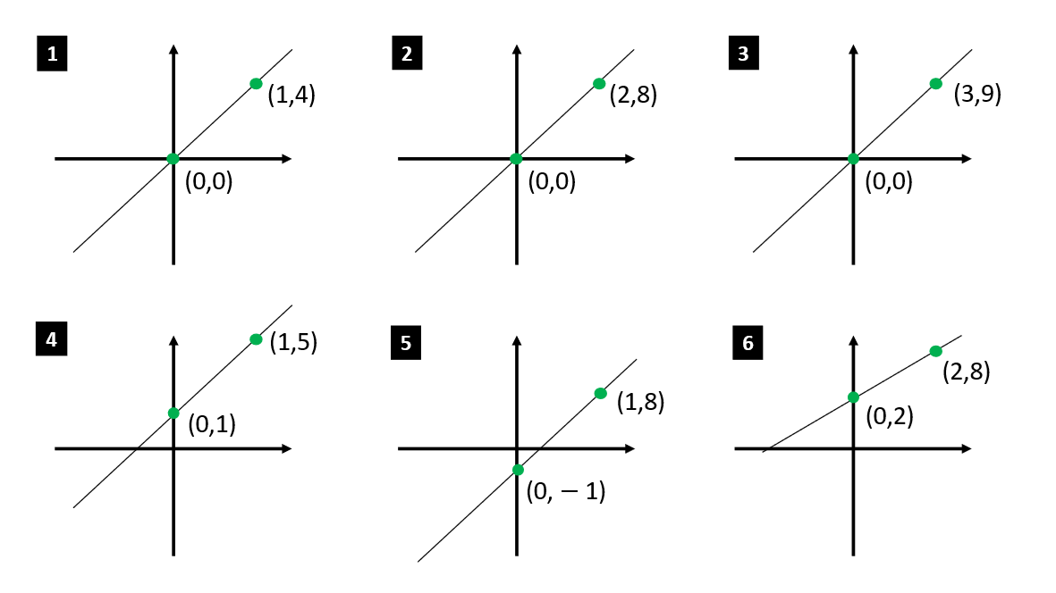
Higher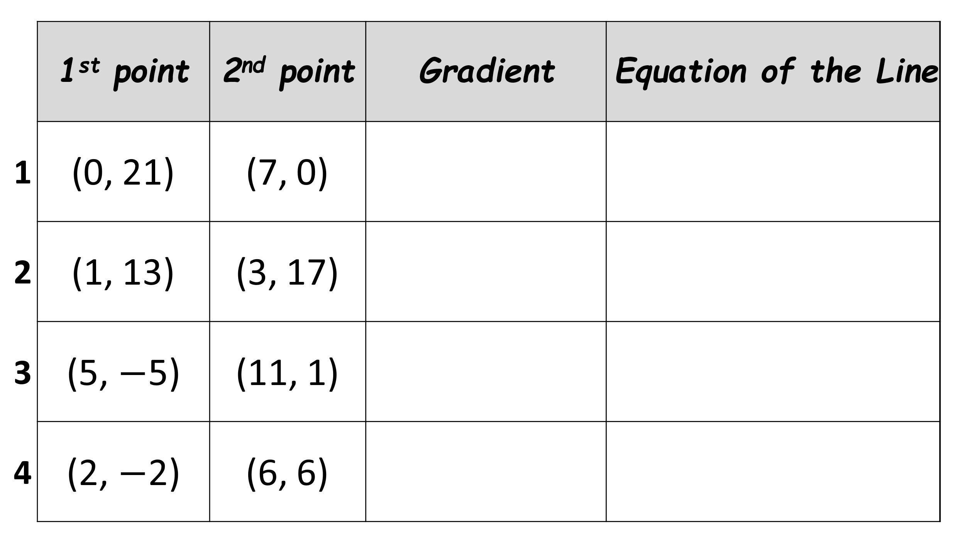
Equations of Linear Graphs from Co-ordiantes
Foundation – Find the equations of each line.
Higher

