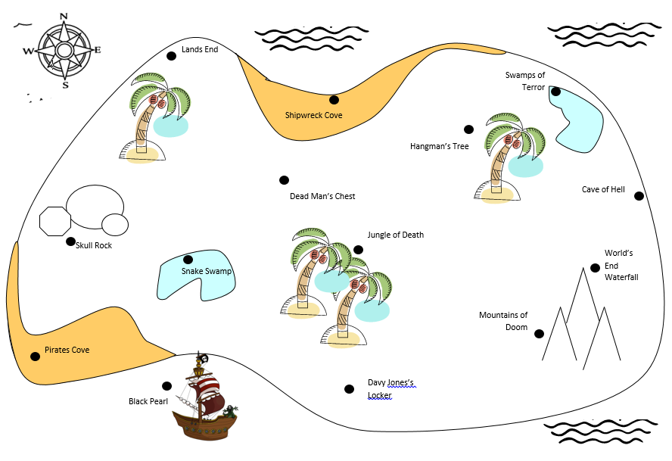

Retrace Jack Sparrow’s steps
so you can find his hidden treasure!
Start at Skull Rock
Follow a bearing of 075°.
Take a bearing of 162°.
Now follow a bearing of 035°.
Walk on a bearing of 268°.
Follow a bearing of 140°.
Next, change your bearing to 305°
Now follow a bearing of 204°.
Next, take a bearing of 077°.
The next bearing is 262°.
Now follow a bearing of 190°.
Next, take a bearing of 075°.
Then follow a bearing of 274°.
Next move on a bearing of 113°.
Take a bearing of 340°,
and here lies your treasure.

