Imperial Units
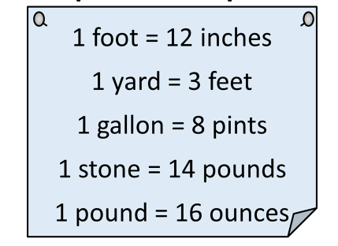
Imperial to Metric Conversions
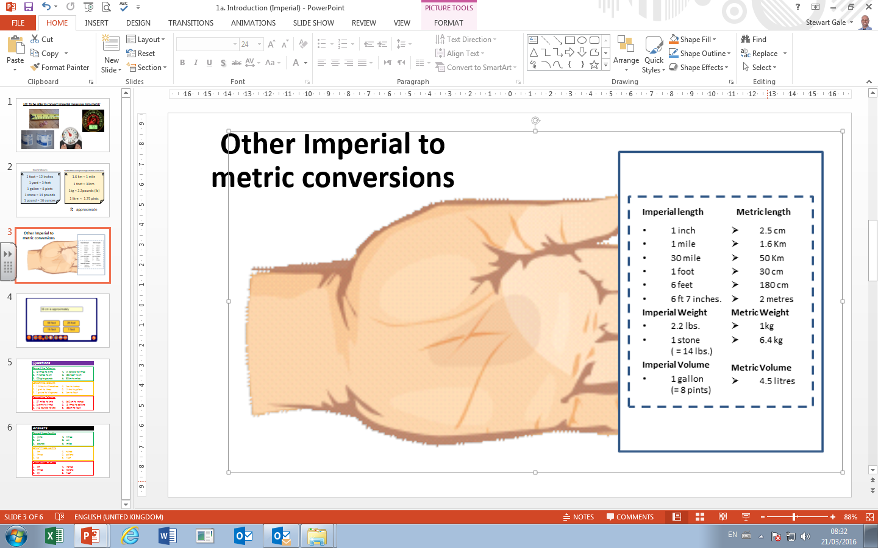
Imperial Units
Imperial to Metric Conversions

