Q1. This is the graph of y =${ x}^{2}-3x-3$.
Use the graph to solve the following equations:

a) $x^{2}-3x-3=0$ b) $x^{2}-3x-3=-4$ c) $x^{2}-3x-3=2$
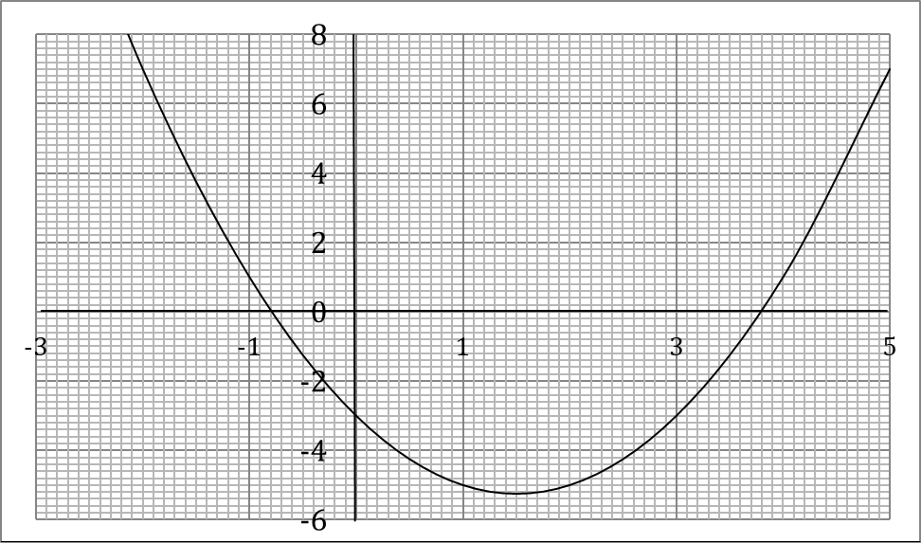

Q2. This is the graph of $y=4+4x-x^{2}$
Use the graph to solve the following equations:

a) $4+4x-x^{2}=0$ b) $4+4x-x^{2}=4$ c) $4+4x-x^{2}=9$

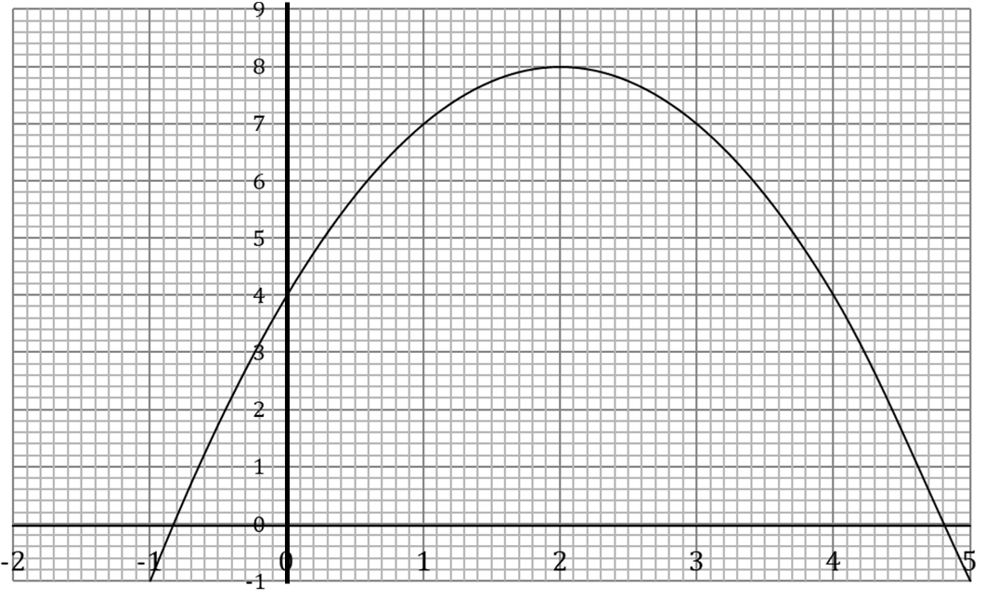
Q3.
(a) Complete the table of values for y = x² − 3x + 1

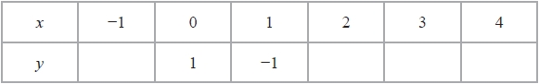

(b) On the grid, draw the graph of y = x² − 3x + 1 for values of x from −1 to 4
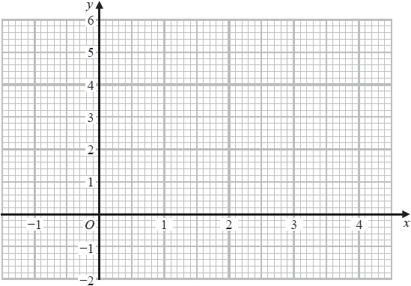

(c) Using your graph, find estimates for the solutions of the equation x² − 3x + 1 = 0

Q4.
Here is the graph of y = x² − 6x + 4
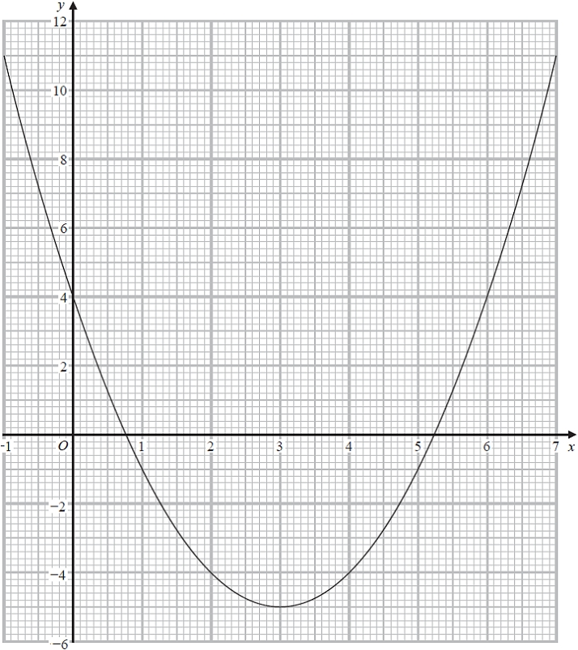
(a) Write down the y intercept of the graph of y = x² − 6x + 4
...........................................................
(1)
(b) Write down the coordinates of the turning point of the graph of y = x² − 6x + 4
( ................ , ................ )
(1)
(c) Use the graph to find estimates for the roots of x² − 6x + 4 = 0
...........................................................
(2)
Q5.
(a) Complete the table of values for y = x² – 2x + 2
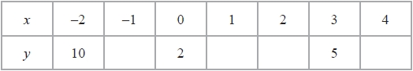
(2)
(b) On the grid, draw the graph of y = x² – 2x + 2 for values of x from –2 to 4
(2)
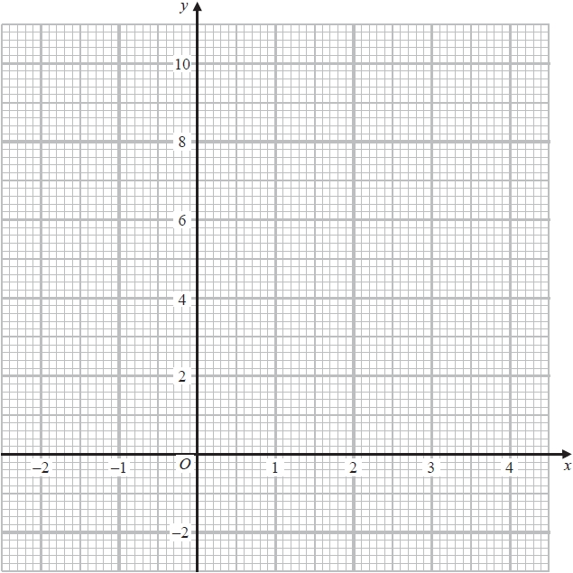
(c) Use your graph to find estimates of the solutions of the equation x² – 2x + 2 = 4

............................................................................................................
(2)
Q6.
(a) Complete the table for the values for y = 6 – x – x²
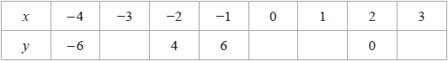
(2)
(b) On the grid, draw the graph of y = 6 – x – x² for values of x from –4 to 3
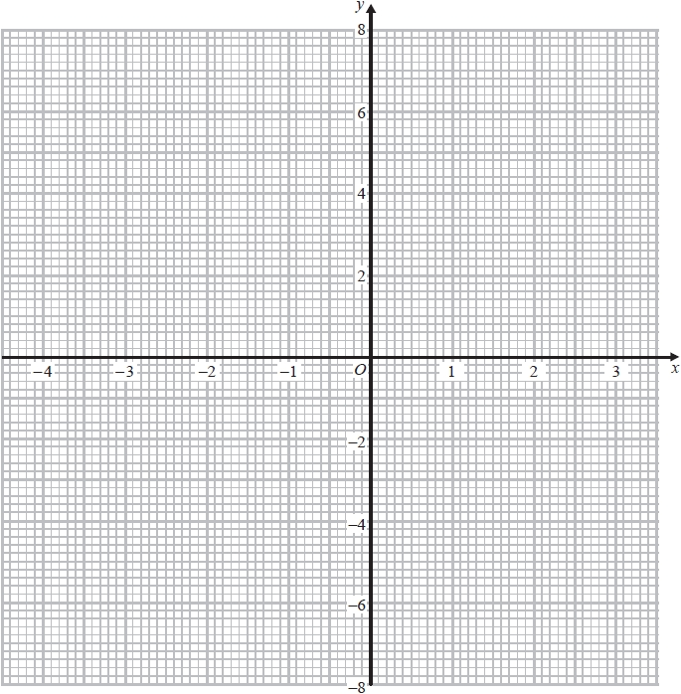
(2)
(c) Find estimates for the solutions of the equation 6 – x – x² = 2
...........................................................
(2)
Q7.
The diagram shows the graph of y = x² – 4x – 2
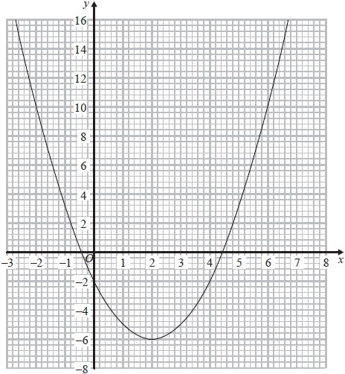
(a) Use the graph to find estimates for the solutions of
(i) x² – 4x – 2 = 0
...........................................................
(ii) x² – 4x – 6 = 0
...........................................................
(3)
(b) Use the graph to find estimates for the values of x that satisfy the simultaneous equations
y = x² – 4x – 2
x + y = 6
...........................................................
(3)

