Real Life Graphs

A) Distance Time Graph

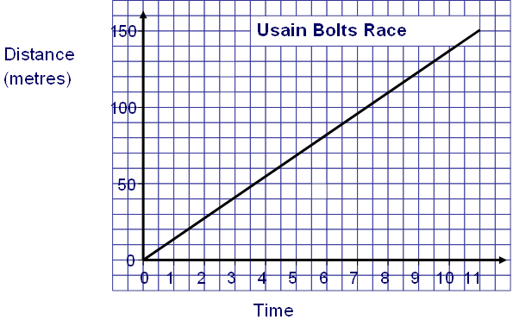
- How far has he run after 4.5 seconds?

- How long has it taken Usain to run 130 metres?

- How far has he run after 8 seconds?

- Why does the line go through the origin?

B) Distance Time Graph

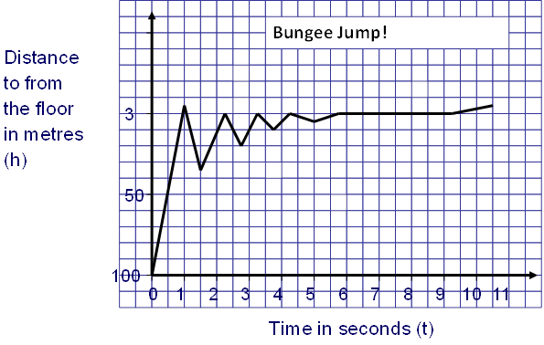
- How high is the bungee jump?

- Why does the graph zig zag?

- How long is the person falling for until they begin to bounce back up?

- Why does the person stop at 3 metres and not 0?

- How long is the person not bouncing but still upside down for?

C) Conversion Graph

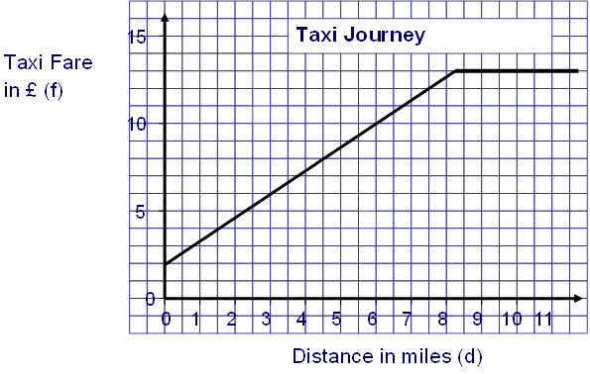
- Why does the taxi fare not go through the origin?

- How much does it cost to travel 6 miles?

- How far can I travel if I only have £10 in my pocket?

- What does the journey cost after 9 miles? And 11 miles?

- What does the flat part of the graph mean?

- What is the equation of the line from 0 to 8 minutes?

- What is the equation of the line from 8 minutes onwards?

D) Depth Time Graph

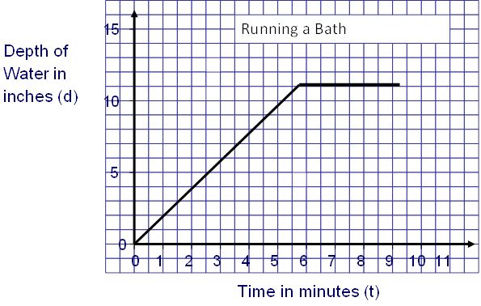
- How deep is the water after 3 minutes?

- What is the equation of the line from 0 to 5 minutes?

- What is happening from 6 minutes onwards?

- What is the equation of the line from 6 minutes onwards?

