Scale Drawings 1 : 20300000
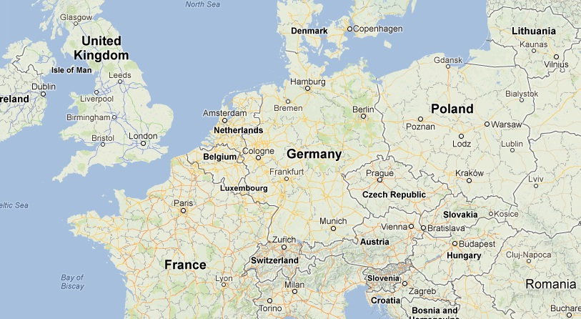
Measure the distances on the map from one location to another.
Be as accurate as you can.
 | Distance on the map | Distance in real life  in KM
Liverpool to Paris
London to Munich
Birmingham to Krakow
Liverpool to Milan
Copenhagen to Berlin
Amsterdam to Zagreb
Zurich to Budapest
Lyon to Torino

Scale Drawings 1 : 20300000
Measure the distances on the map from one location to another.
Be as accurate as you can.
 | Distance on the map | Distance in real life  in KM
Liverpool to Paris
London to Munich
Birmingham to Krakow
Liverpool to Milan
Copenhagen to Berlin
Amsterdam to Zagreb
Zurich to Budapest
Lyon to Torino

