Algebraic Indices – Fractional and Negative
Questions
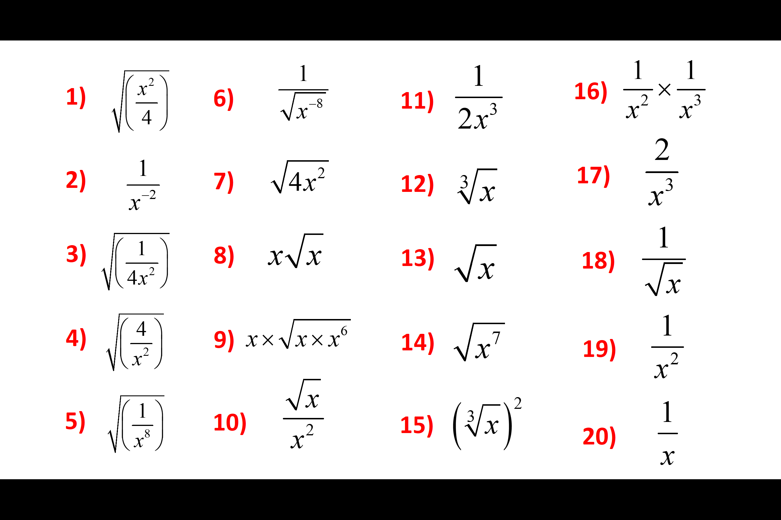
Answers
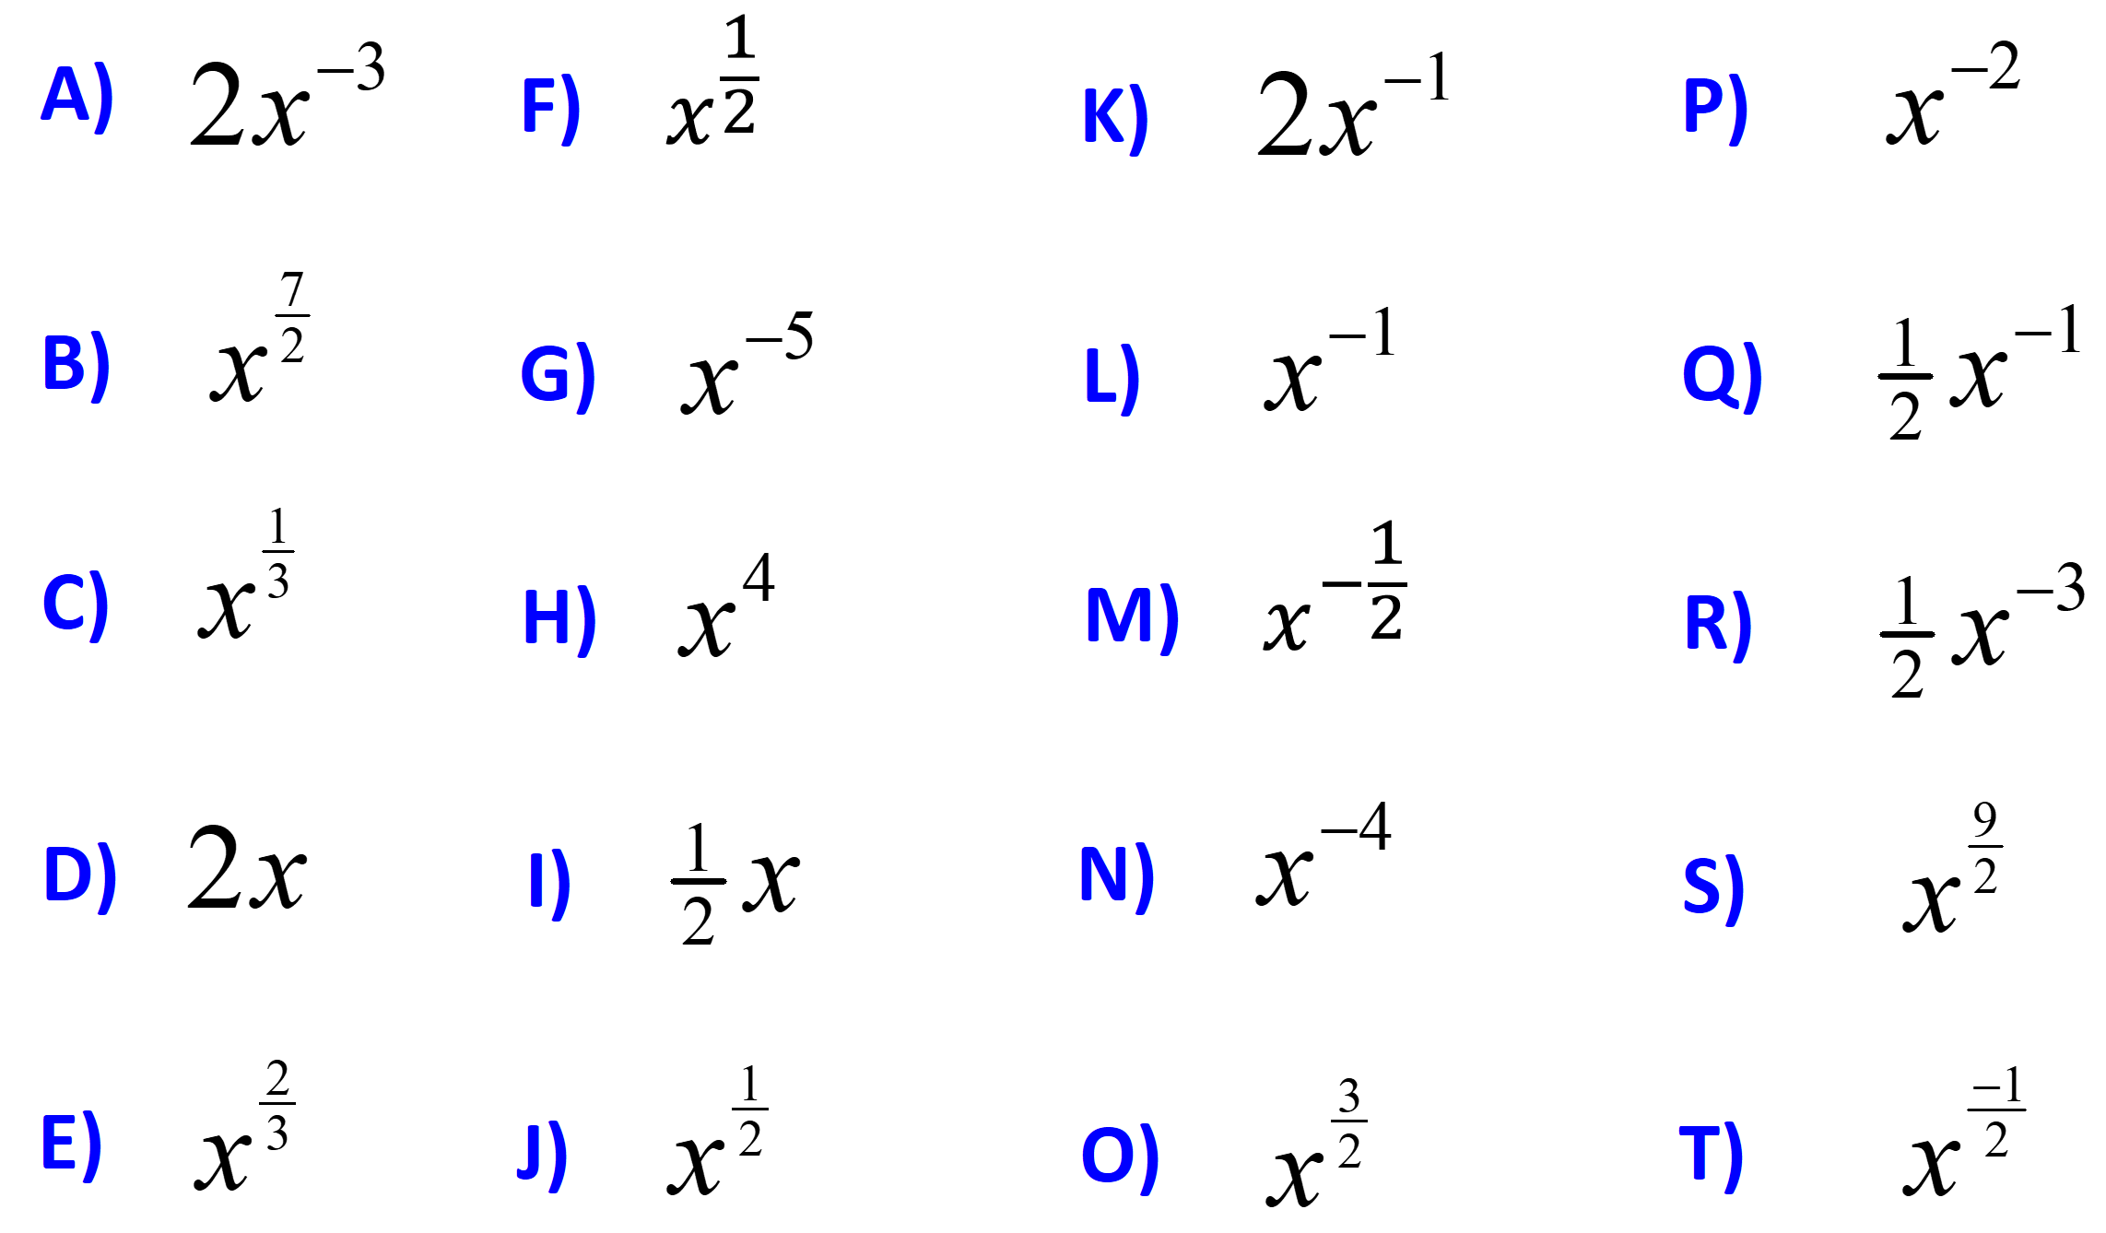
11 | 21 | 31 | 41 | 51 | 61 | 71 | 81 | 91 | 10 | 11 | 12 | 13 | 14 | 15 | 16 | 17 | 18 | 19 | 20
Algebraic Indices – Fractional and Negative
Questions
Answers
11 | 21 | 31 | 41 | 51 | 61 | 71 | 81 | 91 | 10 | 11 | 12 | 13 | 14 | 15 | 16 | 17 | 18 | 19 | 20

