Histograms
Q1) A survey has been conducted on how many hours of TV some children watched last week. Draw a histogram for this data.
Hours (h) spent watching TV last week | Frequency | Frequency Density  (Frequency ÷ Group Width)
0 ≤ h < 2 | 3
2 ≤ h < 5 | 6
5 ≤ h < 10 | 10
10 ≤ h < 20 | 25
20 ≤ h < 40 | 10

Now draw the histogram on the axes below:
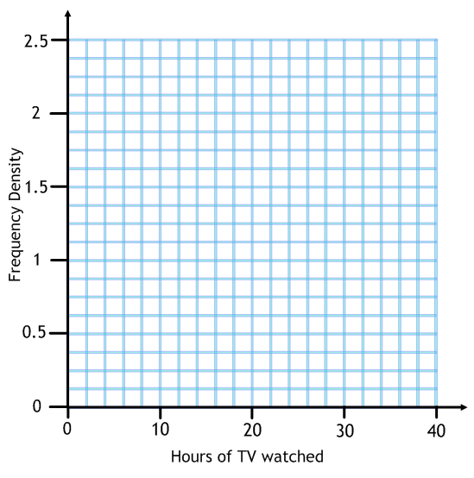

Q2) A survey of the heights of 100 Year 11 students was conducted with the results in the table below. Draw a histogram of this data.
Height (x cm) | Frequency
100 < x ≤ 120 | 20
120 < x ≤ 140 | 25
140 < x ≤ 150 | 25
150 < x ≤ 160 | 20
160 < x ≤ 200 | 10

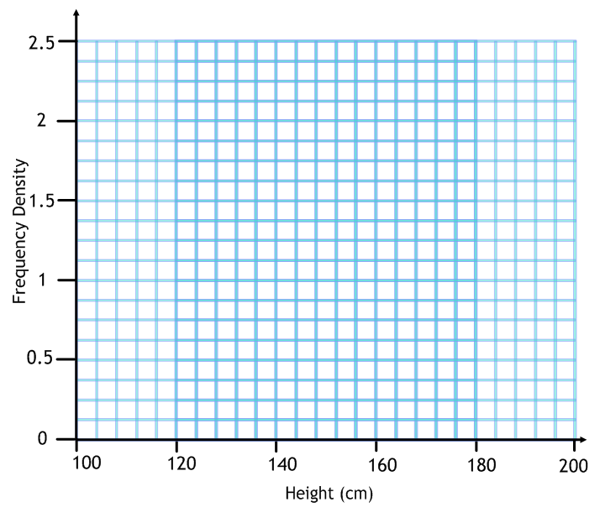
Q3) This is a histogram of how many hours of TV some adults watched last week. How many adults were asked in total?
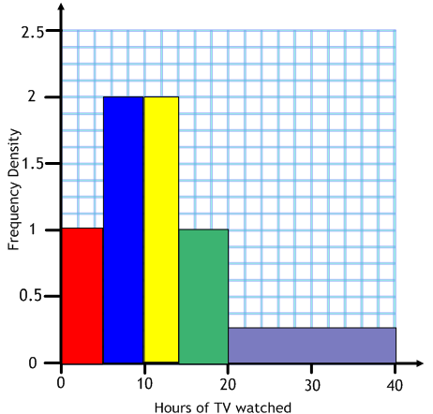
Hours (h) of TV watched last week | Frequency Density | Frequency
Q4) What percentage of people in the survey below
watched 20 hours or more of TV?
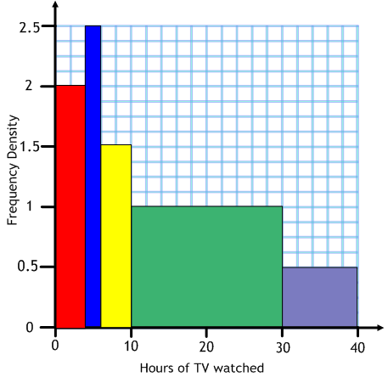
Show your working underneath:

