Who is the best superhero?
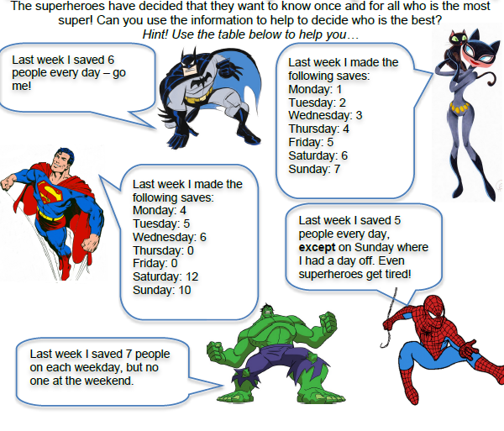
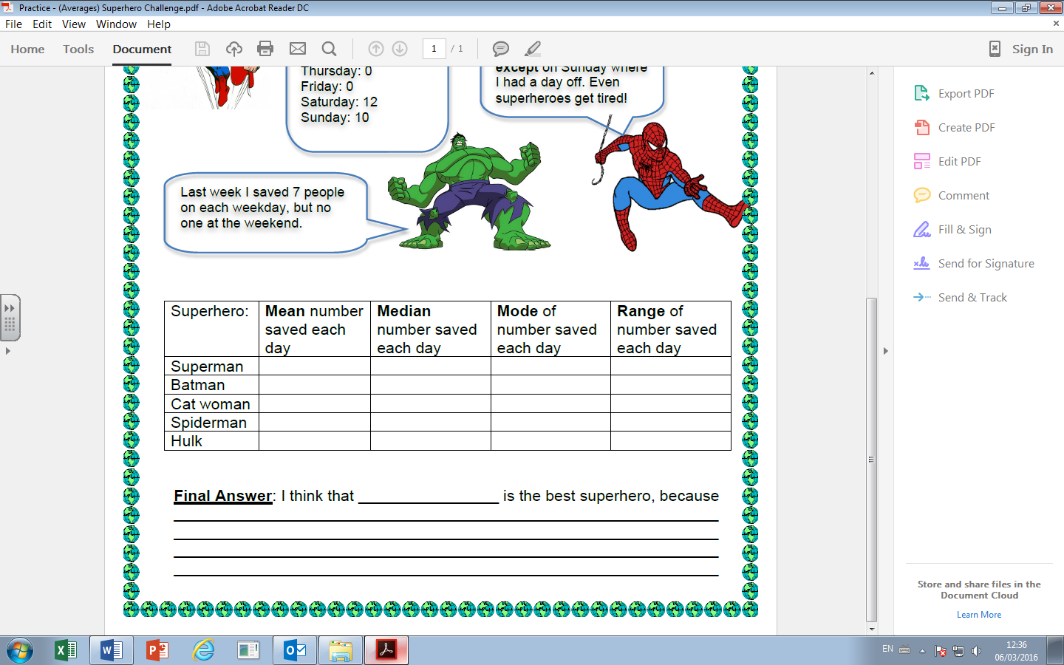
Who is the best superhero and mathematically why?
Who is the best superhero?
Who is the best superhero and mathematically why?

