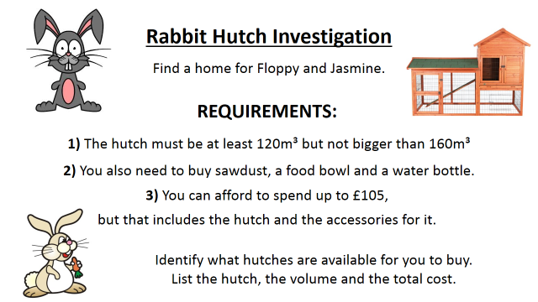
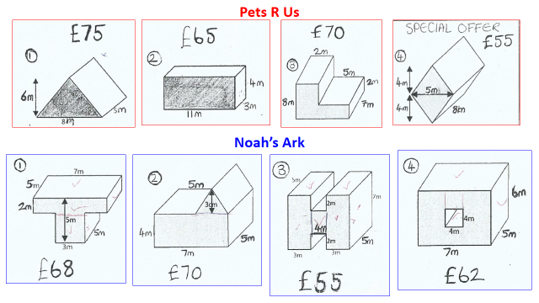
Large bag sawdust = £18 Food Bowl = £5 Water Bottle = £12
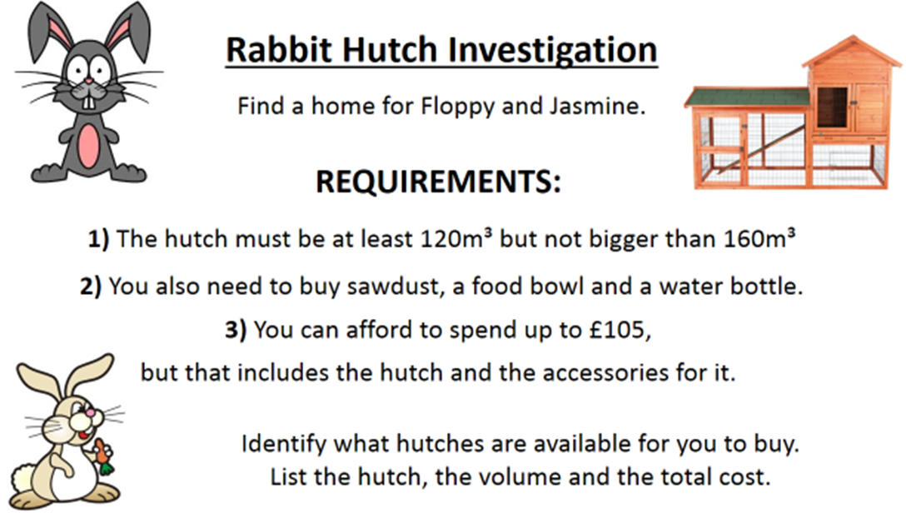
Large bag sawdust = £18 Food Bowl = £5 Water Bottle = £12

