Solving Quadratic Equations - Quadratic Formula
Give you answers to 2 decimal places if necessary

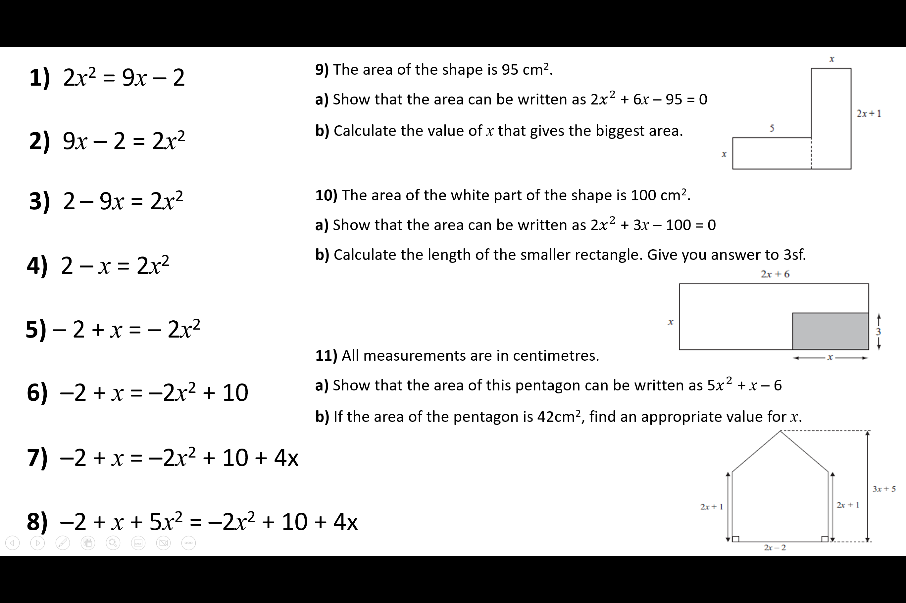
Solving Quadratic Equations - Quadratic Formula
Give you answers to 2 decimal places if necessary

