Calculate the angle of each sector
(Give you answers to 1 decimal place)
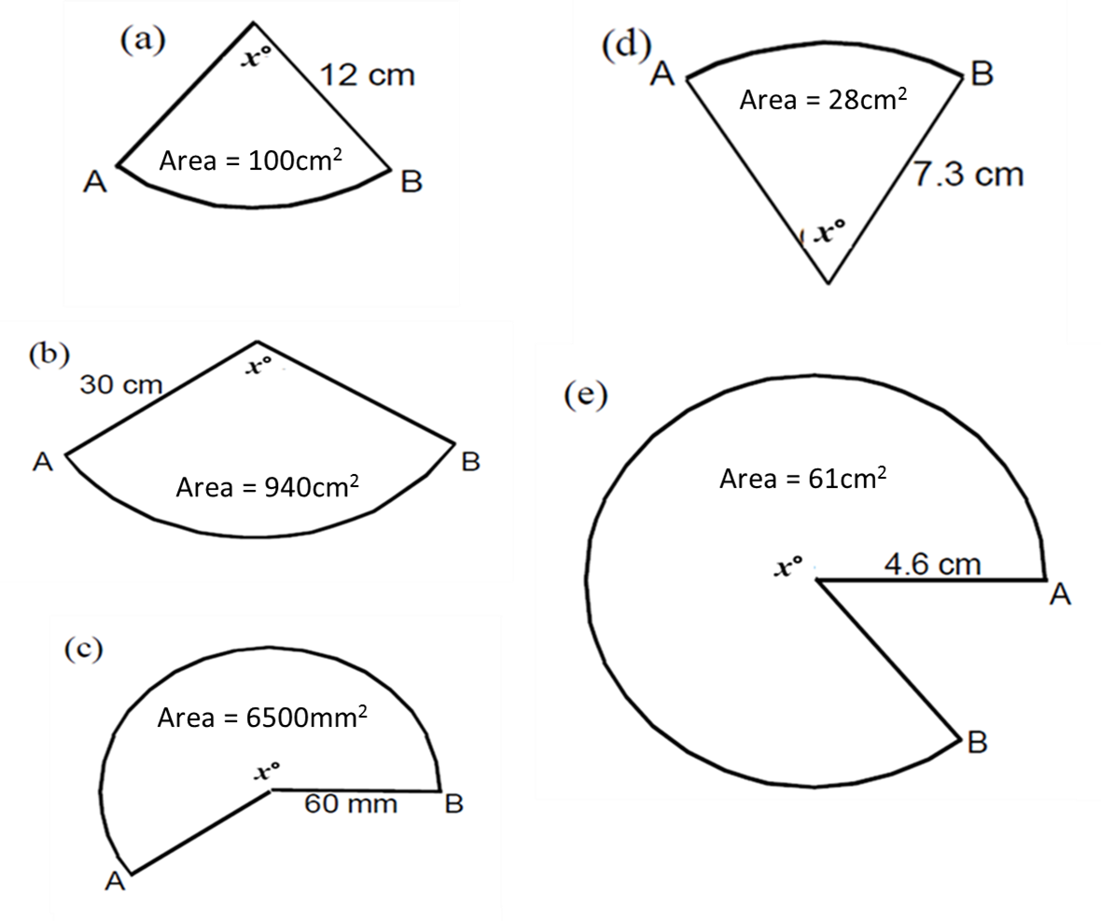
Calculate the radius of each sector
(Give you answers to 1 decimal place)

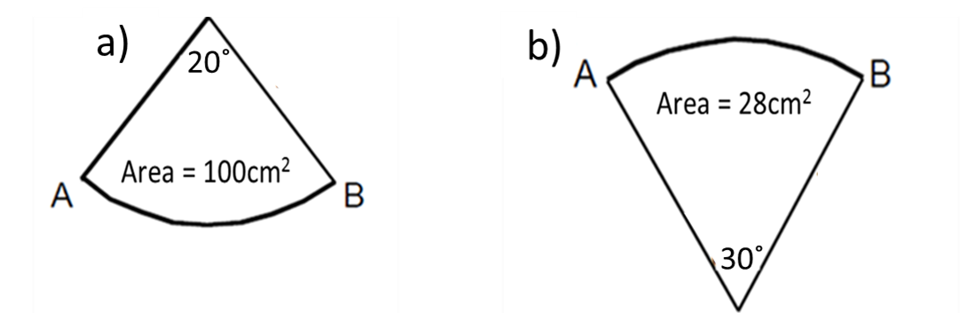
Calculate the angle of each sector
(Give you answers to 1 decimal place)
Calculate the radius of each sector
(Give you answers to 1 decimal place)

