Fill in the venn diagrams and find the HCF and LCM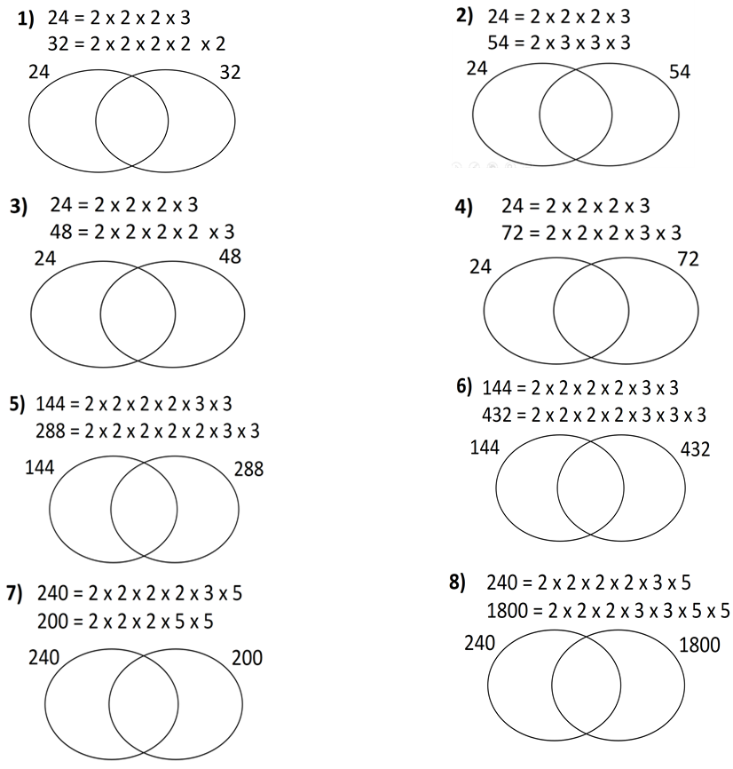 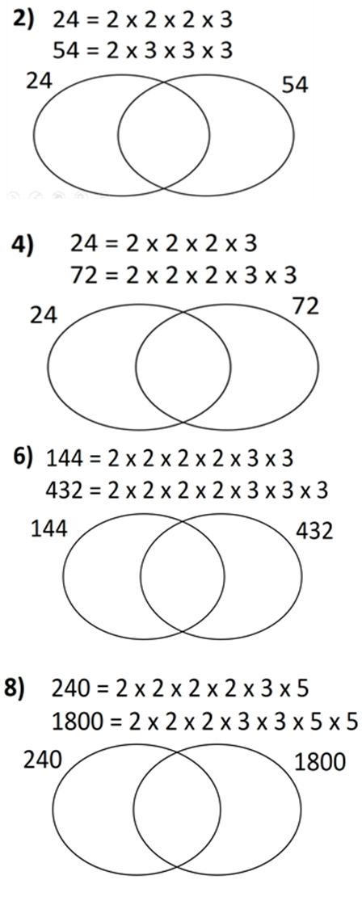

Fill in the venn diagrams and find the HCF and LCM

