Find the missing side or angle that is mark with a letter.
Give you answer to 1 decimal place.
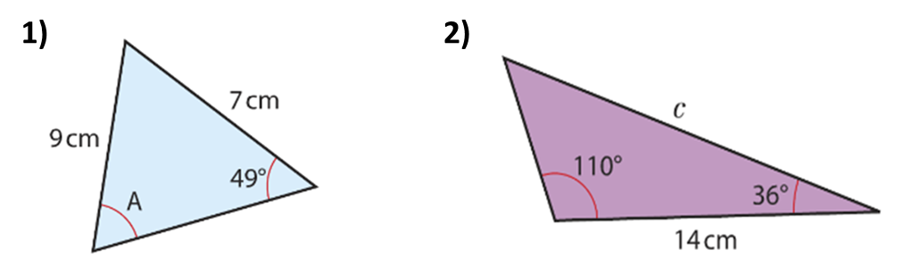

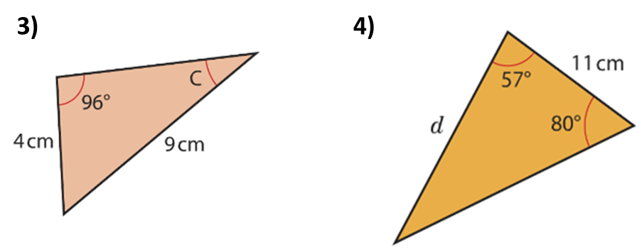

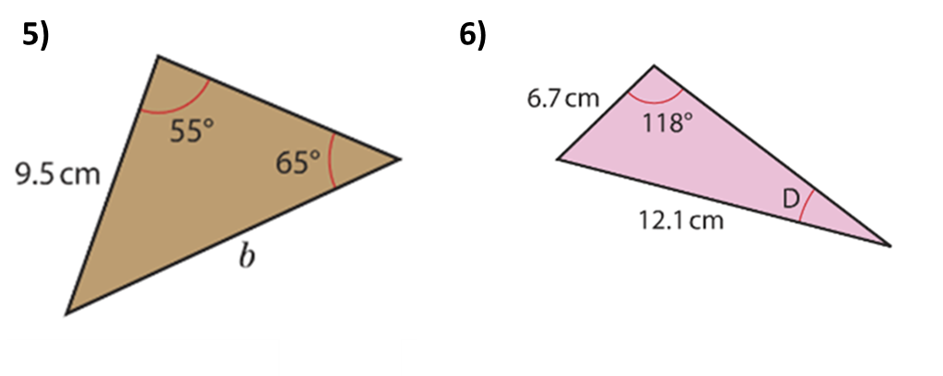

Find the missing side or angle that is mark with a letter.
Give you answer to 1 decimal place.

