Hidato
The aim of Hidato is to fill the cells with consecutive numbers from 1 to the highest number so that consecutive numbers connect. More simply: find the path from 1 to the highest number that covers the grid entirely.
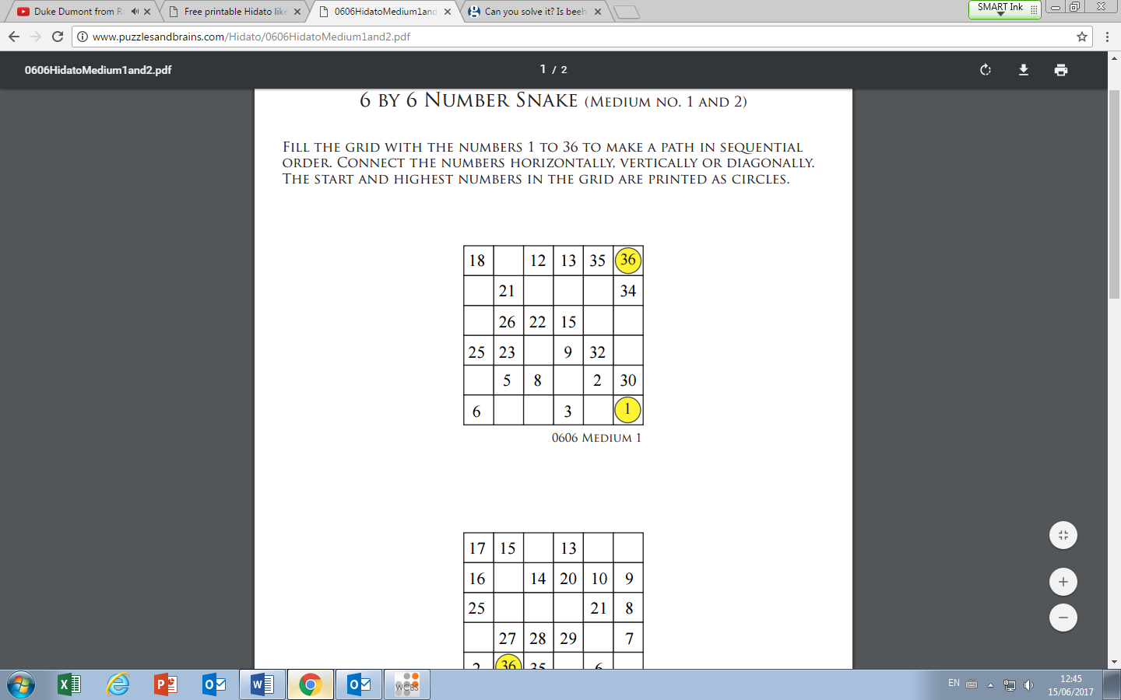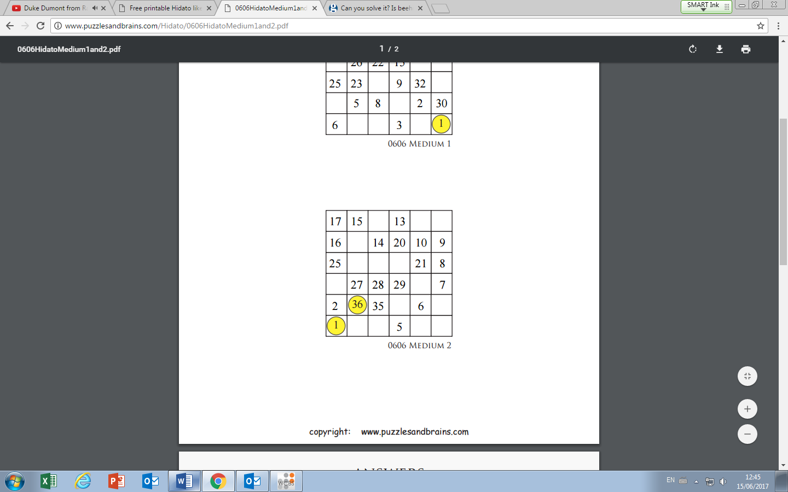
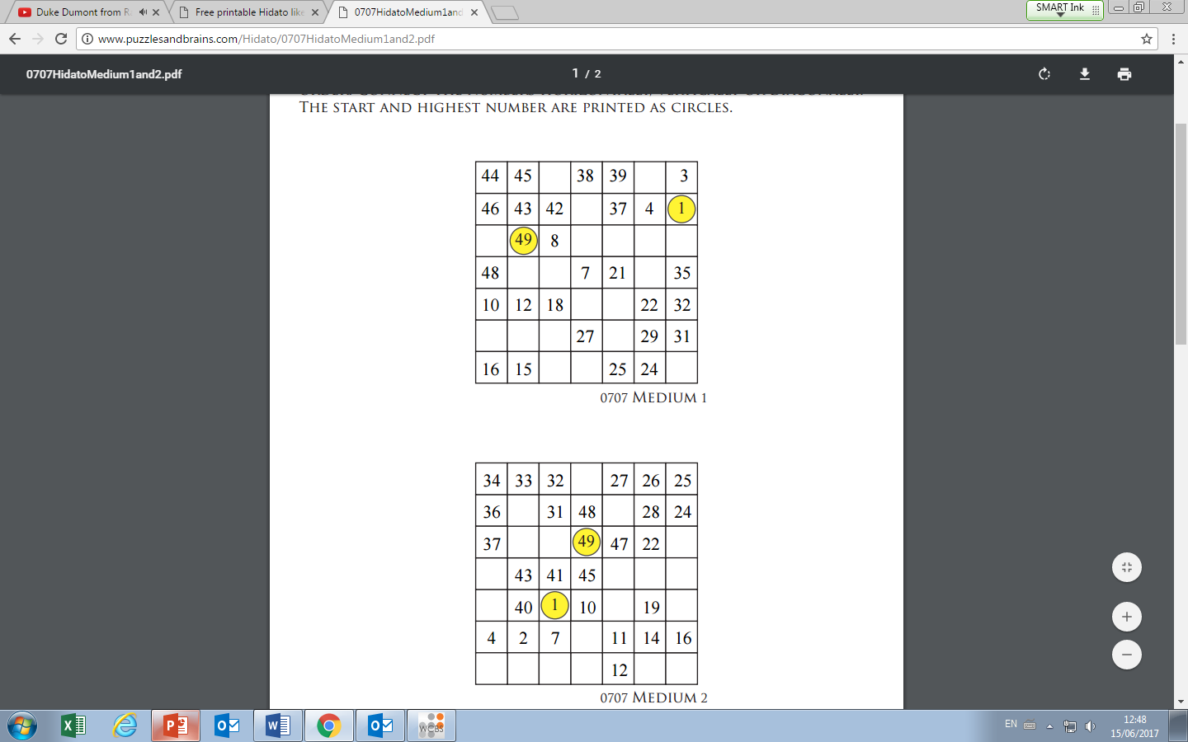
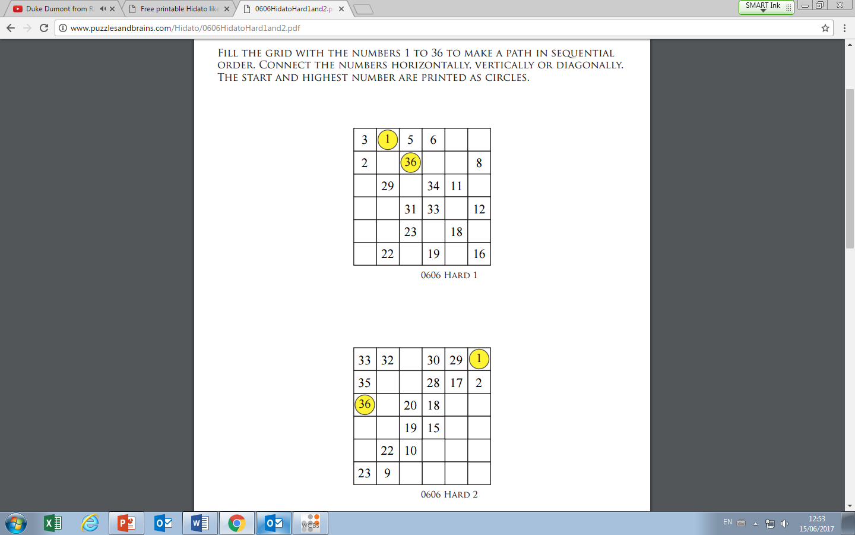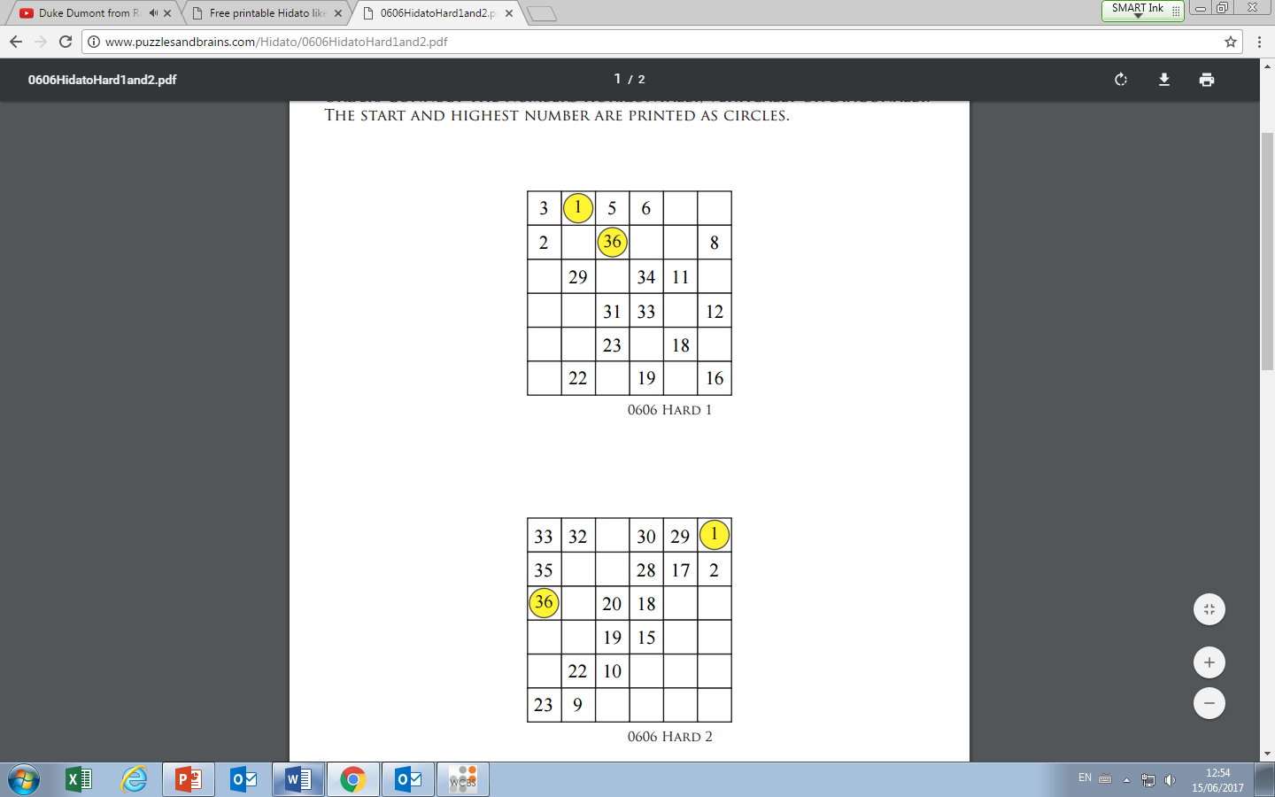
Hidato
The aim of Hidato is to fill the cells with consecutive numbers from 1 to the highest number so that consecutive numbers connect. More simply: find the path from 1 to the highest number that covers the grid entirely.

