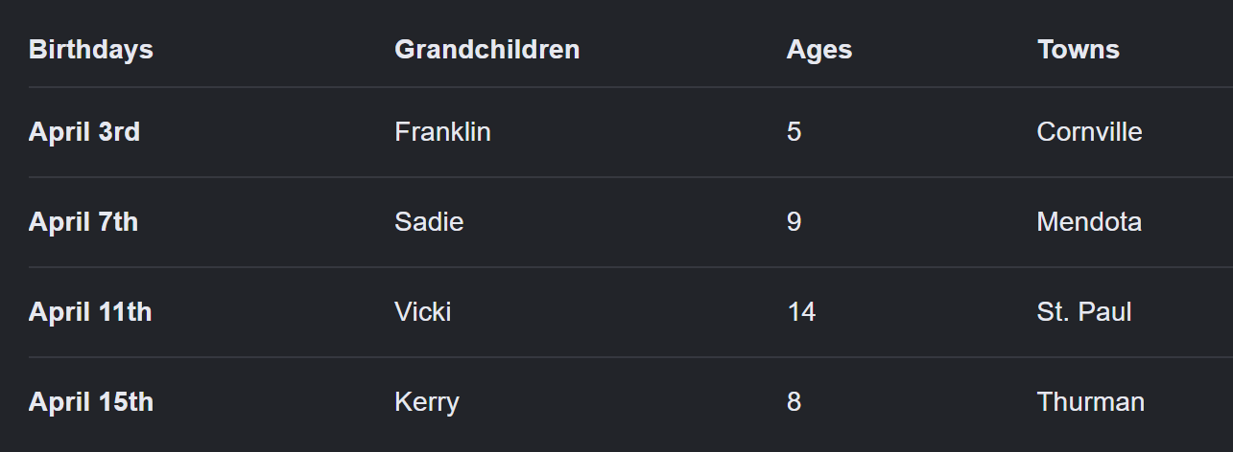
- Direct Matches:
  - From Clue 4, Vicki is 14 years old.
  - From Clue 5, Kerry was born on April 15th.
- Determine Vicki's Birthday & Towns (Clue 1 & 7):
  - Clue 1 states: "Of Vicki and the 8-year-old, one lives in Thurman and the other was born on April 11th."
  - Clue 7 states that Sadie, the child born on April 11th, and the child from Cornville are three different people. This means Vicki or Franklin is born on April 11th.
  - Testing Clue 1 shows that if Vicki lived in Thurman, it leads to a contradiction with Clue 6 and 7. Thus, Vicki must be the one born on April 11th, which means the 8-year-old lives in Thurman.
- Find the Town for St. Paul (Clue 2):
  - Clue 2 states: "The child from St. Paul is either the 14-year-old or Kerry."
  - Since the 8-year-old lives in Thurman, Kerry cannot be from St. Paul if he is the 8-year-old. More directly, because Franklin is from Cornville (deduced from Clue 6 & 7) and the 8-year-old is in Thurman, Vicki must be from St. Paul.
  - This leaves Sadie as the resident of Mendota.
- Determine the Remaining Birthdays and Ages (Clue 3 & 6):
  - Since Sadie is from Mendota, Clue 3 states: "The 5-year-old has a birthday 4 days before the grandchild from Mendota (Sadie)."
  - The only remaining consecutive birthdays 4 days apart (where the later one isn't April 11th/Vicki) are April 3rd and April 7th. Therefore, Sadie's birthday is April 7th, and the 5-year-old's birthday is April 3rd.
  - This leaves Franklin with the April 3rd birthday, making him 5 years old.
  - Consequently, Sadie is 9 years old, and Kerry is the 8-year-old from Thurman.

