Who Kidnapped Santa and where did they hide him?
Santa has been kidnapped from the North Pole and hidden away. The culprit is apparently trying to ruin Christmas for the entire world! Can you figure out who did it and where they hid him before Christmas time is upon us?
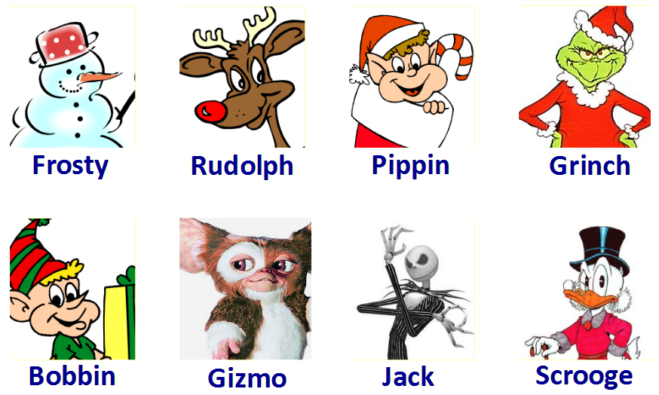

These are the suspects that the North Pole Police Department have provided you with.
Cross them out when you have eliminated them as the kidnapper.

Clue 1 – The Alibi
The police have uncovered that the kidnapping occurred at 7pm on Monday.
Each suspect has provided you with an alibi. Use the information provided to figure out who could have made it to Santa’s House given the locations they were last seen at.

- Frosty says that he was playing with the local children in the Town Square until 3 hours before the kidnapping. The children in the town agree with his whereabouts.
- Rudolph was last seen at Santa’s Workshop around 30 minutes before the kidnapping took place.
- Pippin was given the task of shining Santa’s boots, so he didn’t leave Santa’s Shed all day. Other elves working in Santa’s shed agree with him.
- The Grinch was plotting another way to take over Christmas over at the Bakery, and was seen 200 minutes before the kidnapping by worried onlookers. He says he wishes he had the nerve to kidnap Santa so close to Christmas.
- Bobbin was last seen leaving the park 2 hours before the kidnapping.
- Gizmo was seen by his neighbours 5 hours before the kidnapping. He was running into his house to escape the melting snow.
- Jack Skellington was seen 1 hour before the kidnapping at the local well. He says he was trying to figure out how to get back to Halloween Town.
- Scrooge McDuck was at the bank, bank tellers say that he left the premises 3 hours before the kidnapping took place.
Each side of a square on the town map takes 10minutes to travel.

You should know, however, that all of the suspects are a bit strange. They only travel in vertical and horizontal lines, never diagonally!
The police have kindly placed markers on the map for where each suspect was last seen.
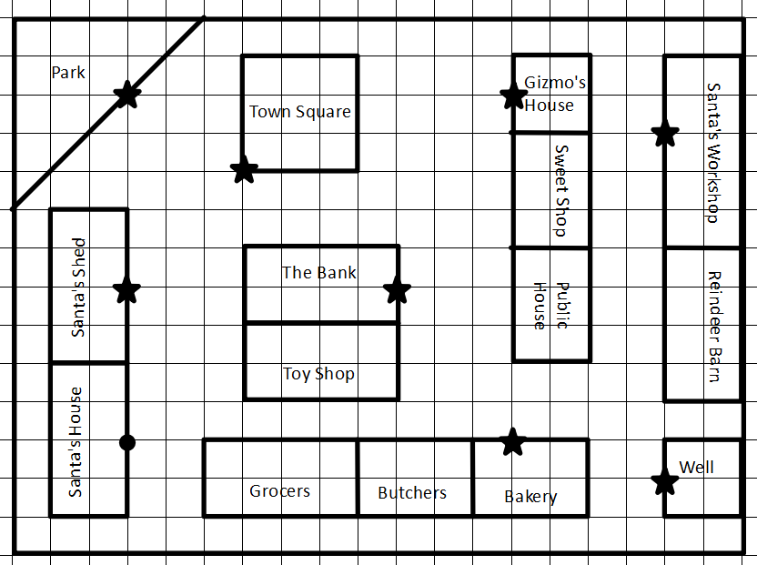

Draw out the routes each suspect would likely have taken. Work out which of the 8 suspects could not have made it to Santa’s house in time for the kidnapping. You should be able to eliminate 3 suspects.
Suspect | Time to Travel | Could have made it? (y/n)
Frosty
Rudolph
Pippin
The Grinch
Bobbin
Jack Skellington
Scrooge McDuck
Gizmo

Clue 2 – The Note
Upon inspecting the crime scene further, the police have found a note from the culprit.
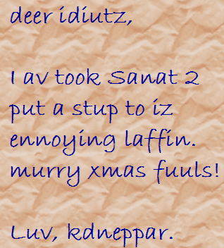

Judging by the poor spelling, the police profiling department have determined that the kidnapper must have an IQ below 75.

Use the clues below to determine the IQ of each suspect and eliminate those that have an IQ above 75.

- Frosty has 5 more than half the IQ of Scrooge McDuck.

- Rudolph has 80% of The Grinch’s IQ.

- Pippin has an IQ of 135.

- The Grinch has (2 x 5) more IQ points than Jack Skellington.

- Bobbin has the combined IQ of Frosty and Rudolph.

- Gizmo has 15 less IQ points than half of Bobbin’s IQ.

- Jack Skellington has 50% more IQ points than Frosty.

- Scrooge McDuck has (5 x 5) less IQ points than Pippin.

Suspect | IQ | Less than 75? (y/n)
Frosty
Rudolph
Pippin | 135
The Grinch
Bobbin
Jack Skellington
Scrooge McDuck
Gizmo

Clue 3 – The Photograph
A witness stepped forward and provided the police with a picture of the culprit.
Unfortunately, because of the extreme blizzard that was occurring at the time, the photograph is extremely poor quality. The only things the police can see are a series of shapes.

Using the co-ordinates provided below, can you plot the silhouette of the photograph and figure out who it is?

For each shape, join the co-ordinates up as you go.

Shape 1 | Shape 2 | Shape 3 | Shape 4 | Shape 5 | Shape 6 | Shape 7
(8,15) | (9,12) | (10,11) | (9,9) | (12,14) | (15,15) | (8,15)
(9,16) | (9,14) | (11,10) | (8,7) | (12,12) | (16,17) | (7,16)
(14,16) | (11,14) | (12,10) | (7,5) | (14,12) | (19,18) | (4,18)
(15,15) | (11,12) | (13,11) | (6,3) | (14,14) | (21,17) | (2,17)
(16,12) | (9,12) | (10,11) | (6,8) | (12,14) | (19,16) | (4,16)
(15,10) |  |  | (6,1) |  | (19,14) | (4,14)
(14,9) |  |  | (8,1) |  | (18,12) | (5,12)
(9,9) |  |  | (8,3) |  | (16,12) | (7,12)
(8,10) |  |  | (9,4) |  | (15,15) | (8,15)
(7,12) |  |  | (9,0)
(8,15) |  |  | (14,0)
 |  |  | (14,4)
 |  |  | (15,3)
 |  |  | (15,1)
 |  |  | (17,1)
 |  |  | (17,3)
 |  |  | (16,5)
 |  |  | (15,7)
 |  |  | (14,9)
 |  |  | (9,9)

Who is in the picture?

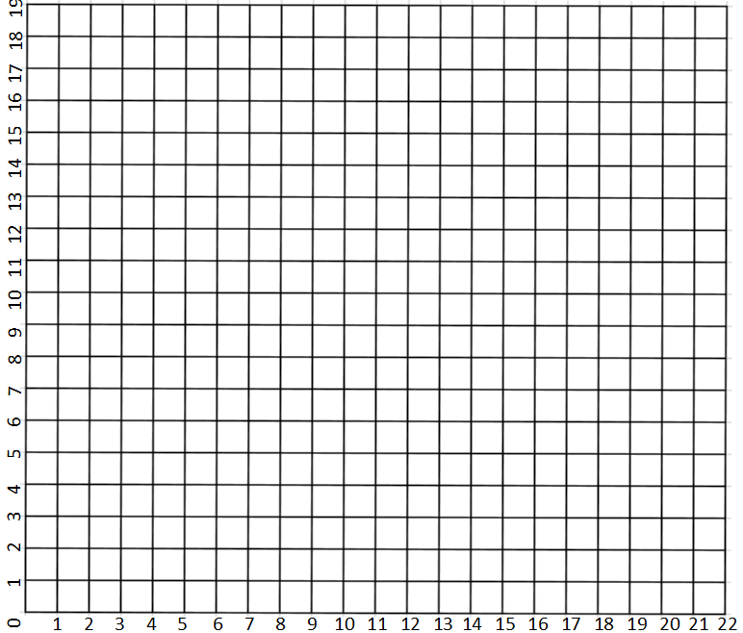

The resident of Christmas Town
who kidnapped Santa is:

Locating Santa – Which area of Christmas Town
During their investigations, the Police have decided that since the Southern area of Christmas Town is a large ice lake, there is no possibility that he is hidden there.

That leaves the police with four other options: Northern, Western, Eastern and Central Christmas Town.

The kidnaper has thought ahead however, and convinced the guards of the locations to help him keep Santa hidden. He has revealed that he has instructed 3 of the guards to lie, and one to tell the truth.

Can you discover which area Santa is hidden, if three of the guards are lying and one is telling the truth?

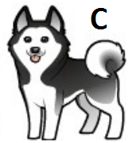 | Santa is hidden in the North.
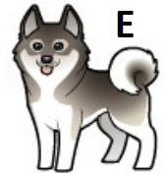 | Santa is hidden in the Centre.
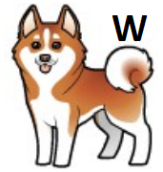 | The Central Guard is lying.
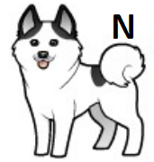 | He’s not hidden in my area.

If Santa is…. | The Central Guard is… | The Eastern Guard is… | The Western Guard is… | The Northern Guard is… | Is only one telling the truth?
In the Centre
In the East
In the West
In the North
Locating Santa – Which area of Christmas Town

During interrogation, the guard let slip that Gizmo loved to leave little clues all over the place. The guard said he had a theory about how the police could figure out where Gizmo has hidden Santa…

The Guard’s Theory:
- The kidnaper went for a walk the night he kidnapped Santa.
- The snow tracks that were left by the kidnaper may spell out where Santa is..

The only problem is that because of the blizzard tearing through Christmas town, the police cannot get a helicopter up in the air to have a look at what the snow tracks could spell out.

They have asked if you can follow the grid references and colour the squares in on the grid that they have provided. This may help them figure it out…

M2 |  | B3 |  | I4 |  | C2 |  | J4 |  | D2 |  | K4 |  | E2 |  | L4 |  | F2
M3 |  | B5 |  | I8 |  | C4 |  | J8 |  | D6 |  | K8 |  | E6 |  | L8 |  | F6
M4 |  | B8 |  | I11 |  | C6 |  | J11 |  | D8 |  | K9 |  | E8 |  | L11 |  | F8
M5 |  | B9 |  | I13 |  | C8 |  | J13 |  | D9 |  | K10 |  | E13 |  | L13 |  | F9
M6 |  | B10 |  | I14 |  | C13 |  |  |  | D10 |  | K11 |  | E16 |  |  |  | F10
M8 |  | B11 |  | I15 |  | C16 |  |  |  | D13 |  | K13 |  |  |  |  |  | F11
M11 |  | B13 |  | I16 |  |  |  |  |  | D16 |  | K14 |  |  |  |  |  | F13
M13 |  | B14 |  |  |  |  |  |  |  |  |  | K15 |  |  |  |  |  | F16
M14 |  | B15
M15 |  | B16
M16 |  | B17
 |  | B18

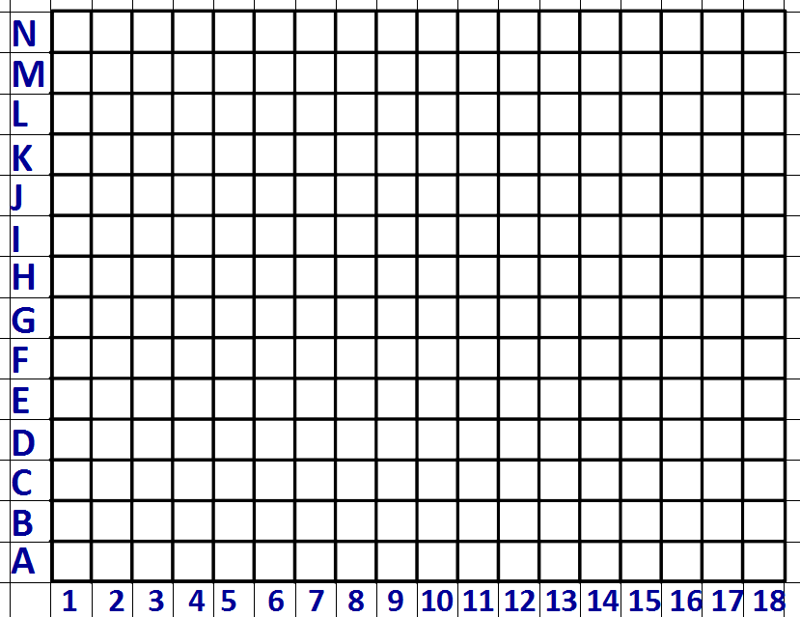

The hidden message is:

