Higher - Expanding Double Brackets
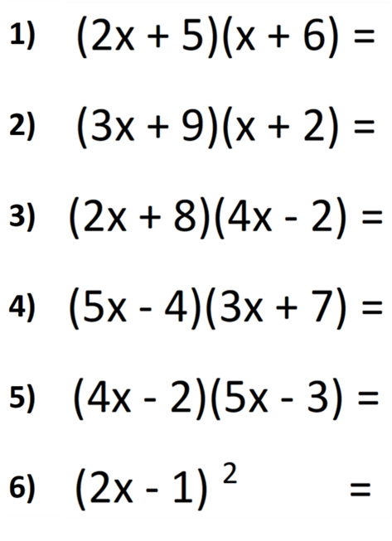
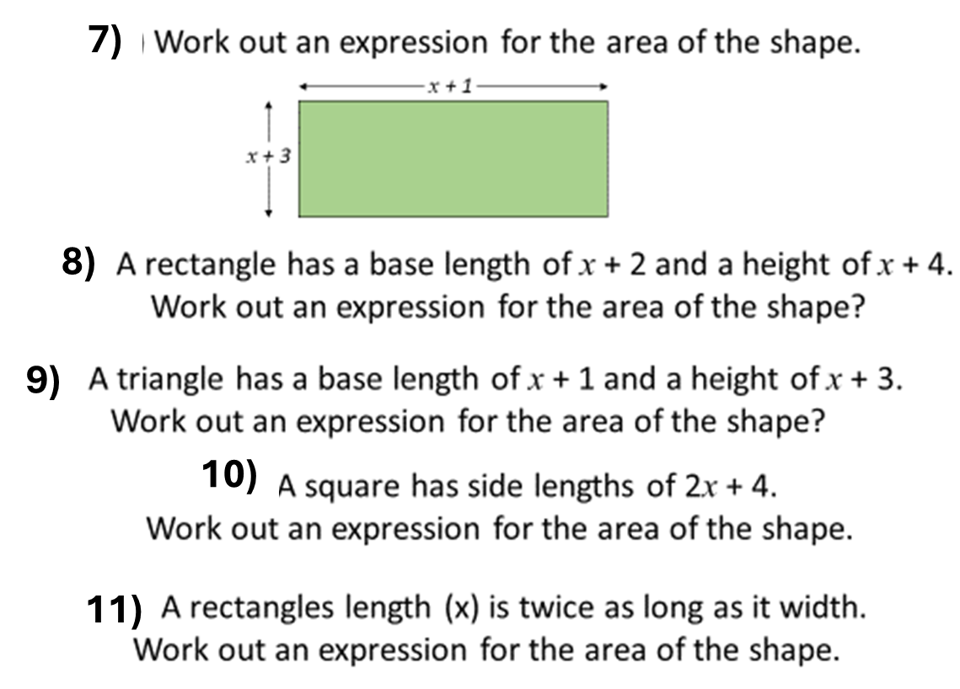
Higher - Expanding Double Brackets

