Extension - Pythagoras Theorem
1) A triangle has sides of length 4cm, 7cm and 9cm. Is this a right-angled triangle?

2) A ship going from a port to a lighthouse heads 20km east and 15km north. How far is the lighthouse from the port?

3) Find the distance between two points, with the given co-ordinates (3, 4) and (-4, 1). Give your answer in surd form.

4) The shape is made of squares and half squares. What is the perimeter? Give you answer in surd form.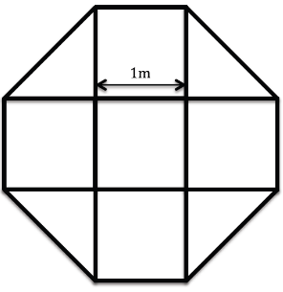
5) Does Pythagoras Theorem work for semi-circles? Explain your answer.
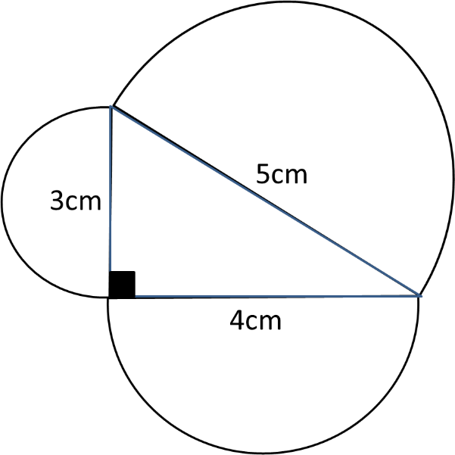
6) Does Pythagoras Theorem work for equilateral triangles? Explain your answer.
.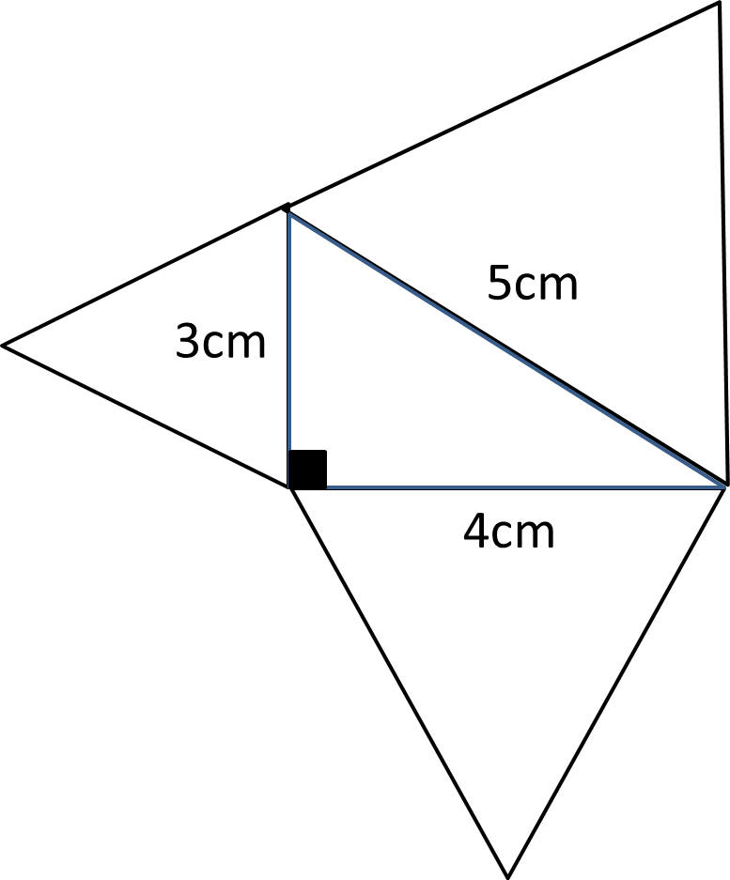
7) Find the length of AG
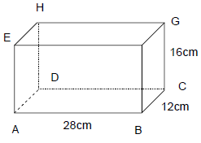

8) Find the length of the vertical height.
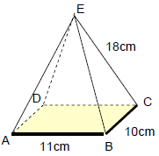

9) I have a metal tin in the shape of a cylinder with diameter 11cm and height 16cm. Can I fit a pencil 20cm long inside the tin and put the lid on? Explain you answer.

10) A thin wire 18cm is bent into the shape shown. Calculate the length from A to B.
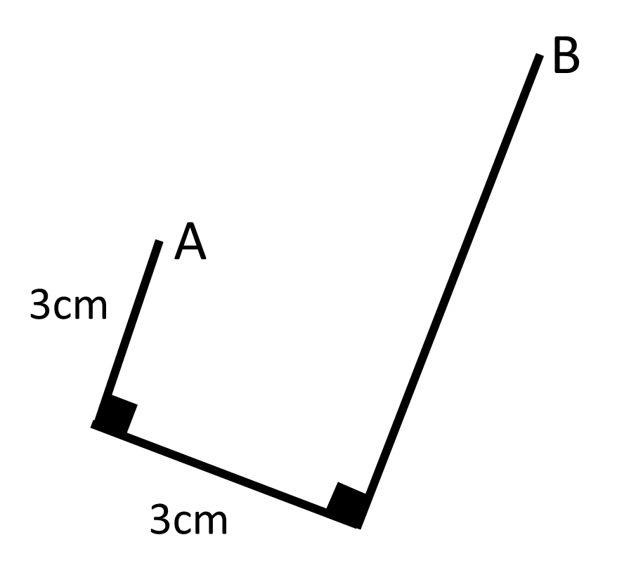
11) The perimeter of the Rhombus is 100cm. What is the value of 𝑥?
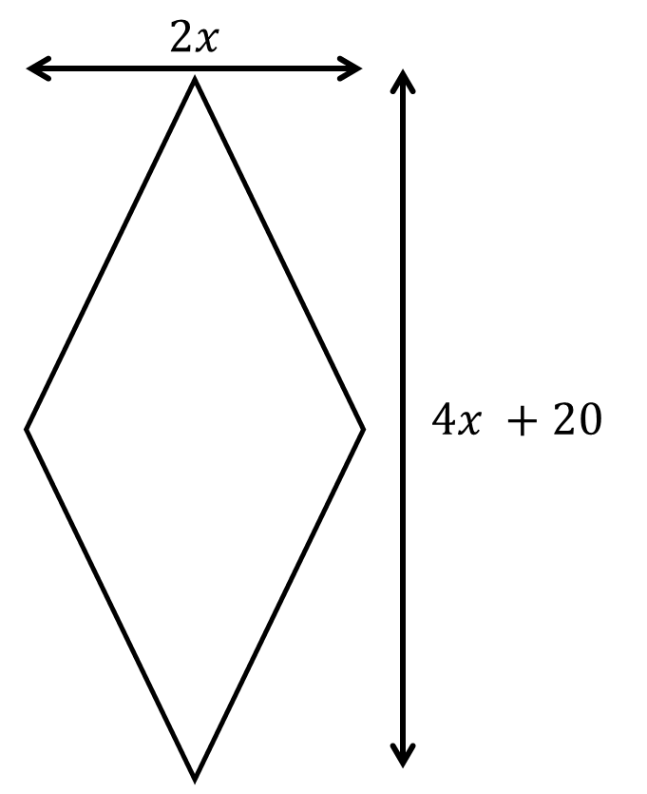
12) Calculate the area of the square.

