For each triangle find the missing angle. Give answers to 1 decimal places.
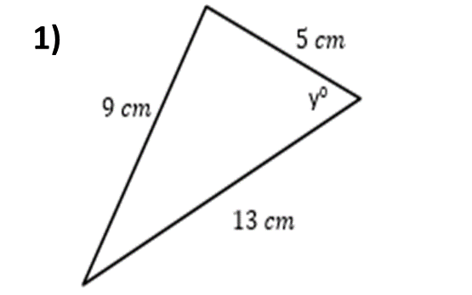
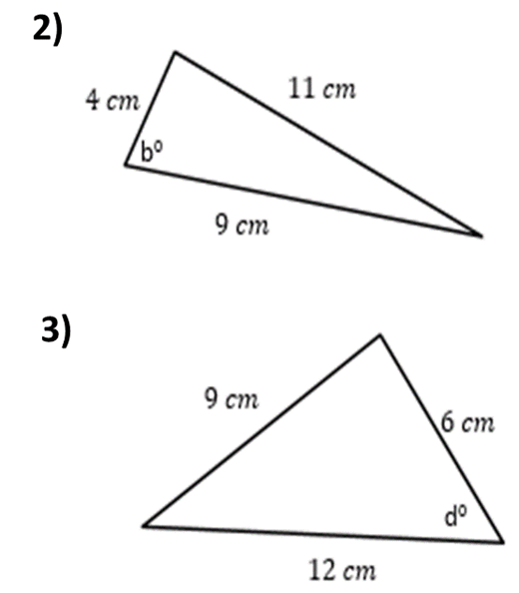

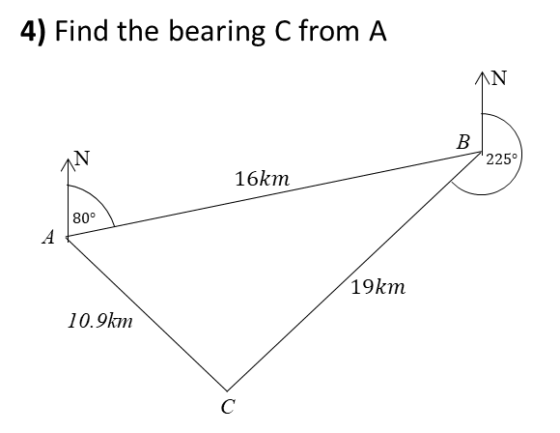
For each triangle find the missing angle. Give answers to 1 decimal places.

