Order of Operations - Connections
Foundation
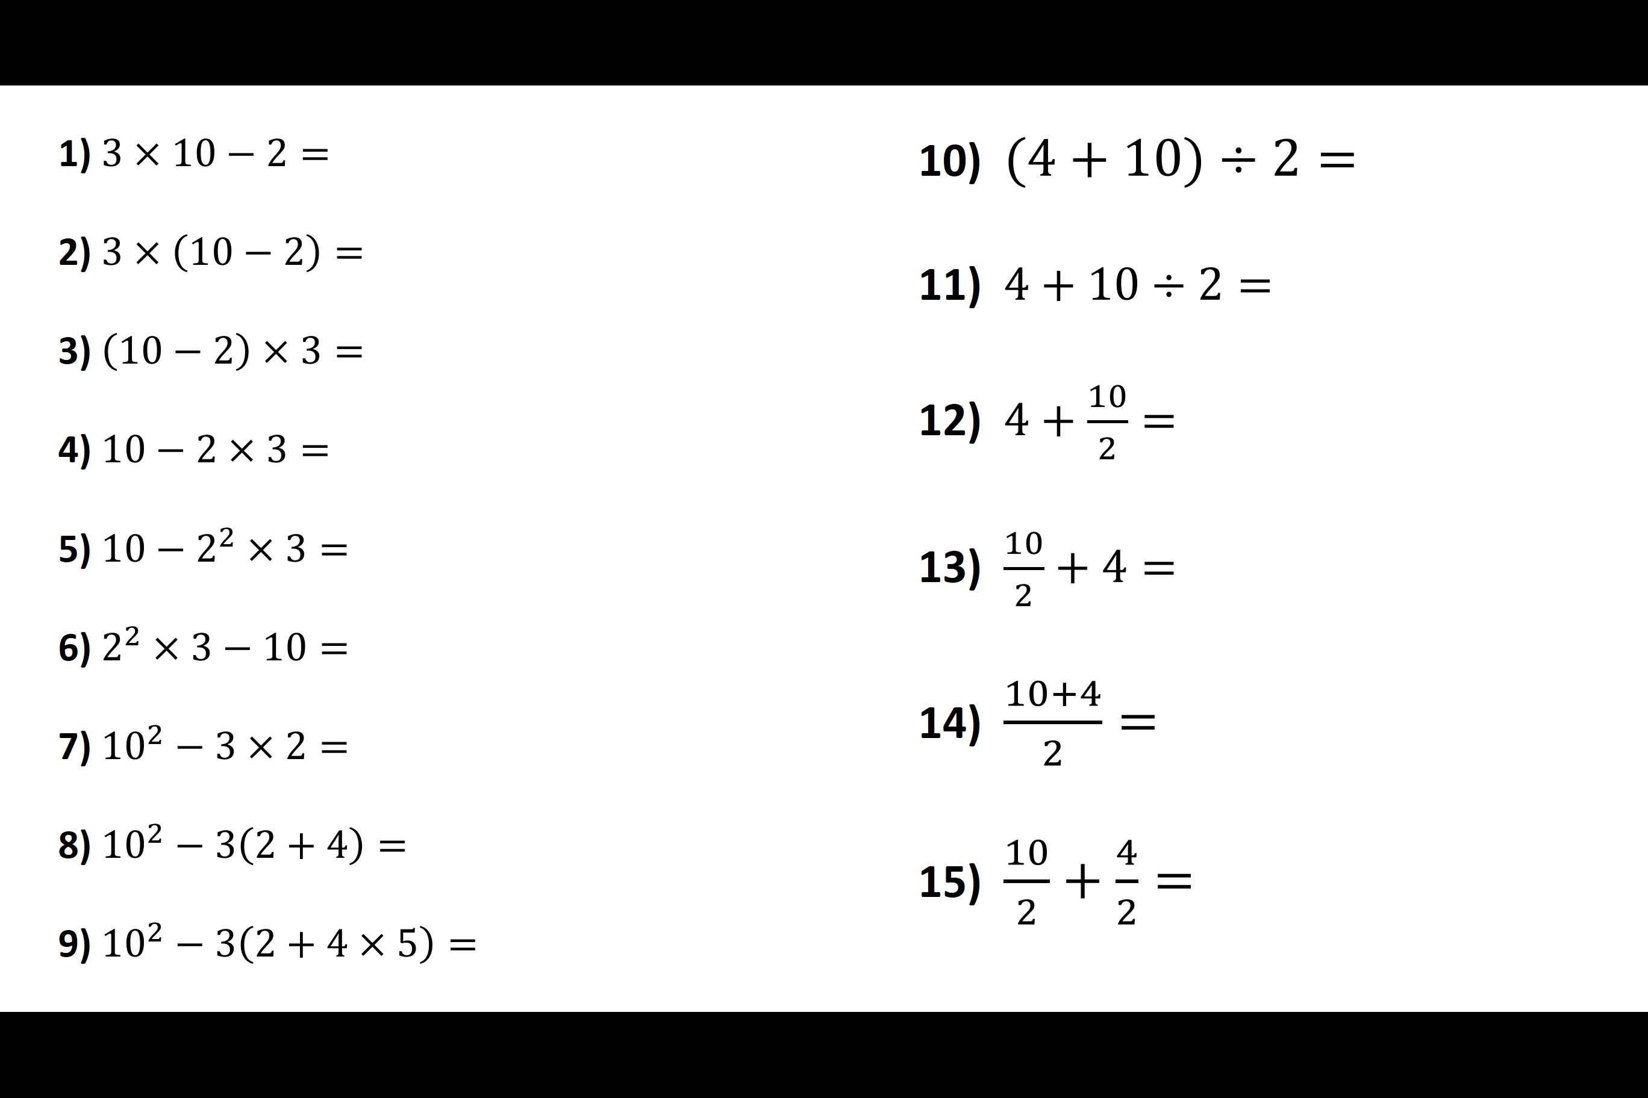
Higher
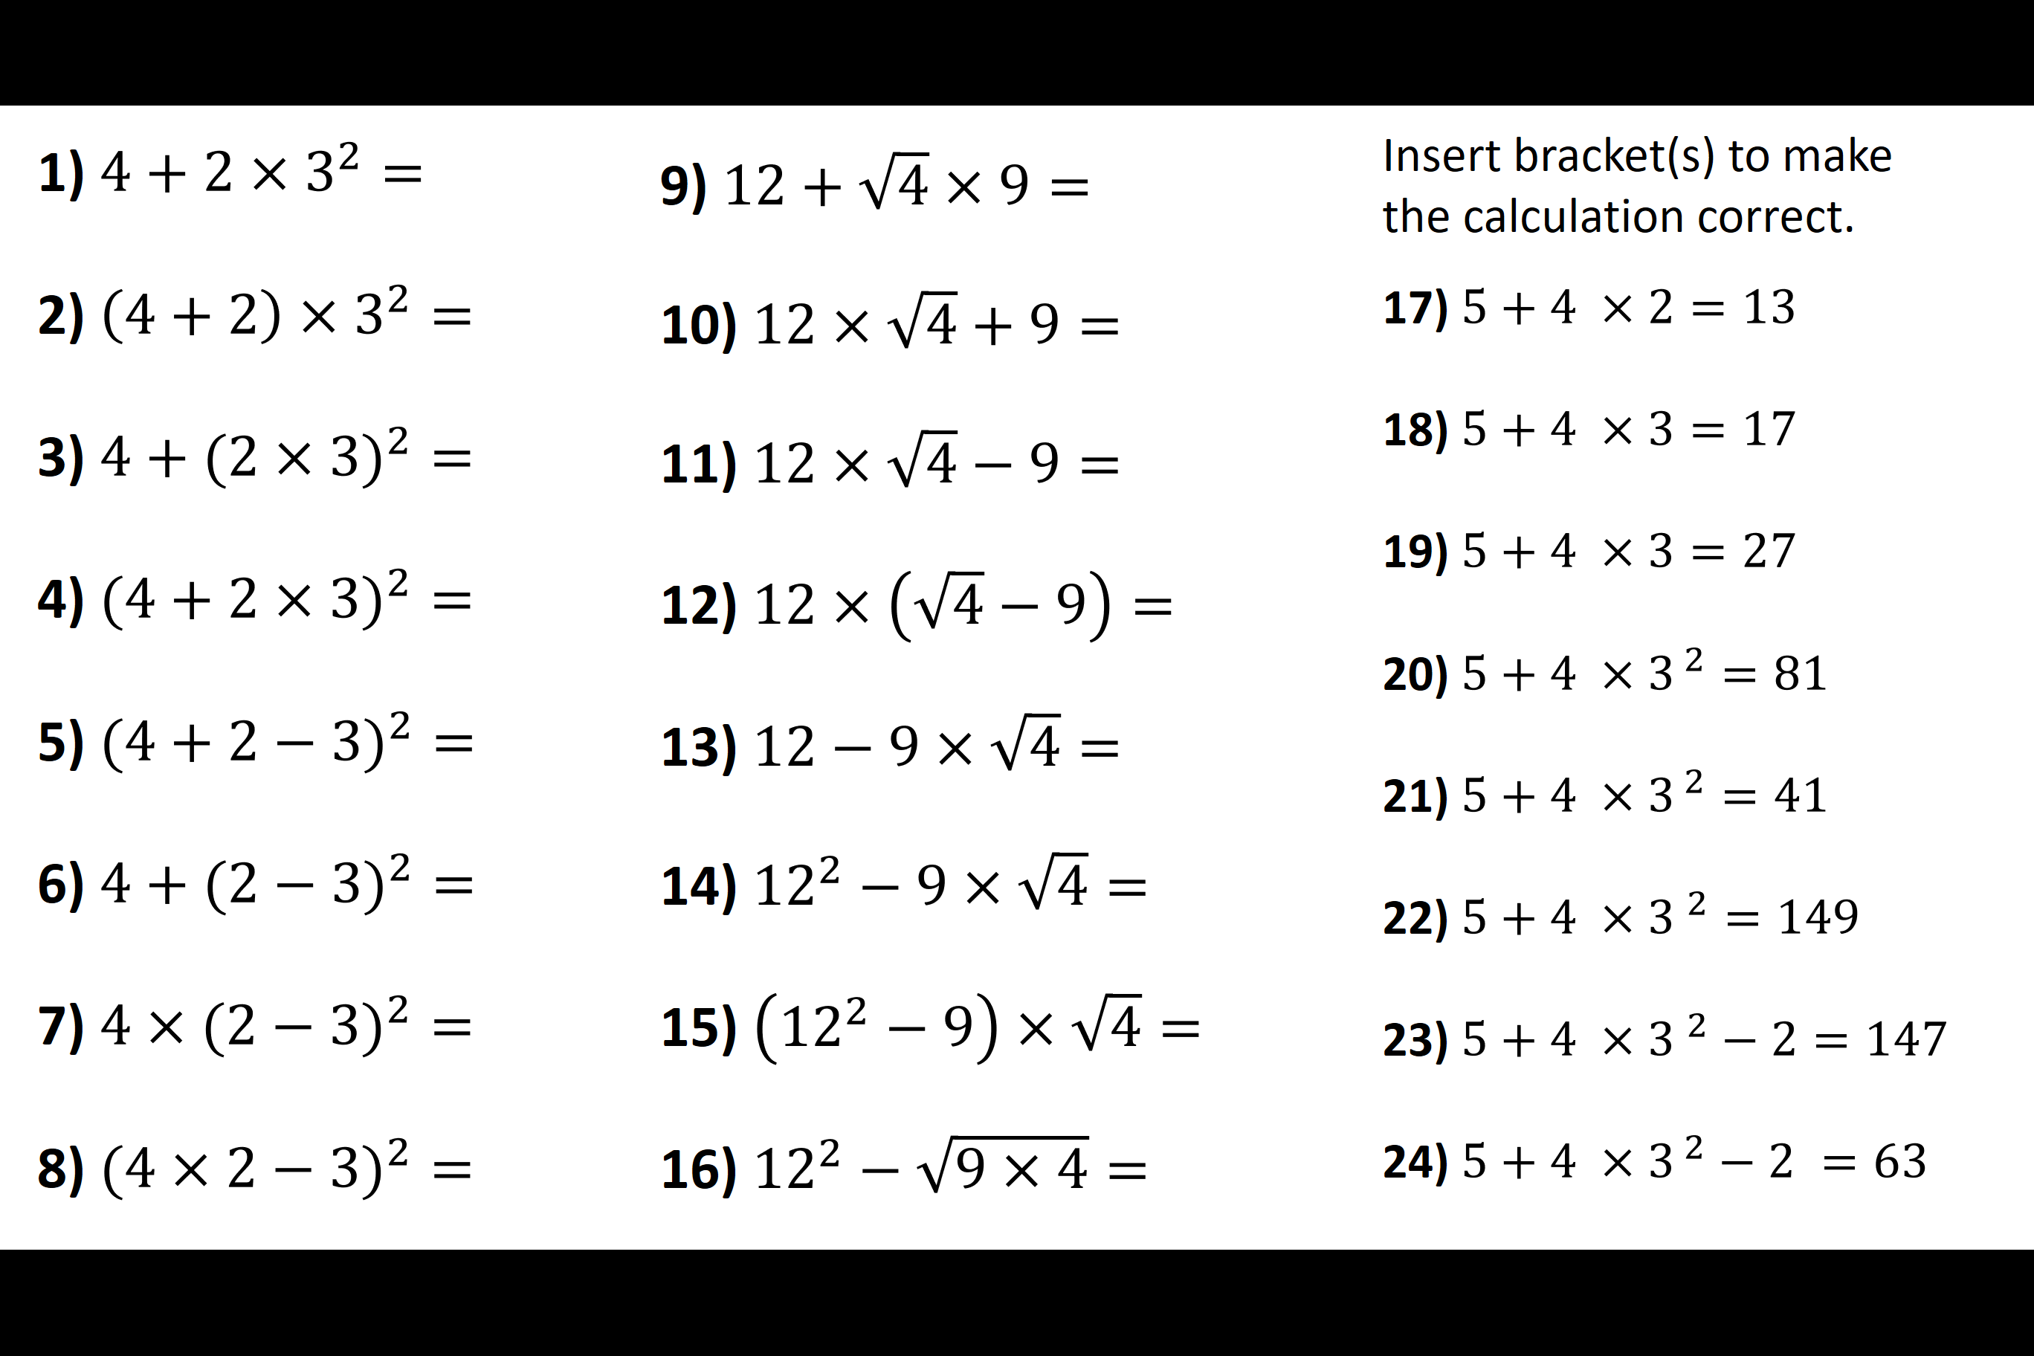
Order of Operations - Connections
Foundation
Higher

