Tessellations – Investigation
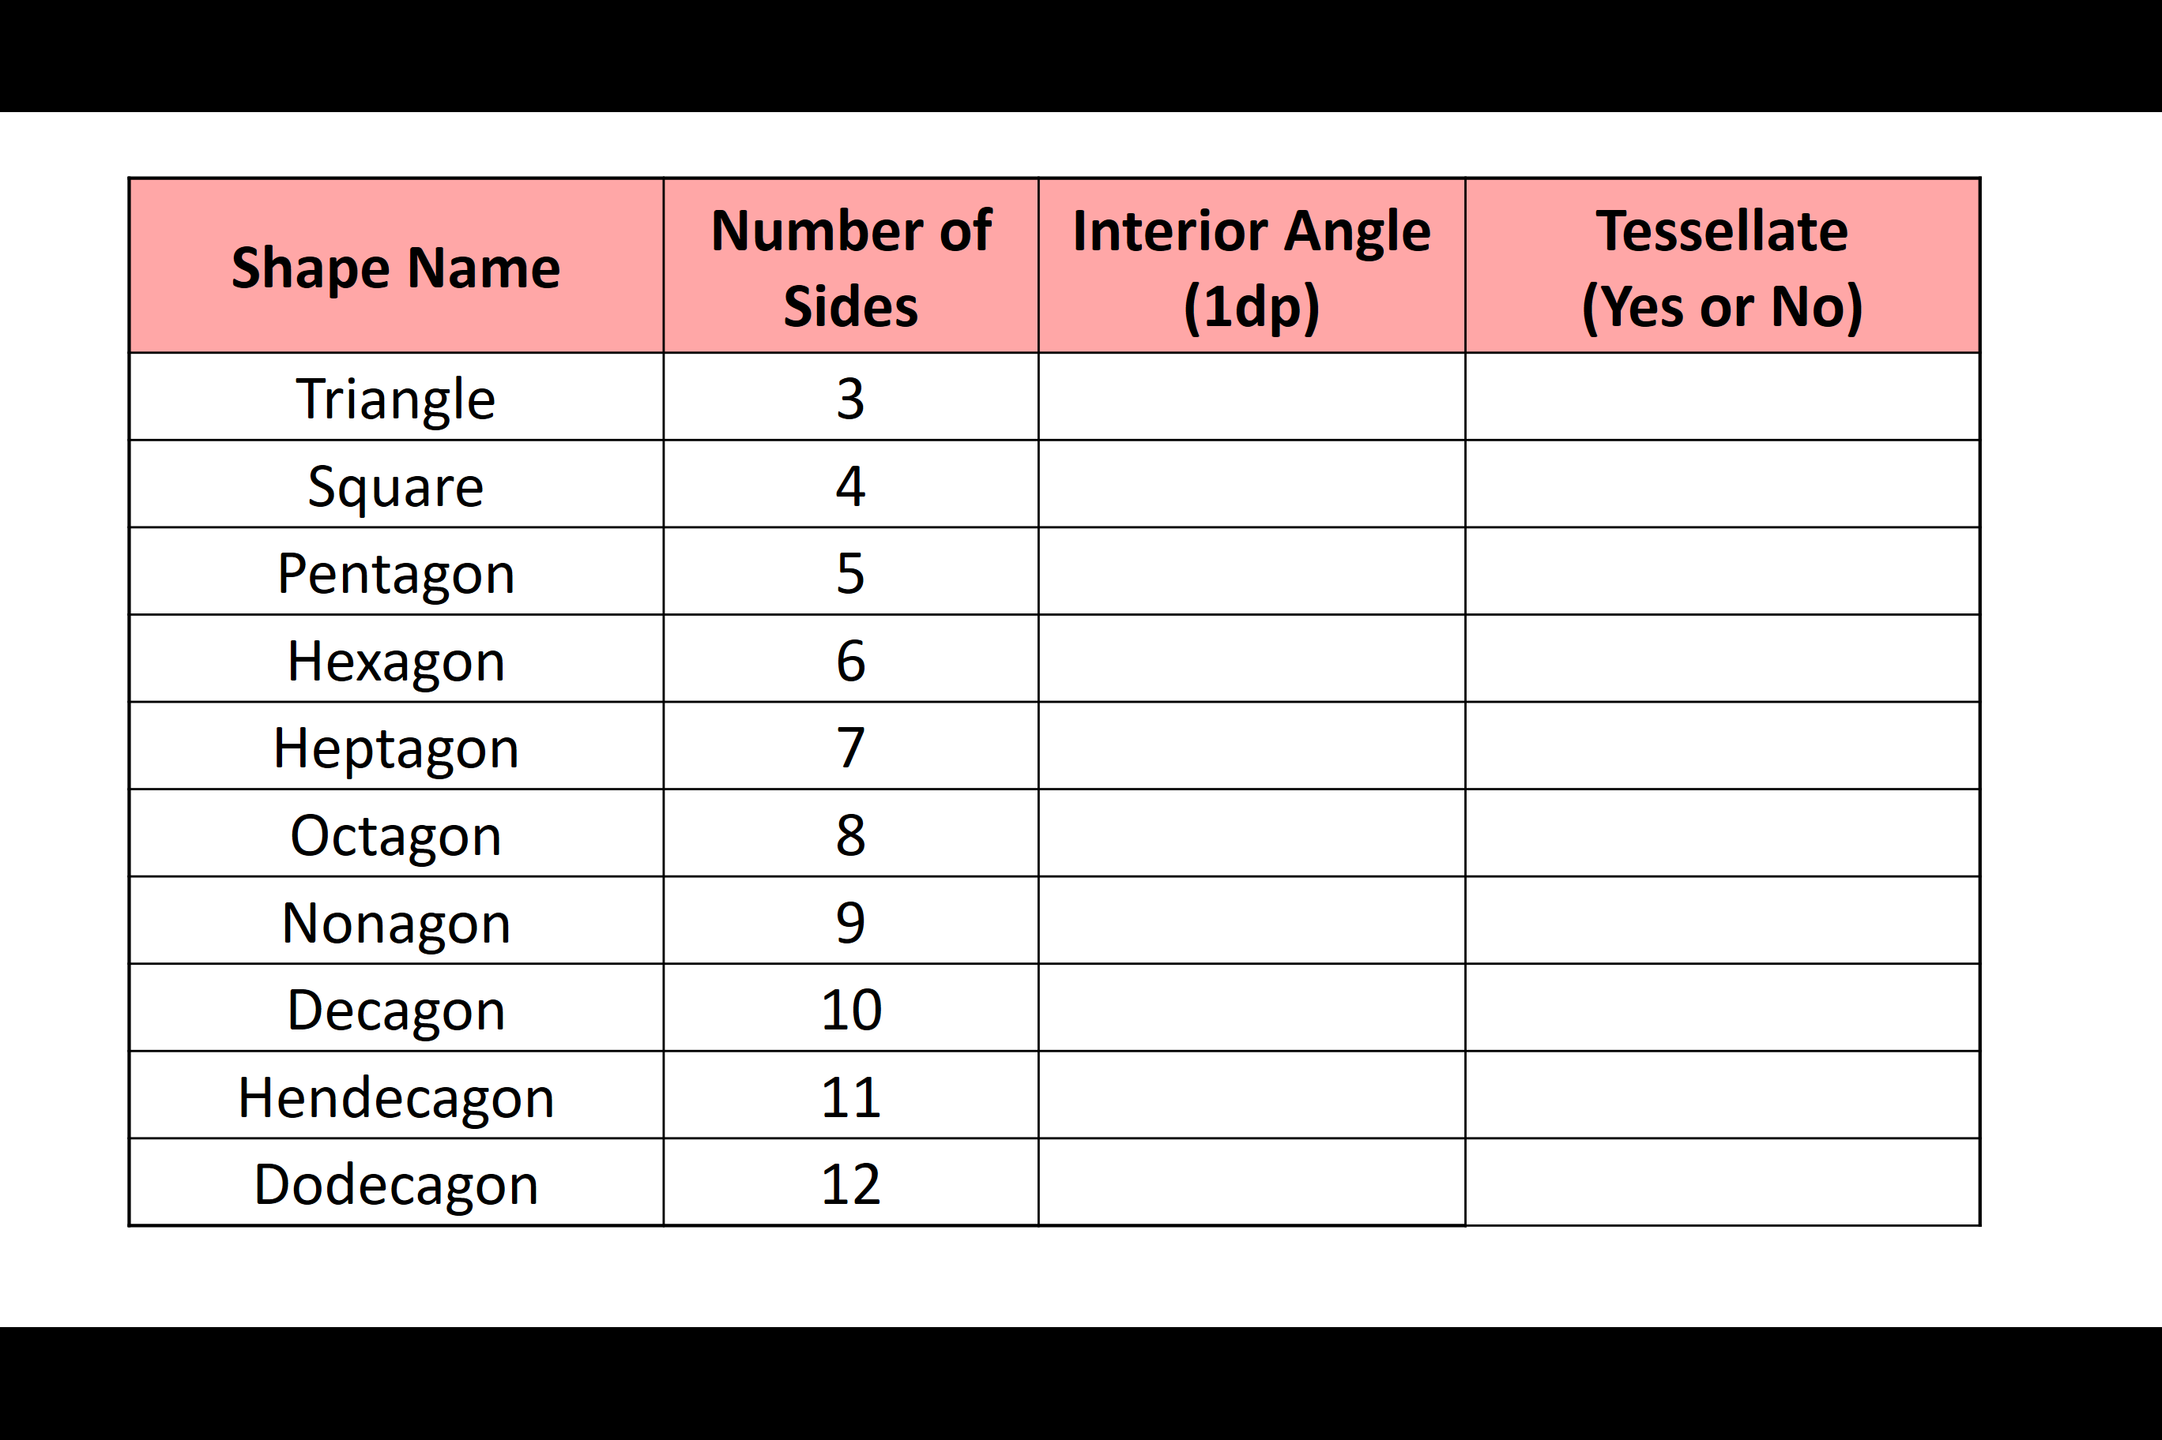
Tessellations – Investigation

