1) Write an expression for the area of the garden.
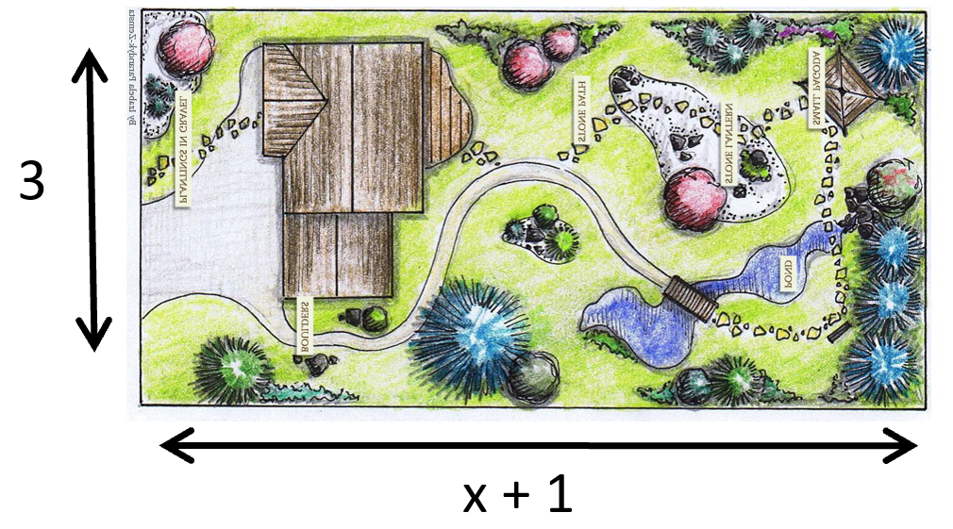
2) Alice gets £x pocket money. Joe gets the same as Alice plus £5.
a) Write an expression for how much Joe gets.
Kate gets double the amount Joe gets.
b) Write an expression for how much Kate gets.

3) A glass can hold k millilitres. A cup holds 30ml less than the glass.
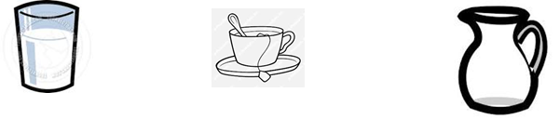
a) Write an expression for the capacity of the cup.
A jug can hold 5 times the amount of the cup.
b) Write an expression for the capacity of the jug.

4) Below are the amounts of money each person gets paid (in pounds)
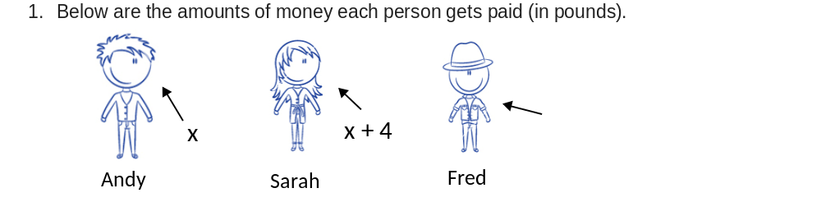
a) Fred gets double the amount of Sarah. Write an expression for how much he gets?
b) Write an expression for how much they get paid altogether?
c) Their boss Jessica gets paid three times the amount of all of them put together. Write an expression for how much she gets paid?
5) Write an expression for the perimeter of the rectangle in terms of x?
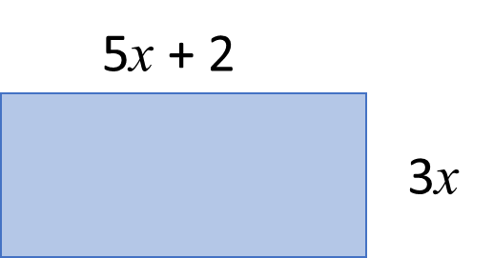

6) Write an expression for the perimeter of the rectangle in terms of x?
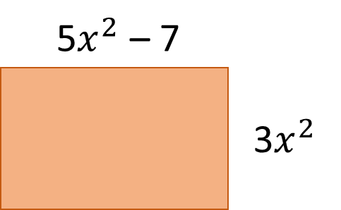

7) Write an expression for the perimeter of the rectangle in terms of x?

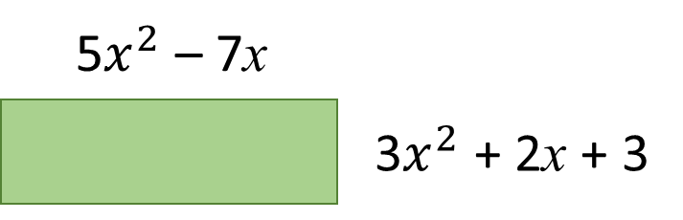

8) Write an expression for the perimeter of the rectangle in terms of x?

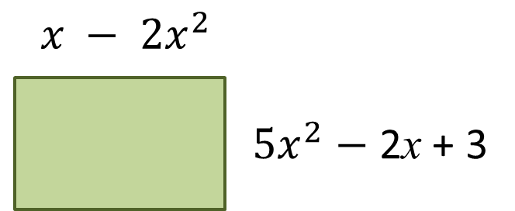

9) Write an expression for the perimeter of the triangle in terms of x?

