1) Describe the transformation make sure that you fully describe each transformation, using equations or names of lines.
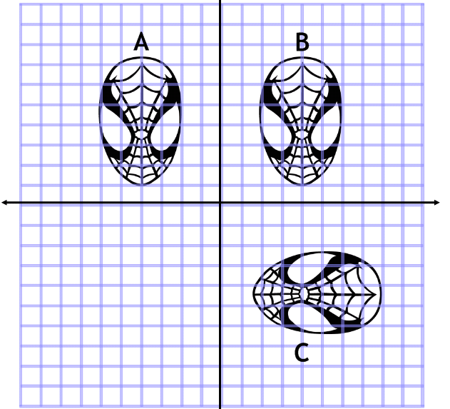
A to B:
B to C
A to C
2) Describe the transformation make sure that you fully describe each transformation, using equations or names of lines.
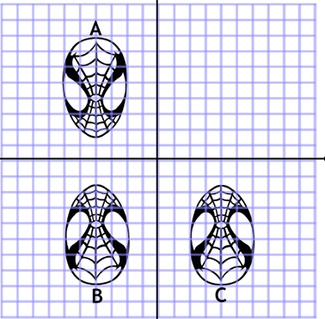
A to B:
B to C
A to C
3) Describe the transformation make sure that you fully describe each transformation, using equations or names of lines.
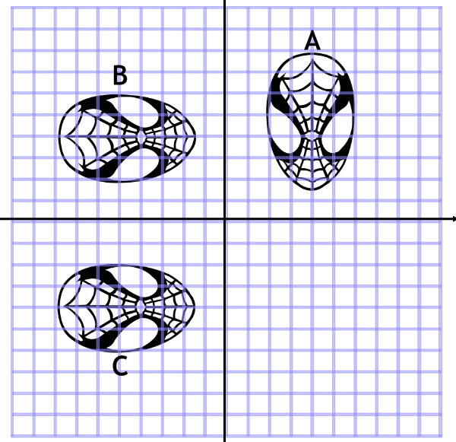
A to B:
B to C
A to C
4) What single combination has the same effect as: a reflection in the line x = -3 followed by a reflection in the line x = 1?
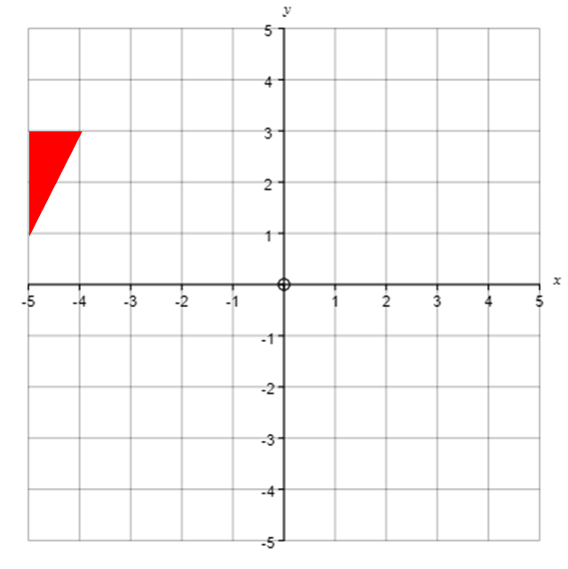
5) What single transformation has the same effect as: a reflection in the line x = -2 followed by a reflection in the line y = -1?
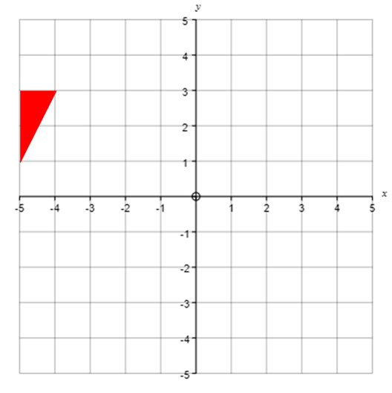
6) What single transformation has the same effect as: a rotation 90⁰ clockwise about point (-3, 1) followed by a translation by column vector $\left(\begin{matrix}2 \\ 0\end{matrix}\right)$?
7) What single transformation has the same effect as: A translation by column vector $\left(\begin{matrix}2 \\ -2\end{matrix}\right)$ followed by a 180⁰ rotation about point (-1, -1)?
8) What single transformation has the same effect as: a 90⁰ clockwise rotation about point (-2, 0) followed by a reflection in the x axis?

