Qualitative, Discrete or Continuous Data

Data | Tick | Tick
Shoe Size | $\left[\right]Qualitative$ $\left[\right]Quantitative$ | $\left[\right] Discrete$ $\left[\right]Continous$
Weight | $\left[\right]Qualitative$ $\left[\right]Quantitative$ | $\left[\right] Discrete$ $\left[\right]Continous$
Height | $\left[\right]Qualitative$ $\left[\right]Quantitative$ | $\left[\right] Discrete$ $\left[\right]Continous$
Drinks in a machine | $\left[\right]Qualitative$ $\left[\right]Quantitative$ | $\left[\right] Discrete$ $\left[\right]Continous$
Number of Magazines in a Shop | $\left[\right]Qualitative$ $\left[\right]Quantitative$ | $\left[\right] Discrete$ $\left[\right]Continous$
Speed | $\left[\right]Qualitative$ $\left[\right]Quantitative$ | $\left[\right] Discrete$ $\left[\right]Continous$
Distance to another city | $\left[\right]Qualitative$ $\left[\right]Quantitative$ | $\left[\right] Discrete$ $\left[\right]Continous$
Favourite Colour | $\left[\right]Qualitative$ $\left[\right]Quantitative$ | $\left[\right] Discrete$ $\left[\right]Continous$
What you are having for lunch | $\left[\right]Qualitative$ $\left[\right]Quantitative$ | $\left[\right] Discrete$ $\left[\right]Continous$
Number taxis at a hotel | $\left[\right]Qualitative$ $\left[\right]Quantitative$ | $\left[\right] Discrete$ $\left[\right]Continous$
Handspan of a person | $\left[\right]Qualitative$ $\left[\right]Quantitative$ | $\left[\right] Discrete$ $\left[\right]Continous$
Number of people in an office | $\left[\right]Qualitative$ $\left[\right]Quantitative$ | $\left[\right] Discrete$ $\left[\right]Continous$
Volume of water in a glass | $\left[\right]Qualitative$ $\left[\right]Quantitative$ | $\left[\right] Discrete$ $\left[\right]Continous$
Favourite Subject | $\left[\right]Qualitative$ $\left[\right]Quantitative$ | $\left[\right] Discrete$ $\left[\right]Continous$
Cost of a drink | $\left[\right]Qualitative$ $\left[\right]Quantitative$ | $\left[\right] Discrete$ $\left[\right]Continous$

Questions | Tick | Tick
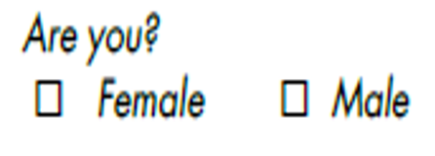 | $\left[\right]Qualitative$ $\left[\right]Quantitative$ | $\left[\right] Discrete$ $\left[\right]Continous$
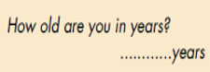 | $\left[\right]Qualitative$ $\left[\right]Quantitative$ | $\left[\right] Discrete$ $\left[\right]Continous$
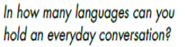 | $\left[\right]Qualitative$ $\left[\right]Quantitative$ | $\left[\right] Discrete$ $\left[\right]Continous$
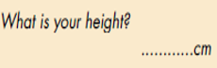 | $\left[\right]Qualitative$ $\left[\right]Quantitative$ | $\left[\right] Discrete$ $\left[\right]Continous$
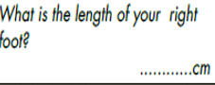 | $\left[\right]Qualitative$ $\left[\right]Quantitative$ | $\left[\right] Discrete$ $\left[\right]Continous$
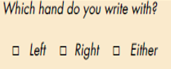 | $\left[\right]Qualitative$ $\left[\right]Quantitative$ | $\left[\right] Discrete$ $\left[\right]Continous$
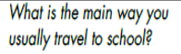 | $\left[\right]Qualitative$ $\left[\right]Quantitative$ | $\left[\right] Discrete$ $\left[\right]Continous$
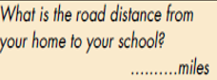 | $\left[\right]Qualitative$ $\left[\right]Quantitative$ | $\left[\right] Discrete$ $\left[\right]Continous$

