1) Write an expression for the area and find the value of x
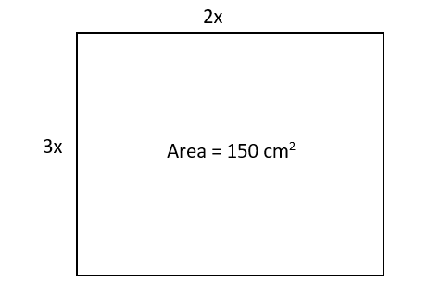
2) Write an expression for the area and find the value of x
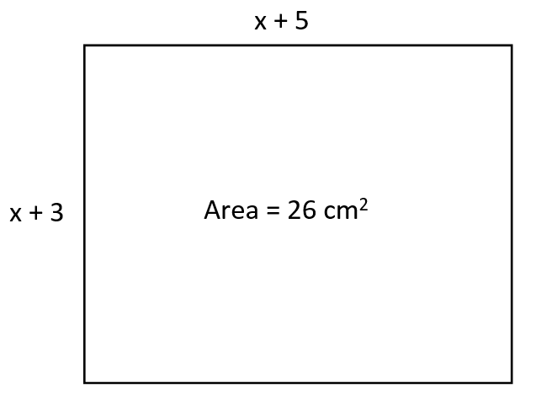
Area = 8cm²
3) The area of the shape is 85 cm2. Show that the 9x2 – 17x – 85 = 0
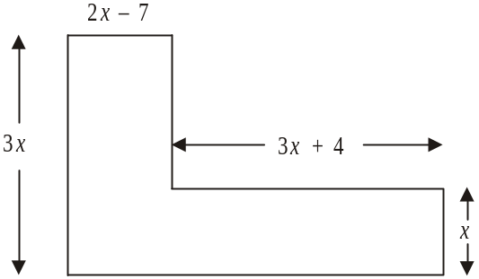

4) The area of the shape is 25 cm2. Show that 6x2 + 17x – 39 = 0
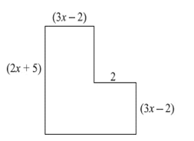
5) The area of the trapezium is 36 cm2. Find the length of the shortest side of the trapezium.
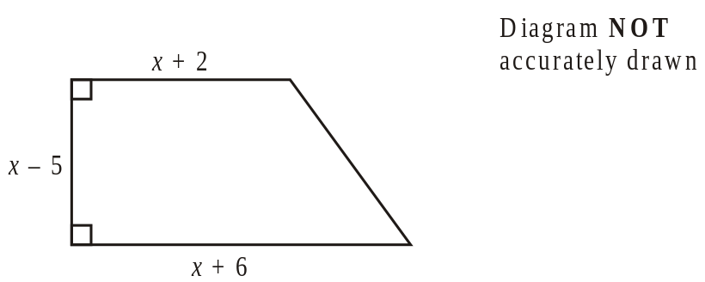
1) Write an expression for the area and find the value of x
2) Write an expression for the area and find the value of x
Area = 8cm²
3) The area of the shape is 85 cm2. Show that the 9x2 – 17x – 85 = 0

4) The area of the shape is 25 cm2. Show that 6x2 + 17x – 39 = 0
5) The area of the trapezium is 36 cm2. Find the length of the shortest side of the trapezium.

