Europe Flight Plan
There are a lot of jobs to be done in organising your flight plan!
Job 1 – Calculate the bearing to fly on from each city to the next destination. You should also draw the course on the map.
Job 2 – Measure the distance between the cities with a ruler,
then work it out in miles. The scale is on the map.

Job 3 – Calculate the flight time (Distance ÷ Speed). The average speed of a Boeing 747 is around 500mph.
Job 4 – Fill in an estimated arrival time (based on how long the flight will take…)
Job 5 – Planes take around 30 minutes to be refuelled, cleaned and safety checked for the next flight. You need to choose time to set off for the next destination. Remember that times are often rounded.

Journey | Departure Time | Distance (miles) | Bearing | Flight Time (rounded) | Arrival Time
    London – Stockholm | Monday 09:00
  Stockholm – Moscow | 11:40
  Moscow – Tunis | 14:00
  Tunis – Madrid | 18:40
Madrid - London | 20:30
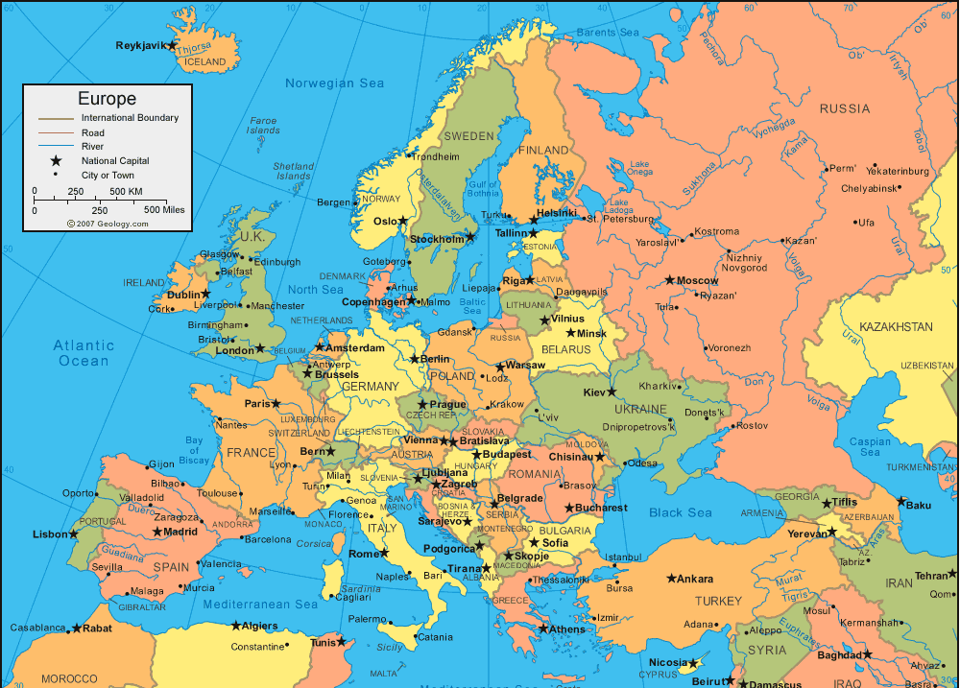

Africa Flight Plan
There are a lot of jobs to be done in organising your flight plan!
Job 1 – Calculate the bearing to fly on from each city to the next destination. You should also draw the course on the map.
Job 2 – Measure the distance between the cities with a ruler, then work it out in miles. The scale is on the map.
Job 3 – Calculate the flight time (Distance ÷ Speed). The average speed of a Boeing 747 is around 500mph.
Job 4 – Fill in an estimated arrival time (based on how long the flight will take…)
Job 5 – Planes take around 30 minutes to be refuelled, cleaned and safety checked for the next flight. You need to choose what time to set off for the next destination. Remember that times are often rounded.

Journey | Departure Time | Distance (miles) | Bearing | Flight Time (rounded) | Arrival Time
    Addis Ababa – Nairobi | Saturday 22:00
    Nairobi – Antananarivo | Sunday  00:15
  Antananarivo – Cape Town | 04:00
  Cape Town – Dakar | 09:15
Dakar - Nairobi | 18:30

