Crack the Code |  | Large Numbers in Standard Form
A | 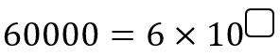 |  | B | 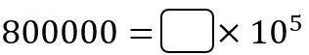
C | 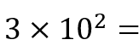 |  | D | 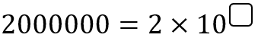
E | 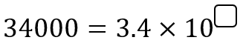 |  | F | 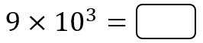
G | 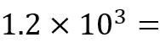 |  | H | 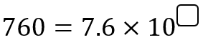
I | 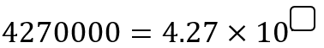 |  | J | 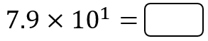
K | 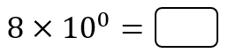 |  | L | 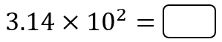
M | 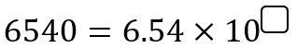 |  | N | 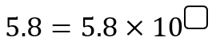
P | 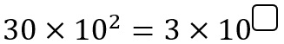 |  | Q | 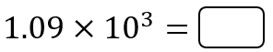
R | 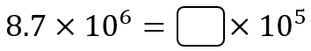 |  | S | 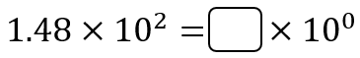
T | 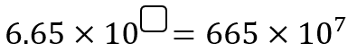 |  | U | 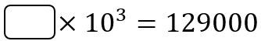
Add together all your answers and divide by 100
to give the three-digit code.

Crack the Code |  | Small Numbers in Standard Form
A | 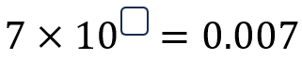 |  | B | 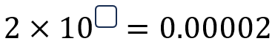
C | 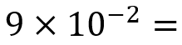 |  | D | 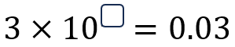
E | 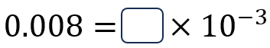 |  | F | 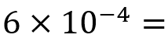
G | 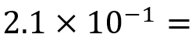 |  | H | 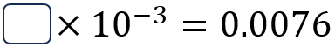
I | 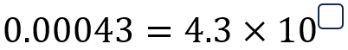 |  | J | 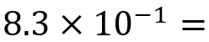
K | 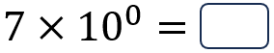 |  | L | 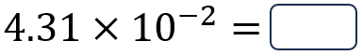
M | 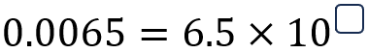 |  | N | 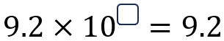
P | 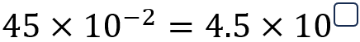 |  | Q | 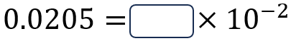
R | 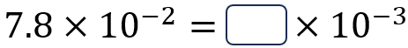 |  | S | 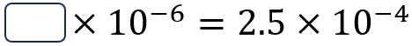
T | 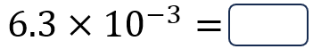 |  | U | 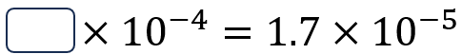
Add together all your answers to give the three-digit code.

