Simplifying Algebraic Fractions (With Factorsing)
Foundation
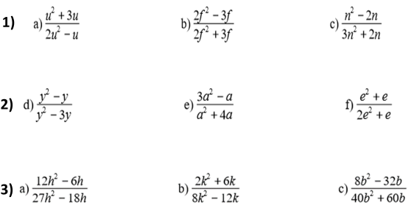
Higher
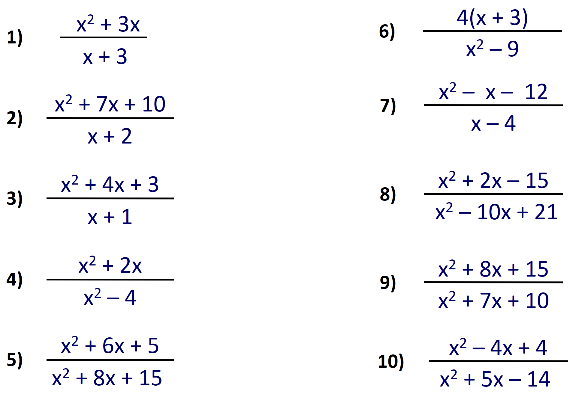
Simplifying Algebraic Fractions (With Factorsing)
Foundation
Higher

