Frequency Polygons
Part 1: Fluency
- The table shows the age in years of 60 people.
  - On the grid, draw a frequency polygon for the information in the table.
Age (in years) | Frequency
0 < a ≤ 10 | 5
10 < a ≤ 20 | 14
20 < a ≤ 30 | 12
30 < a ≤ 40 | 10
40 < a ≤ 50 | 7
50 < a ≤ 60 | 4
60 < a ≤ 70 | 8
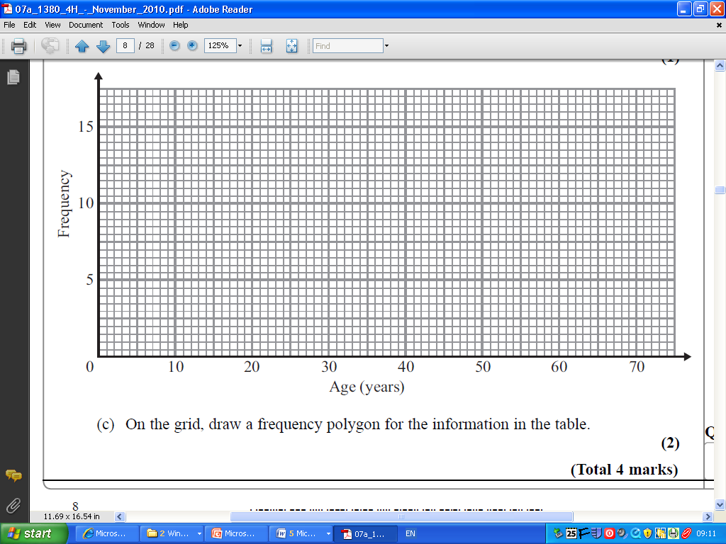
  - What is the modal class?
  - Write down an observation from the frequency polygon
.................................................................................................................................................................................................................................................................................................................................................................................
Part 2: Reasoning
- The data below shows the groupings for the time period when every goal was scored in the 2013/2014 Premier League Season by Arsenal or Chelsea. For example Arsenal scored five times between zero and ten minutes across the entire season.
  - Plot a frequency polygon for each team (two different lines) with axes labels and title.
  - What is the modal class for each team?
  - State one difference and one similarity between the two teams.

Time of goal grouping | Arsenal Frequency | Chelsea Frequency
0 ≤ t < 10 | 5 | 5
10 ≤ t < 20 | 5 | 7
20 ≤ t < 30 | 4 | 4
30 ≤ t < 40 | 6 | 9
40 ≤ t < 50 | 9 | 6
50 ≤ t < 60 | 10 | 8
60 ≤ t < 70 | 11 | 10
70 ≤ t < 80 | 9 | 7
80 ≤ t < 90 | 9 | 15
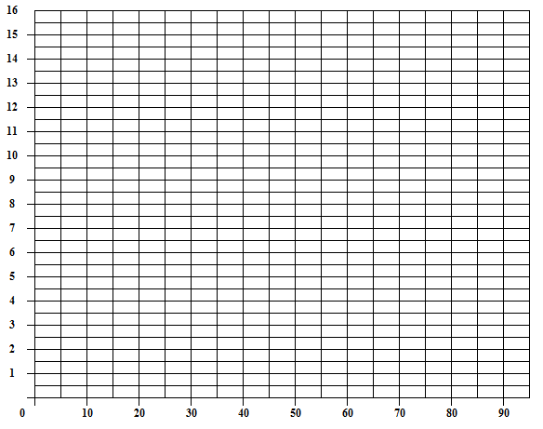
Part 3: Median
3. The following data represents the temperature of 20 different cities around the world
on a particular day.

Temperature (°C) | Frequency
0 < T ≤ 10 | 5
10 < T ≤ 20 | 6
20 < T ≤ 30 | 5
30 < T ≤ 40 | 4

a) Draw a frequency polygon for the above data.
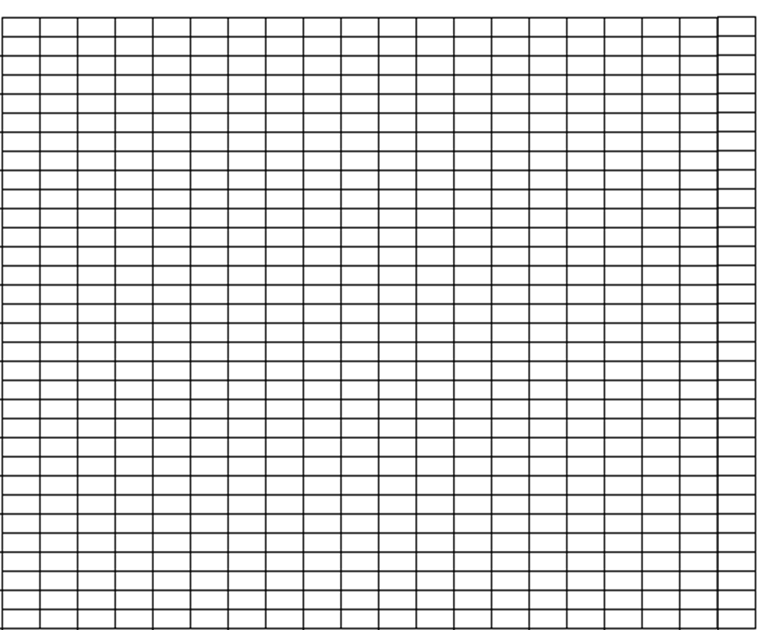

b) In which class interval would you find the median value?
Part 4: Mean
4. The following data represents the ages of 100 pupils involved in a primary school.
Age | Frequency
7 | 12
8 | 23
9 | 20
10 | 28
11 | 17

a) Draw a frequency polygon for the above data.
b) Calculate the mean using the table.

