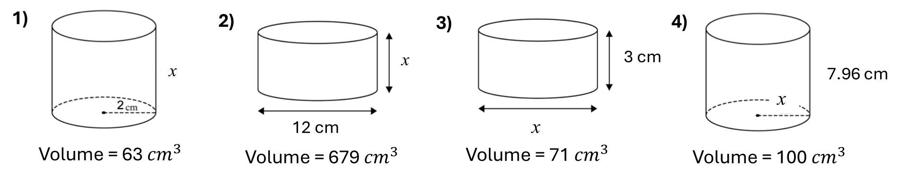

5) A cylinder has a height of 15cm and a volume of 500cm³ Calculate the radius of the cylinder.

6) A cylinder has a volume of 250cm³ and a height of 10cm. Calculate the diameter.

7) A cylinder and a cube have the same volume find y.

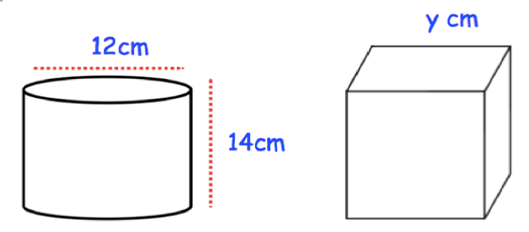

8) A cube is 8cm on each side. What is the height of a cylinder having the same volume, if its radius is 4cm.

5) A cylinder has a height of 15cm and a volume of 500cm³ Calculate the radius of the cylinder.

6) A cylinder has a volume of 250cm³ and a height of 10cm. Calculate the diameter.

7) A cylinder and a cube have the same volume find y.

8) A cube is 8cm on each side. What is the height of a cylinder having the same volume, if its radius is 4cm.

