Adding and Subtracting
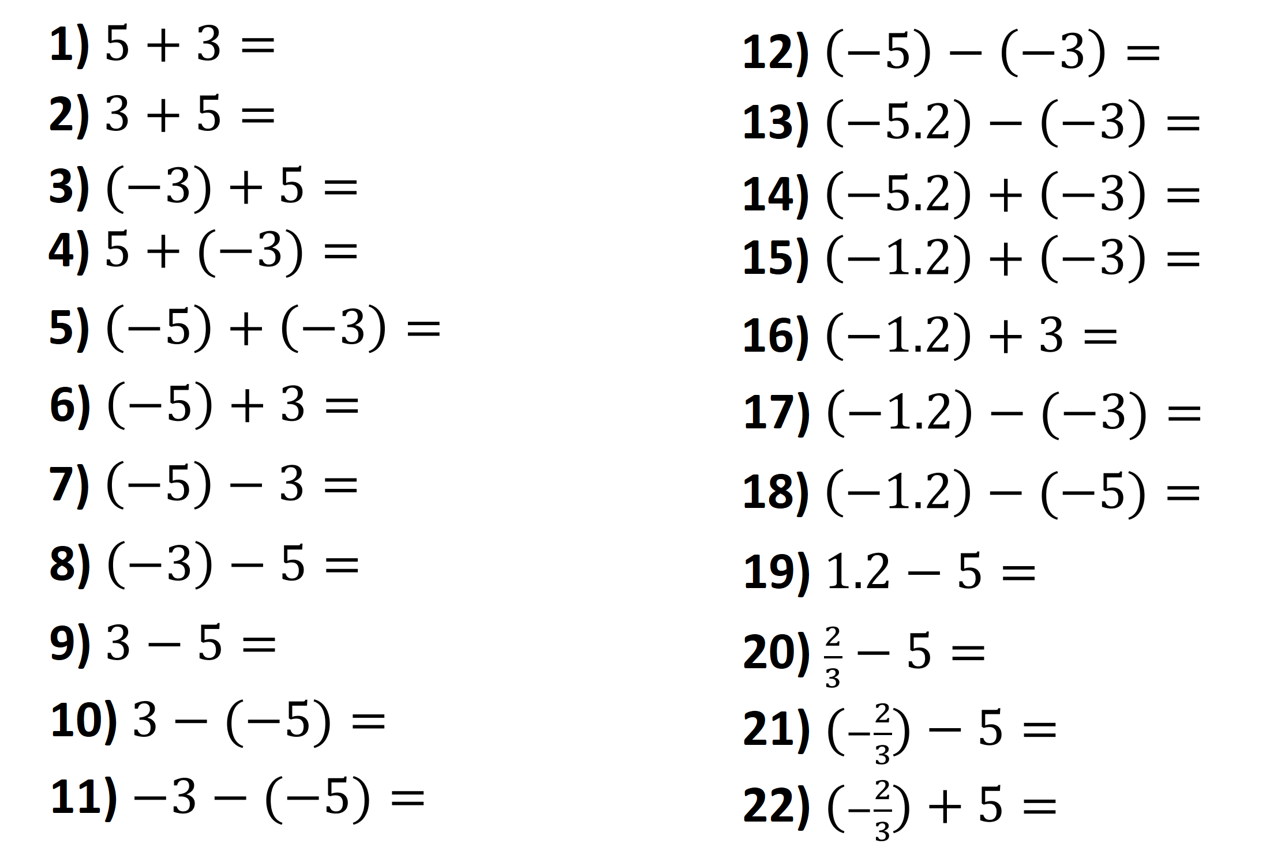
Multiplying and Dividing

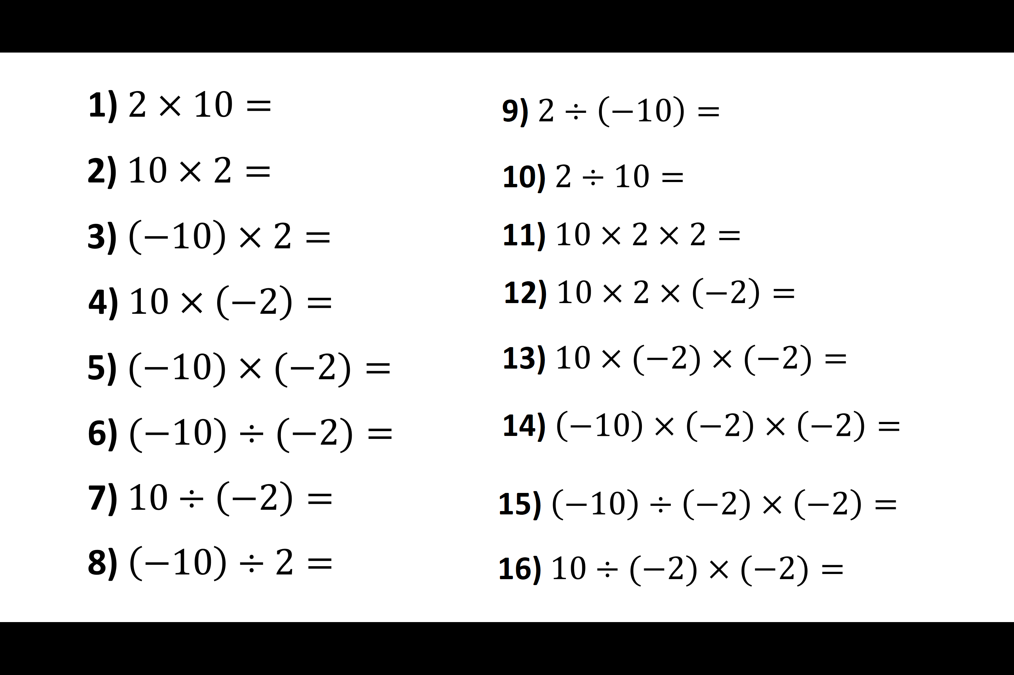
Adding and Subtracting
Multiplying and Dividing

