Transformation - Code Breaker
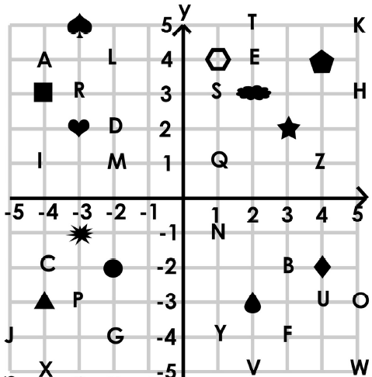
Find the shape. Make the Transformation. Write down the letter. Break the code!
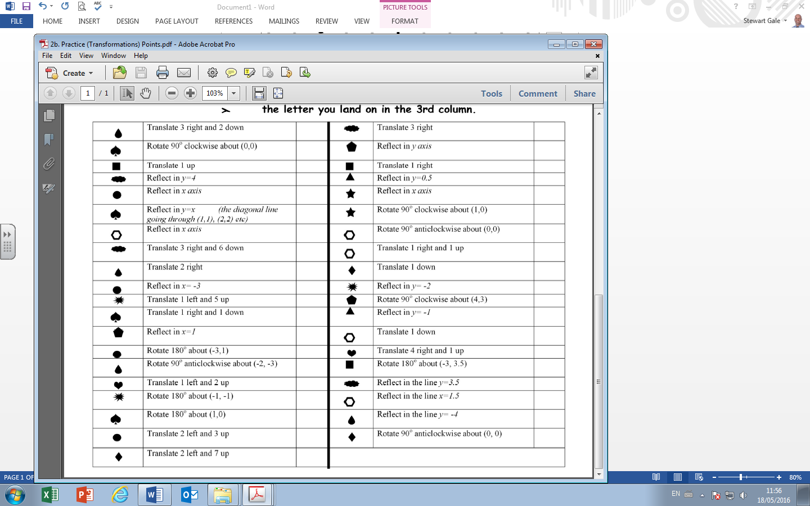
Transformation - Code Breaker
Find the shape. Make the Transformation. Write down the letter. Break the code!

