Foundation | Intermediate | Higher
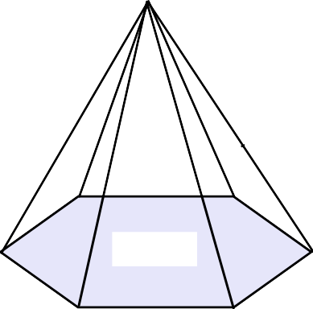Volume =  Height = 12 cm  Base Surface Area = 30cm² | 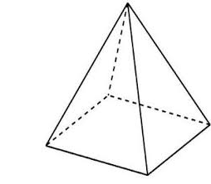 Volume =  4 cm  4 cm  Height = 3 cm | 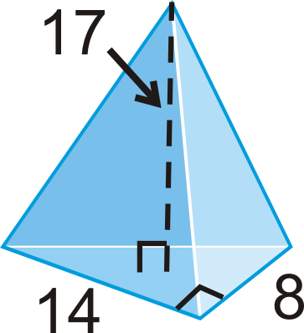  What is the volume?
Volume =  Height = 6 cm  Base Surface Area = 9.1cm² | 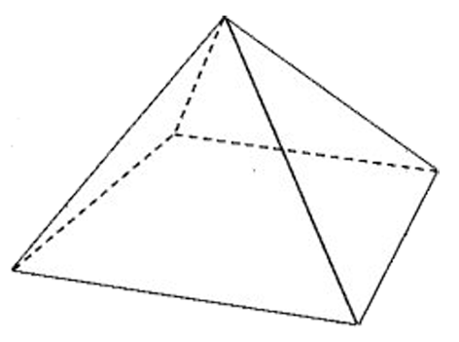Volume =  Height = 18 cm  7 cm  8 cm | 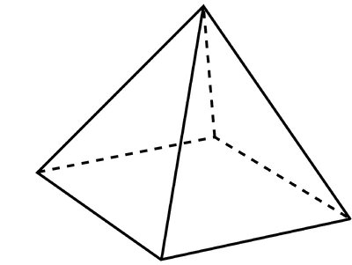  6 cm  6 cm  Volume = 156 cm³  What is the height?
Height = 11 cm  Base Surface Area = 6cm²  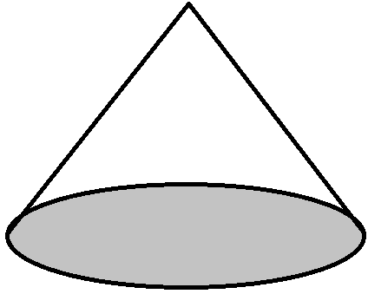  Volume = | 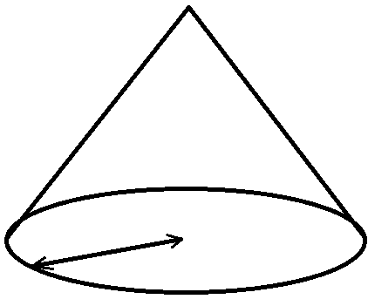 Volume =  4 cm  Height = 9 cm | 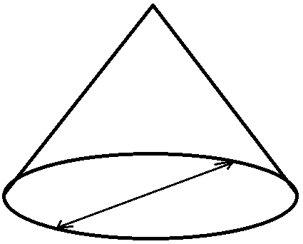  Height = 14 cm  Volume =  8 cm
Height = 8.5 cm  Base Surface Area = 24cm²  Volume = | Volume =  3.1 cm  Height = 12 cm | 13 cm  Volume = 310 cm³  What is the height?

