Equations of a Tangent to a Circle
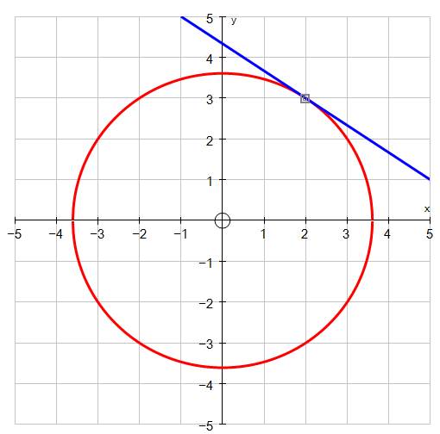
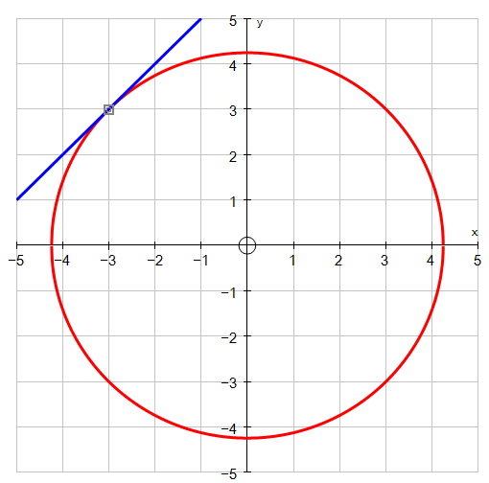
1) Find the gradient of the tangents to each of the circles shown below
a) b)

$x^{2}+y^{2}=18$ $x^{2}+y^{2}=13$
at (-3, 3) at (2, 3)
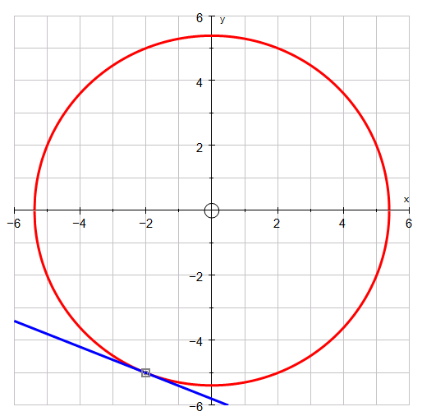
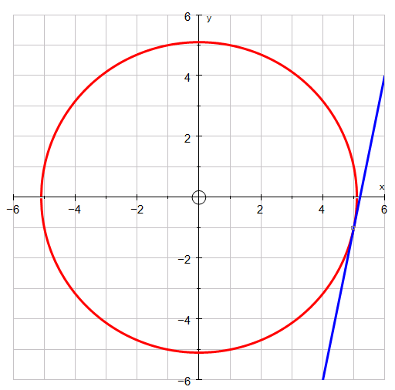
c) d)

$x^{2}+y^{2}=26$ $x^{2}+y^{2}=29$
at (5, -1) at (-2, -5)

2) Find the equation of the tangent passing through the following points on the circles below:

a) $x^{2}+y^{2}=17$ at the point (4, -1)

b) $x^{2}+y^{2}=164$ at the point (8, 10)

c) $x^{2}+y^{2}=80$ at the point (-4, -8)

d) $x^{2}+y^{2}=100$ at the point (6, 8)
Equations of a Tangent to a Circle
1) Find the gradient of the tangents to each of the circles shown below
a) b)

$x^{2}+y^{2}=18$ $x^{2}+y^{2}=13$
at (-3, 3) at (2, 3)
c) d)

$x^{2}+y^{2}=26$ $x^{2}+y^{2}=29$
at (5, -1) at (-2, -5)

2) Find the equation of the tangent passing through the following points on the circles below:

a) $x^{2}+y^{2}=17$ at the point (4, -1)

b) $x^{2}+y^{2}=164$ at the point (8, 10)

c) $x^{2}+y^{2}=80$ at the point (-4, -8)

d) $x^{2}+y^{2}=100$ at the point (6, 8)

