Foundation - Expanding Double Brackets

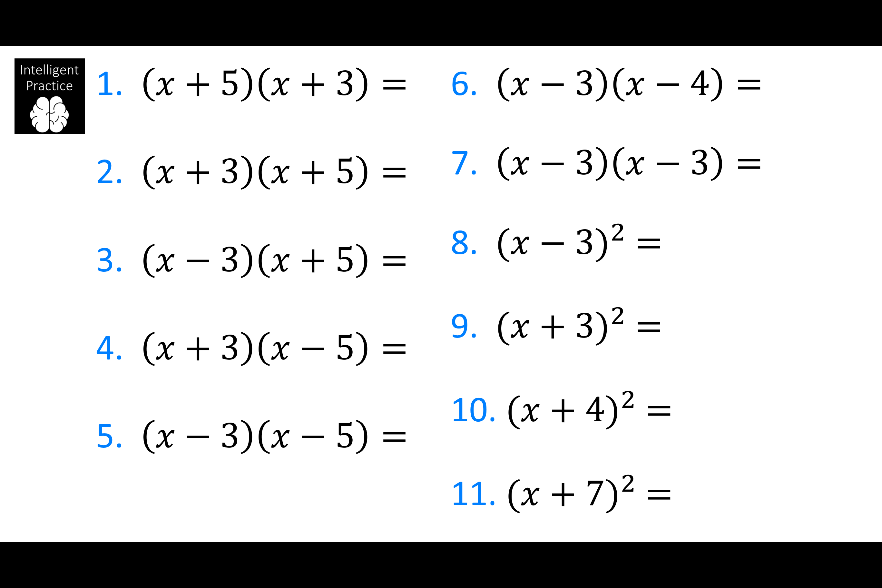

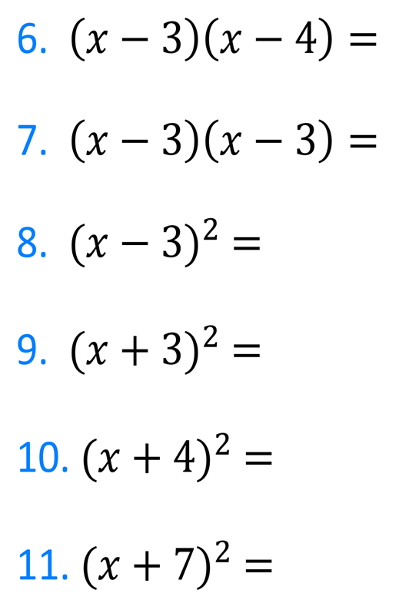
Foundation - Expanding Double Brackets

