Similar Shapes – Length, Area and Volume
Section A
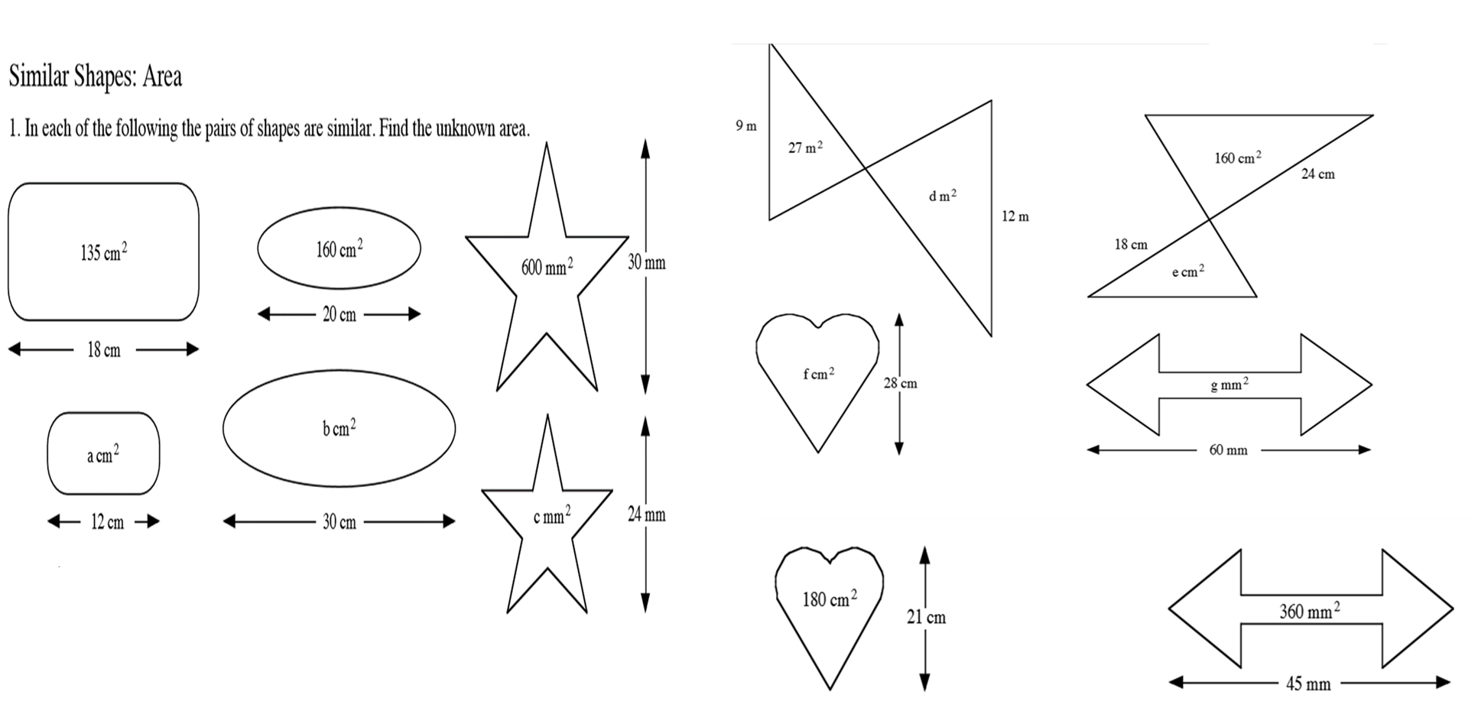
Section B
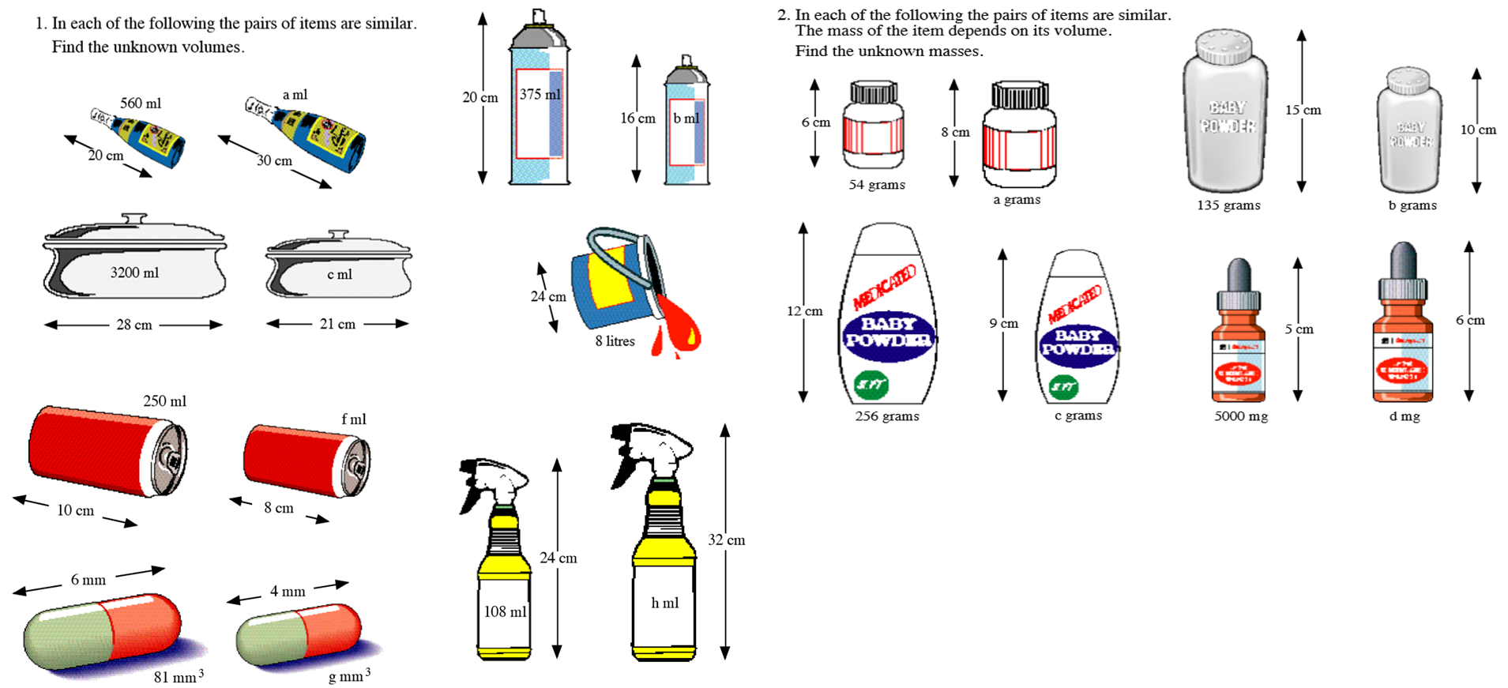

Similar Shapes - Length, Area and Volume
Section A
Section B

