Algebraic Indices – Fractional and Negative
Negative
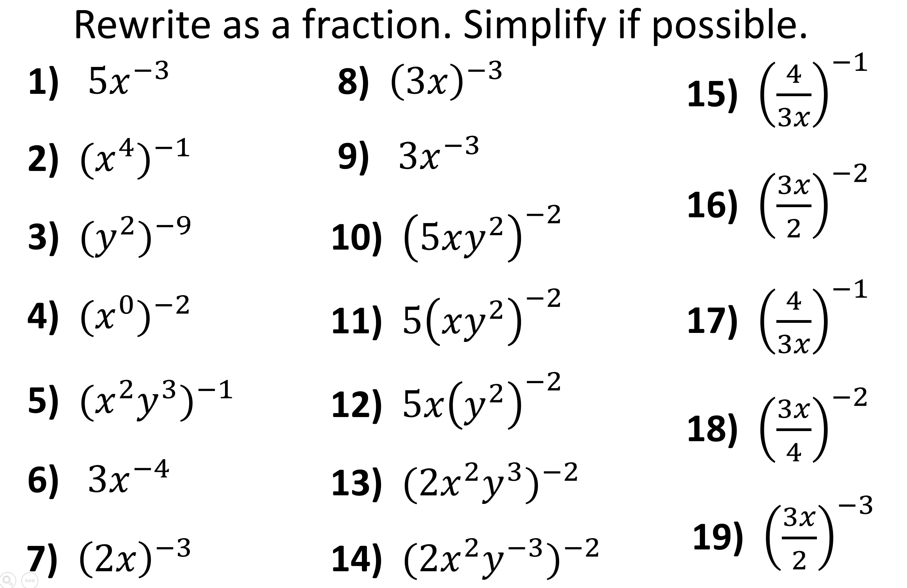
Fractional
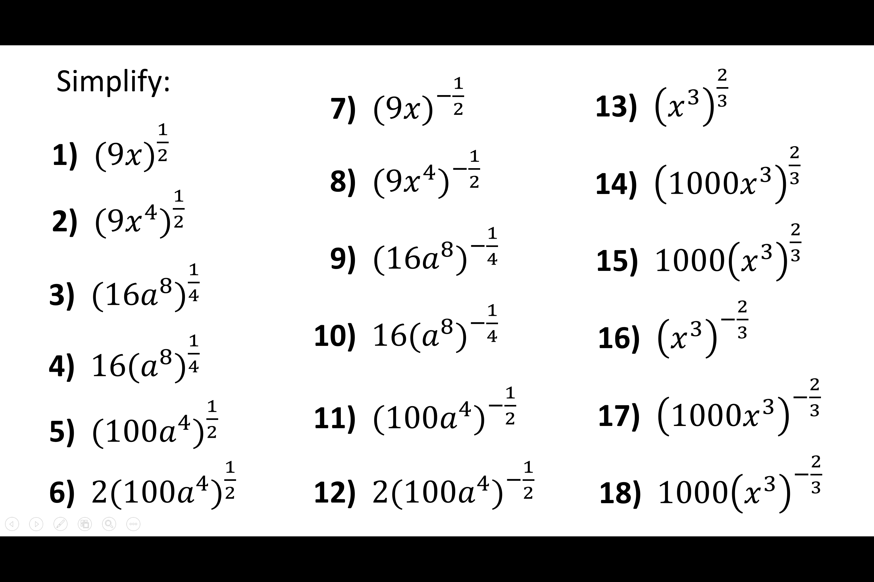
Algebraic Indices – Fractional and Negative
Negative
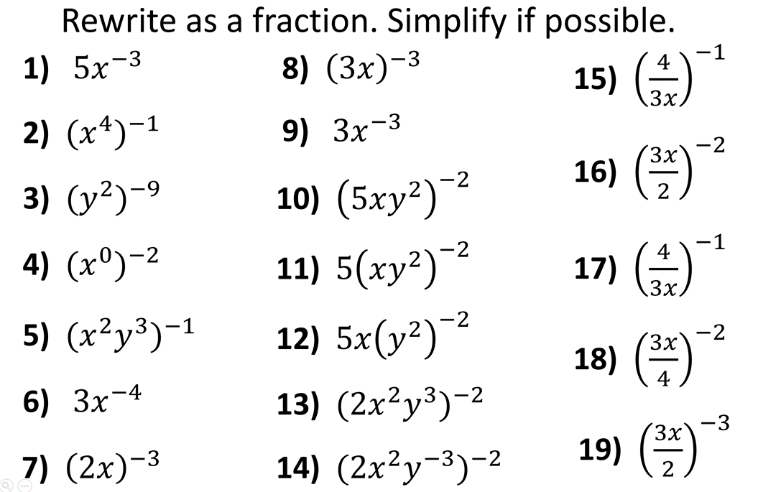
Fractional

