1) Find the missing sides 2) Find the missing sides
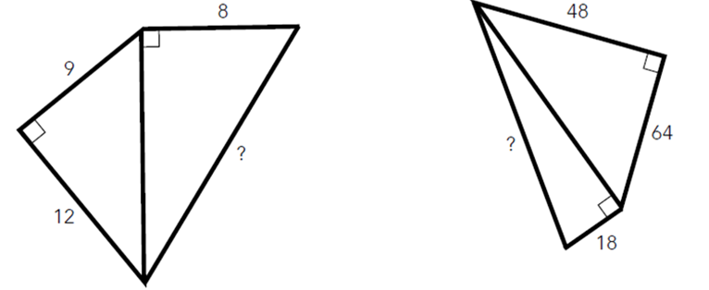
3) Find the length of AB 4) Find the length of DE 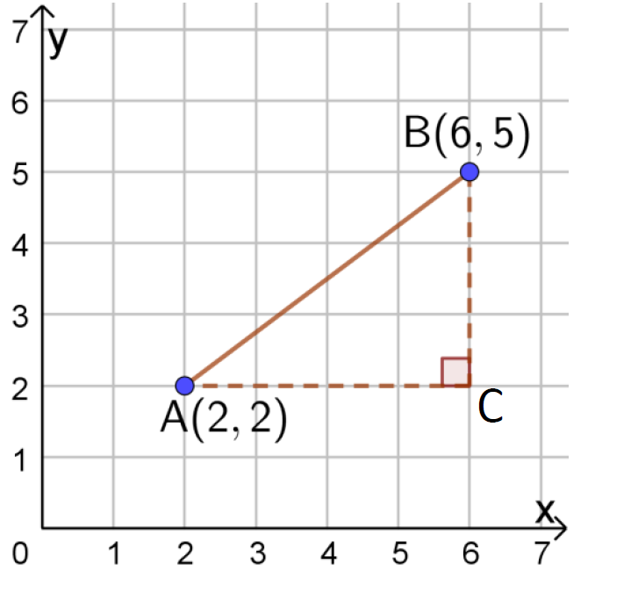 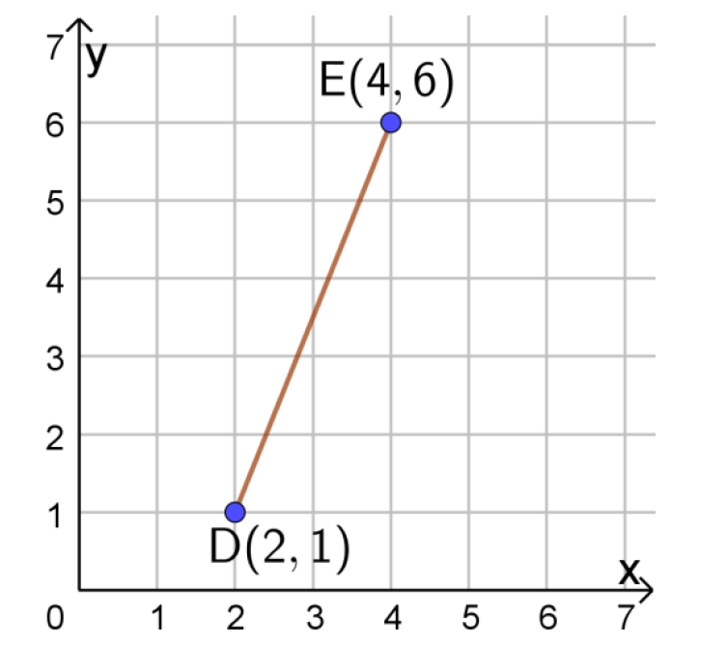
5) Find the length of AB 6) Find the length of DE 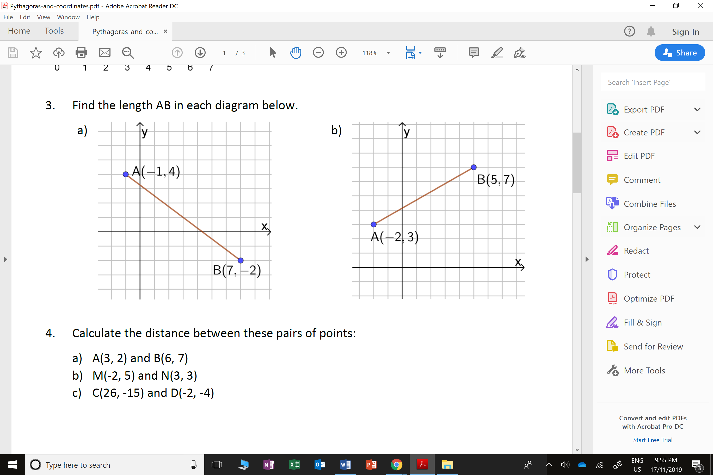
7) Find the length of the line 8) Find the length of the line 9) Find the length of the line
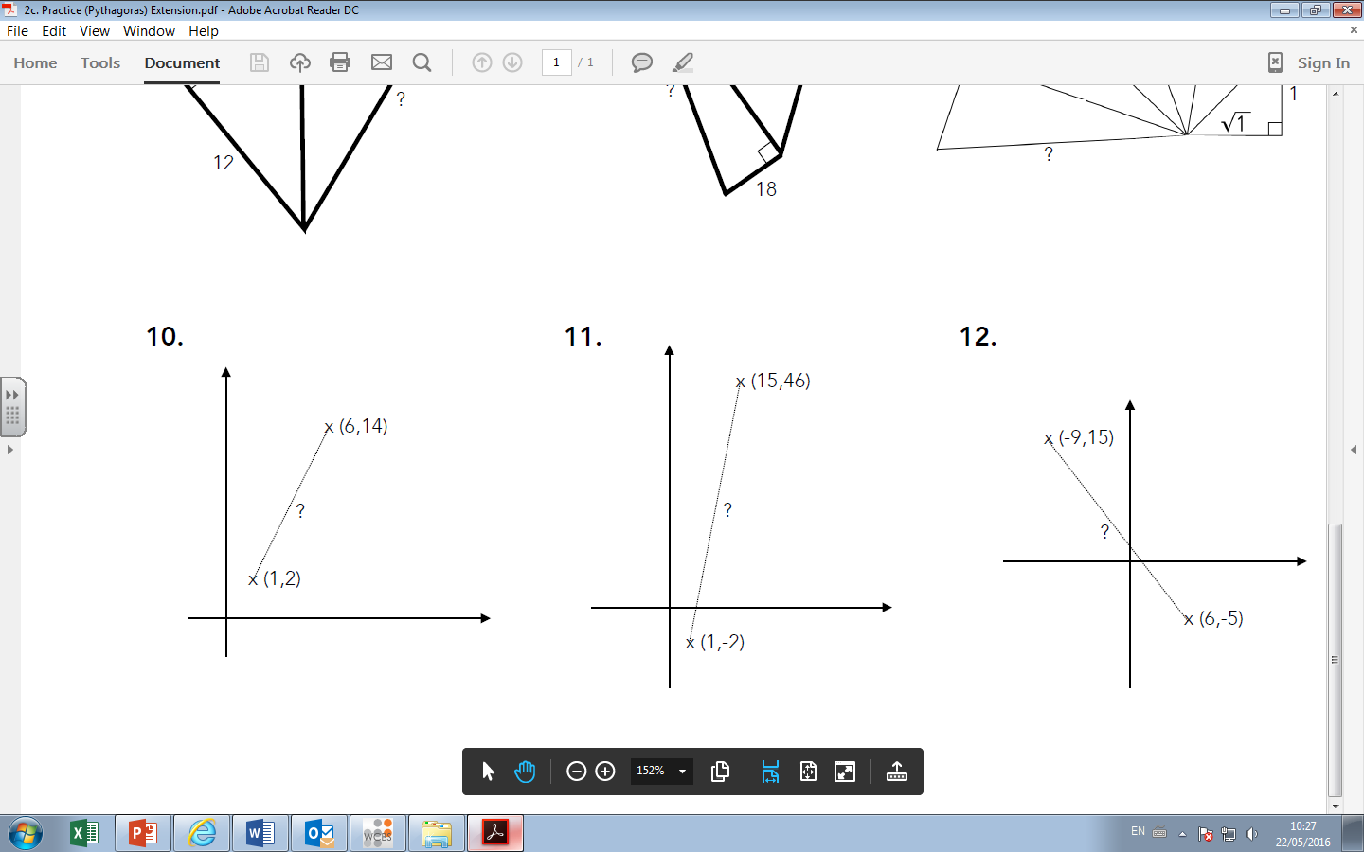
1) Find the missing sides 2) Find the missing sides
3) Find the length of AB 4) Find the length of DE
5) Find the length of AB 6) Find the length of DE
7) Find the length of the line 8) Find the length of the line 9) Find the length of the line

