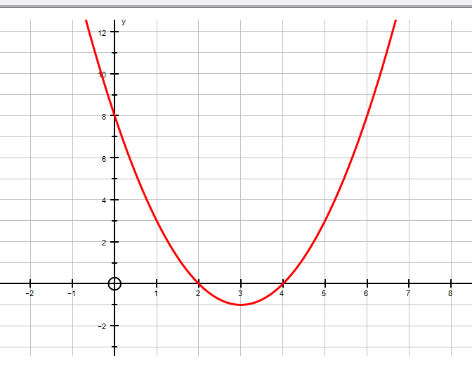
ANSWER:

QUESTION:
$$y=x^{2}+ 5x+6$$
1
Treasure Hunt!
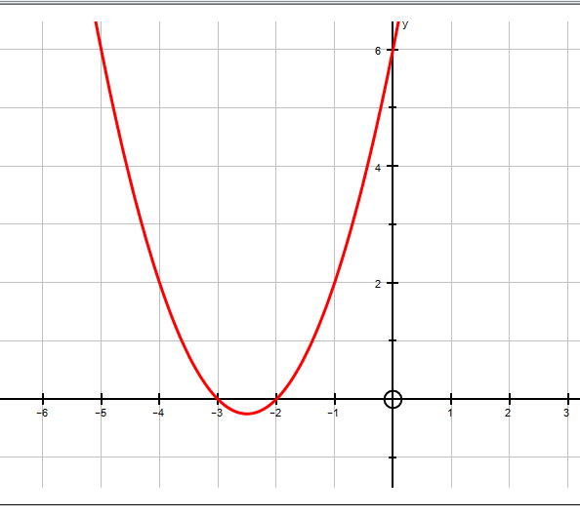
ANSWER:

QUESTION:
$$y=x^{2}+ 9x+8$$
5
Treasure Hunt!
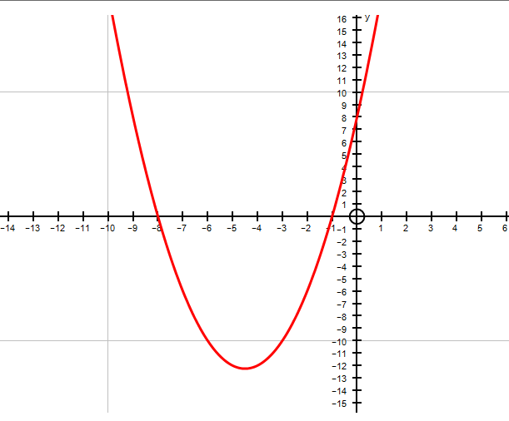
ANSWER:

QUESTION:
$$y=x^{2}- 6x+9$$
7
Treasure Hunt!
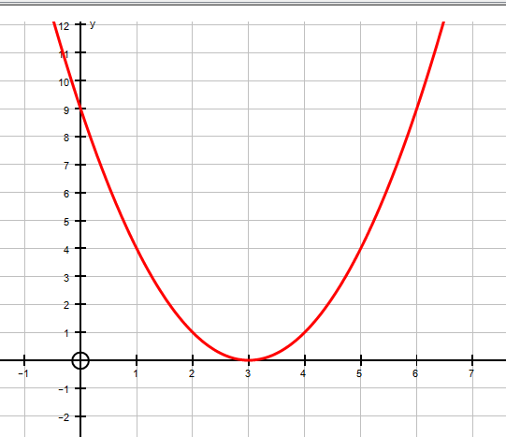
10
ANSWER:

QUESTION:
$$y={16-x}^{2}$$
Treasure Hunt!
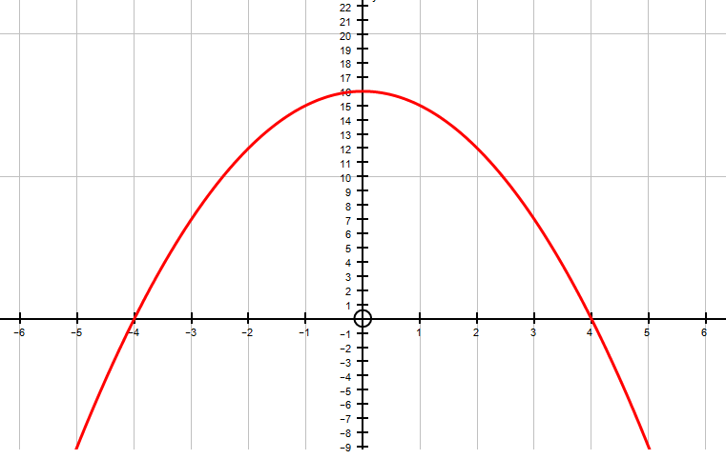
ANSWER:

QUESTION:
$$y=x^{2}- x-6$$
2
Treasure Hunt!
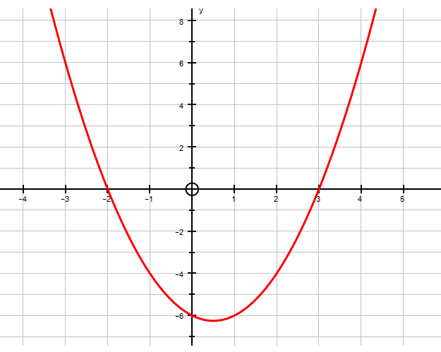
ANSWER:

QUESTION:
$$y=x^{2}+ 7x-8$$
9
Treasure Hunt!
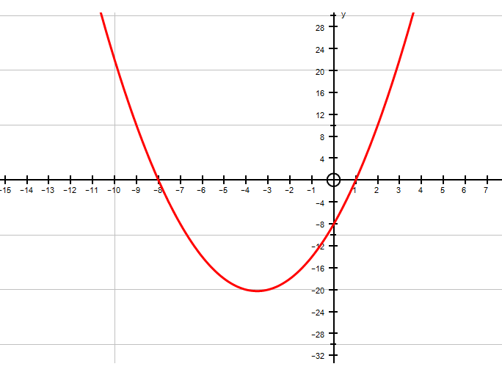
ANSWER:

QUESTION:
$$y={-x}^{2}+ 9x-8$$
4
Treasure Hunt!
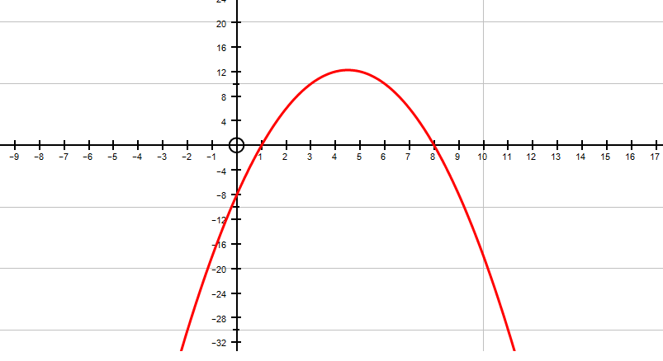
ANSWER:

QUESTION:
$$y=x^{2}+ 7x+12$$
6
Treasure Hunt!
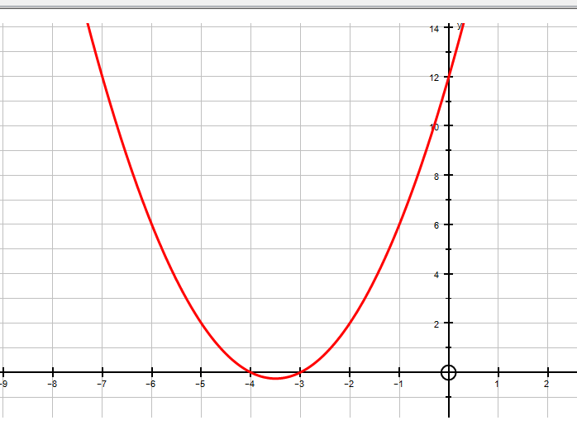
ANSWER:

QUESTION:
$$y=x^{2}+ 8x+16$$
3
Treasure Hunt!
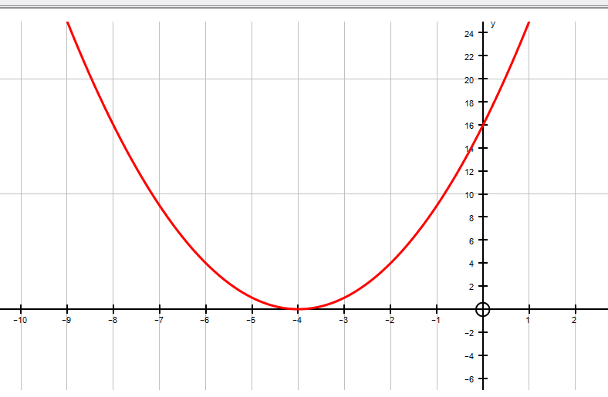
11
ANSWER:

QUESTION:
$$y={8+2x-x}^{2}$$
Treasure Hunt!
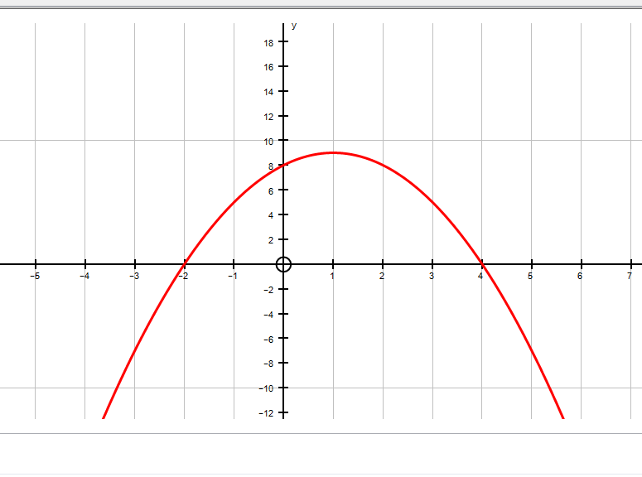
ANSWER:

QUESTION:
$$y={-x}^{2}+ 5x-6$$
8
Treasure Hunt!
12
Treasure Hunt!
ANSWER:

QUESTION:
$$y=x^{2}-6x+8$$

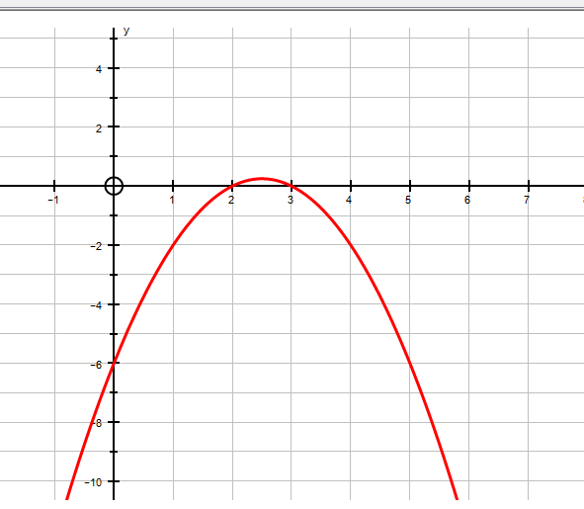
Treasure Hunt!

