Non-Linear Graphs (Area Under a Graph)
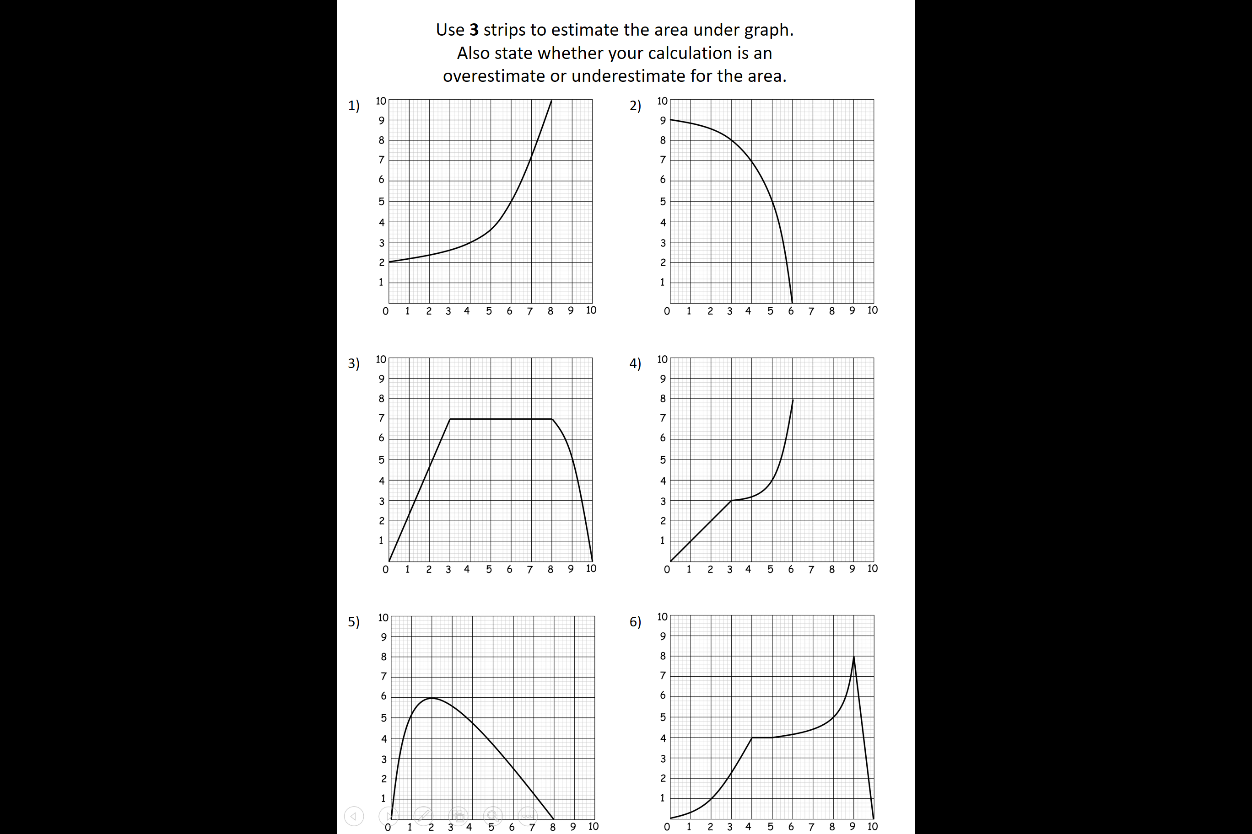

Non-Linear Graphs (Area Under a Graph)

