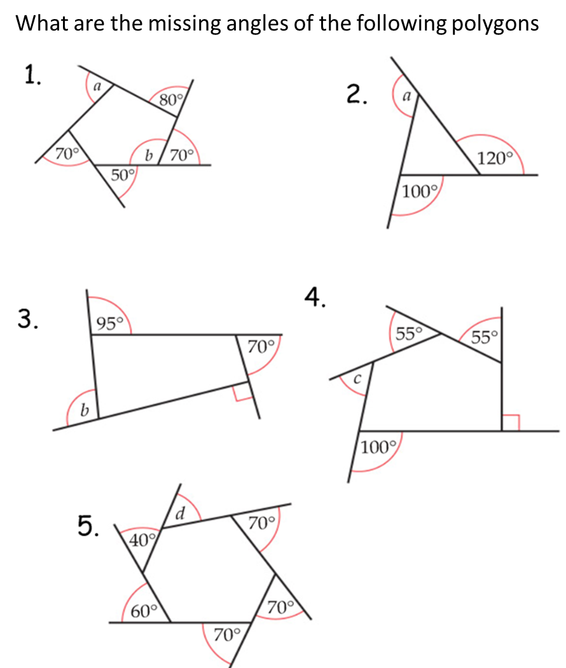
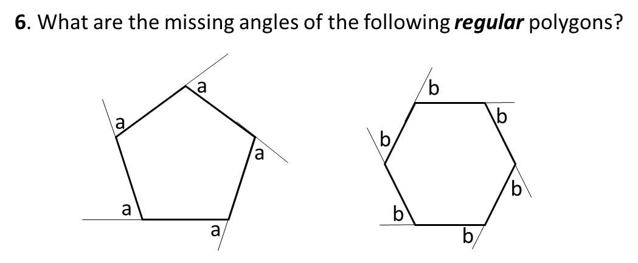
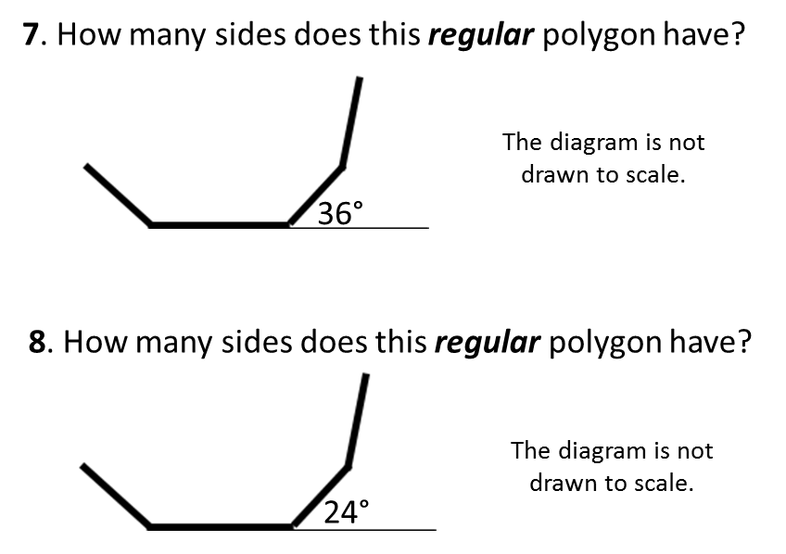
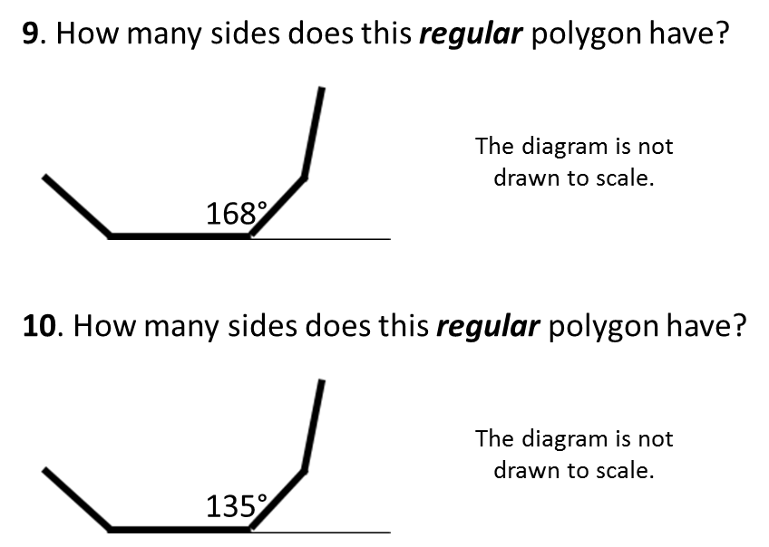
11. A regular polygon has an exterior angle of 60°.
How many sides does the regular polygon have?

12. A regular polygon has an interior angle of 140°.
How many sides does the regular polygon have?

