Picture Round (1 point each)
1. Name the company   | 2. Name the company  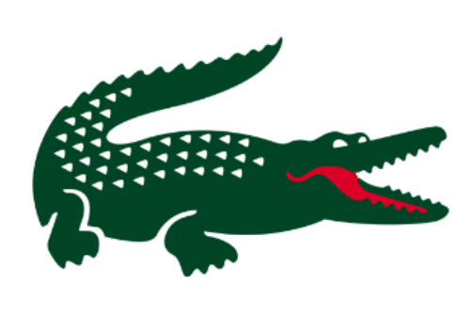
3. Which is correct? Right or Left   | 4. Which is correct? Right or Left  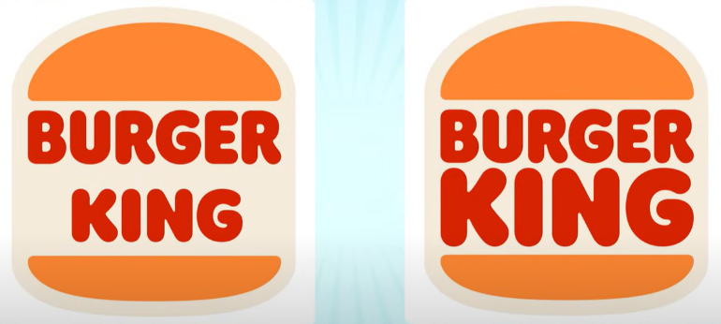
5. Name the movie  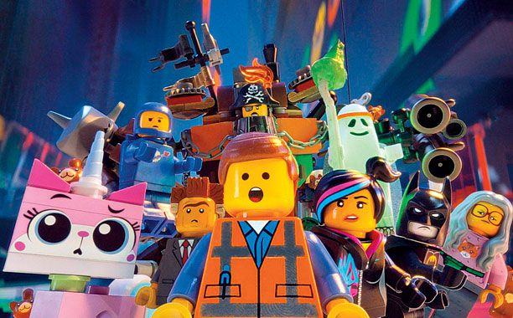 | 6. Name the movie  
7. Name the country  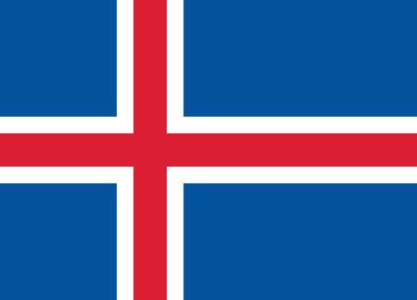 | 8. Name the country  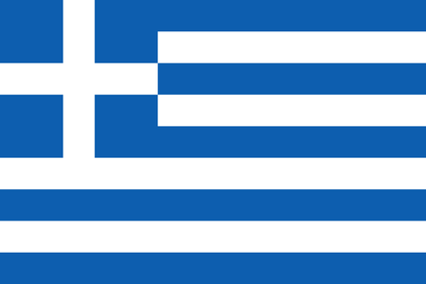
9. Who is the famous person   | 10. Who is the famous person  
11. Name the Country  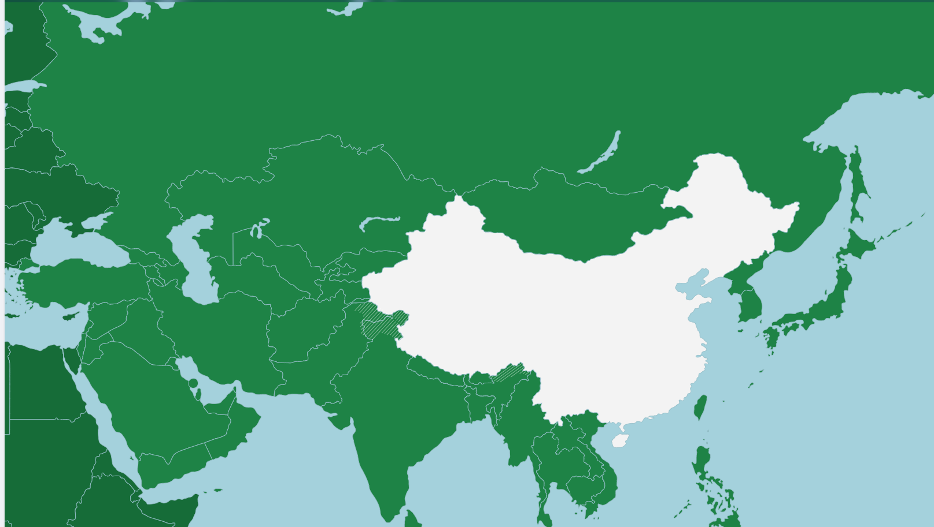 | 12. Name the Country  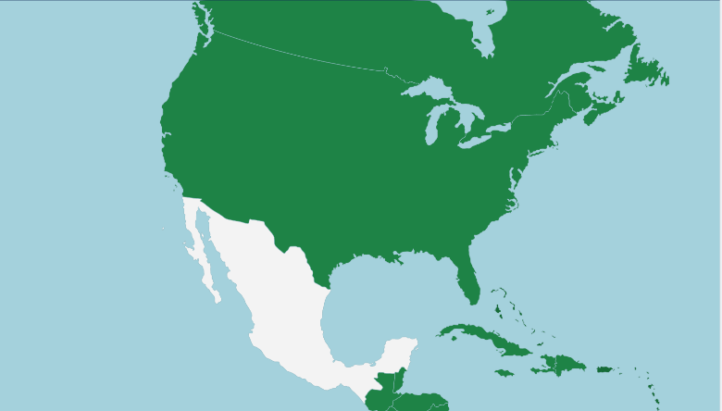

Wipeout Round
List up to 10 answers.
Give as many answers as you feel confident.
Get 1 point for every correct answer given.
Get 1 wrong answer and score zero for the whole round!

List the 8 winners of the men’s football world cup. (Does not need to be in order):

1.
2.
3.
4.
5.
6.
7.
8.

